Dichloro-bis(1,1-diphenylmethanimine)-copper (Blind Test XXVIII)
(Last updated February 2026)
Figure 1. The molecular diagram of Dichloro-bis(1,1-diphenylmethanimine)-copper.

CSP studies
REFCODE | OJIGOG
Formula | Cu1 Cl2 N2 C26 H22
Common Name | Blind Test XXVIII
IUPAC Systematic Name | dichloro-bis(1,1-diphenylmethanimine)-copper
Other Names
CSD Refcodes | OJIGOG01
Search Identifier | A
Scientist | Rui Guo, Louise Price
Date | October 2021
Publication | Hunnisett LM, et al, Acta Cryst B, 2024, 80(6), 517-547
Energy model | 2
Study_ID | 10
Programs | CrystalPredictor (2.4.3), CrystalOptimizer (2.4.8_07_05), DMACRYS (2.3.1.1)
Location on S Drive | CHEMISTRY_CPOSS\BlindTest2020-2022\XXVIII\LimitedCO\
Potential Description | CrystalOptimizer PCMdielectric=11(PBEPBE/6-31G) intramolecular + GDMA2.2(PCMdielectric=11(PBEPBE/6-31G)) DMA + FIT + UFF Cu parameters
Intramolecular Description | PCMdielectric=11(PBE(6-31G))
Energy model | 1
Study_ID | 20
Programs | CrystalPredictor (2.4.3), DMACRYS (2.3.1.1)
Location on S Drive | CHEMISTRY_CPOSS\BlindTest2020-2022\XXVIII\RigidCP\
Potential Description | Rigid CrystalPredictor + DMACRYS with GDMA2.2(PCMdielectric=11(PBEPBE/6-31G)) + FIT + UFF Cu potential
Intramolecular Description | PCMdielectric=11(PBE/6-31G)
Search Identifier | B
Scientist | Rui Guo, Louise Price
Date | February 2022
Publication | Hunnisett LM, et al, Acta Cryst B, 2024, 80(6), 548-574
Energy model | 2
Study_ID | 12
Programs | CCDC supplied crystal structures, CrystalOptimizer (2.4.8_07_05), DMACRYS (2.3.1.1)
Location on S Drive | CHEMISTRY_CPOSS\BlindTest2020-2022\XXVIII\CO_sub2_basis\
Potential Description | CrystalOptimizer PCMdielectric=11(PBEPBE/6-31G) intramolecular + GDMA2.2(PCMdielectric=11(PBE1PBE/6-31G(d,p))) DMA + FIT + UFF Cu parameters
Intramolecular Description | PCMdielectric=11(PBE(6-31G))
Energy model | 1
Study_ID | 11
Programs | CCDC supplied crystal structures, CrystalOptimizer (2.4.8_07_05), DMACRYS (2.3.1.1)
Location on S Drive | CHEMISTRY_CPOSS\BlindTest2020-2022\XXVIII\CO_sub2\
Potential Description | CrystalOptimizer PCMdielectric=11(PBEPBE/6-31G) intramolecular + GDMA2.2(PCMdielectric=11(PBEPBE/6-31G)) DMA + FIT + UFF Cu parameters
Intramolecular Description | PCMdielectric=11(PBE(6-31G))

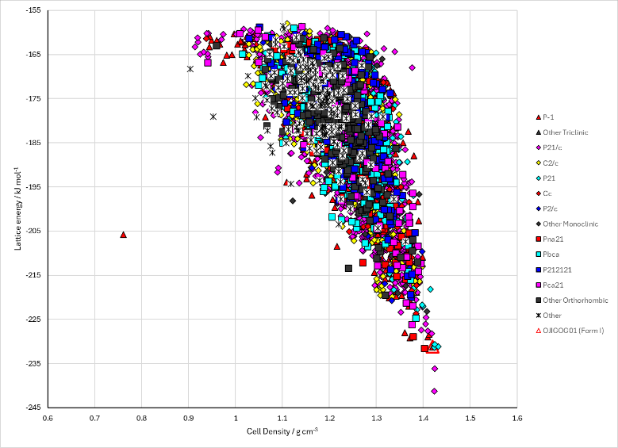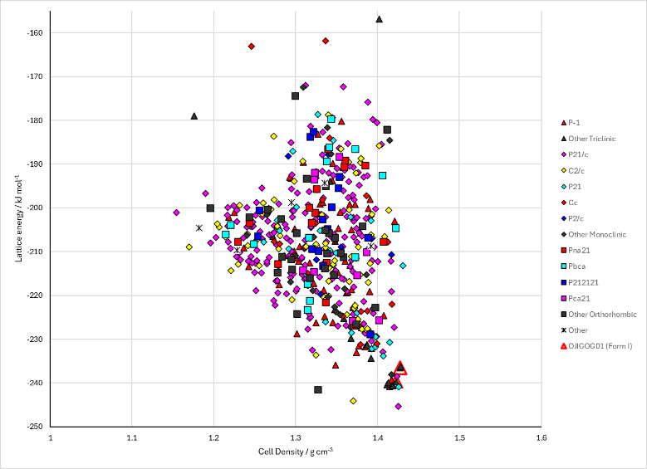
Figure 2. Crystal energy landscape of Dichloro-bis(1,1-diphenylmethanimine)-copper from previous work. Left: Energy model A2. Right: Energy model B2.

CSD structures (CSD version 6.01)

Table 1. Crystallographic information for CSD entries for Dichloro-bis(1,1-diphenylmethanimine)-copper. Different polymorphs are coloured differently.
REFCODE | space group | Z’ | a / Å | b / Å | c / Å | α / ° | β / ° | γ / ° | density / g cm⁻³ | Form
OJIGOG | P-1 | 0.5 | 5.25130 | 9.58480 | 12.2752 | 111.548 | 91.115 | 99.923 | 1.4636 | None
OJIGOG01 | P-1 | 0.5 | 5.26120 | 9.6022 | 12.268 | 111.642 | 91.09 | 99.961 | 1.4602 | None

Table 2. Experimental information for CSD entries for Dichloro-bis(1,1-diphenylmethanimine)-copper.
REFCODE | space group | R factor | T / K | Year | Comments
OJIGOG | P-1 | 2.74 | 150 K | 2021 | 10.1016/j.poly.2020.114977
OJIGOG01 | P-1 | 3.46 | 150 K | 2022 | None

Make this table include whether polymorphs are solution-grown, sublimation grown, templated or otherwise. Add references.

Other notes

