Nitrofurantoin
(Last updated March 2026)
Figure 1. The molecular diagram of Nitrofurantoin.

CSP studies
REFCODE | LABJON
Formula | C8 H6 N4 O5
Common Name | Nitrofurantoin
IUPAC Systematic Name | 1-{[(5-nitrofuran-2(5H)-ylidene)methyl]amino}imidazolidine-2,4-dione
Other Names
CSD Refcodes | LABJON06, LABJON07
Search Identifier | A
Scientist | Agris Berzins
Date | 2018
Publication | Trimdale-Deksne A, Kons A, Orola, L, Mishnev A, Stepanovs D, Mazur L, Skiba M, Dudek MK, Fantozzi N, Virieux D, et al. Crystal Growth & Design 2023, 23 (2), 930-945
Energy model | 1
Study_ID | 10
Programs | CrystalPredictor, CrystalOptimizer, DMACRYS (2.3.0)
Location on S Drive | \CHEMISTRY_CPOSS\Agris\Nitrofurantoin
Potential Description | CrystalOptimizer MO62X/6-31G(d,p) intramolecular + GDMA2.2(MO62X/6-31G(d,p)) DMA + FIT
Intramolecular Description | M062X/6-31G(d,p)

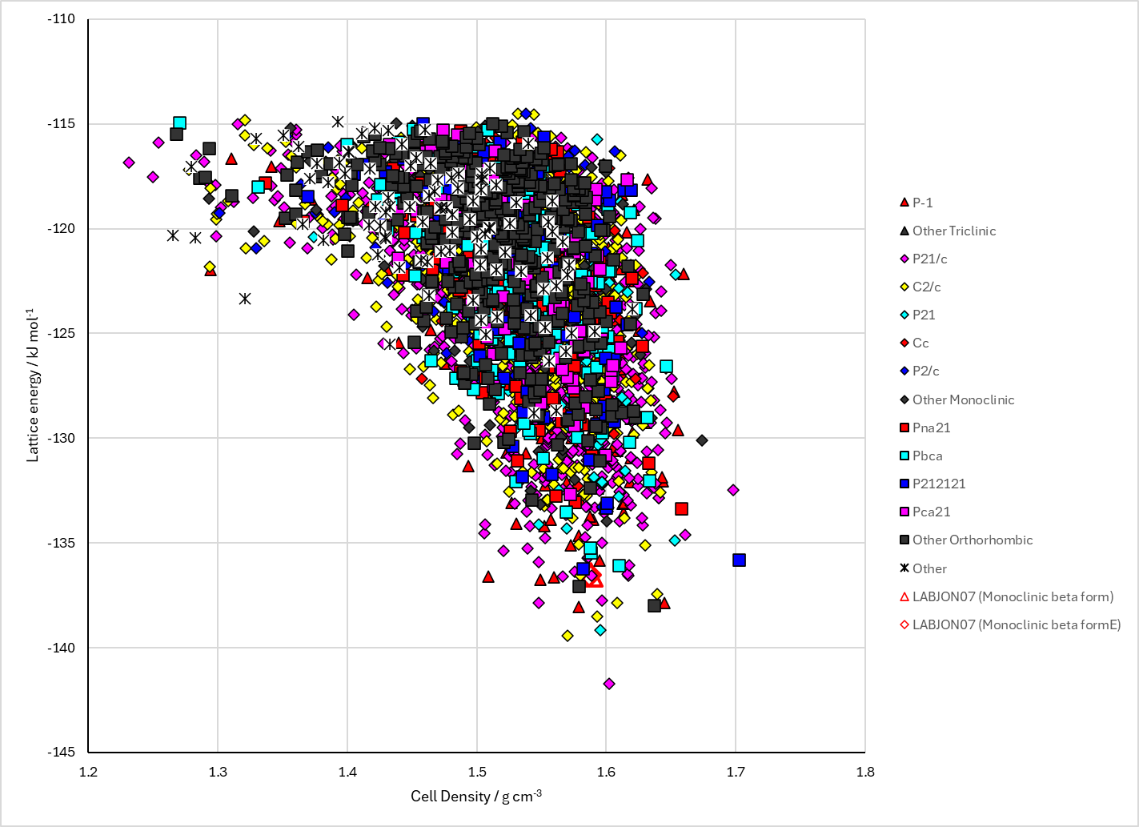
Figure 2. Crystal energy landscape of Nitrofurantoin from previous work.

CSD structures (CSD version 6.01)

Table 1. Crystallographic information for CSD entries for Nitrofurantoin. Different polymorphs are coloured differently.
REFCODE | space group | Z’ | a / Å | b / Å | c / Å | α / ° | β / ° | γ / ° | density / g cm⁻³ | Form
LABJON | P21/n | 1.0 | 7.845 | 6.462 | 18.92 | 90.0 | 93.18 | 90.0 | 1.6518 | monoclinic beta form
LABJON01 | P-1 | 1.0 | 6.774 | 7.795 | 9.803 | 106.68 | 104.09 | 92.29 | 1.6562 | triclinic alpha form
LABJON02 | P21/n | 1.0 | 7.84 | 6.486 | 18.911 | 90.0 | 93.17 | 90.0 | 1.6475 | monoclinic beta form
LABJON04 | P21/c | 1.0 | 7.849 | 6.5 | 20.0570 | 90.0 | 109.675 | 90.0 | 1.6417 | P21/c form
LABJON05 | P-1 | 1.0 | 6.78060 | 7.79320 | 9.81590 | 106.699 | 104.105 | 92.306 | 1.6531 | triclinic alpha form
LABJON06 | P-1 | 1.0 | 6.78790 | 7.6074 | 9.7707 | 106.991 | 103.821 | 92.294 | 1.6999 | triclinic alpha form
LABJON07 | P21/n | 1.0 | 7.6855 | 6.46500 | 18.8252 | 90.0 | 91.869 | 90.0 | 1.6920 | monoclinic beta form
LABJON08 | P21/n | 1.0 | 7.83970 | 6.48600 | 18.943 | 90.0 | 92.754 | 90.0 | 1.6441 | monoclinic beta form

Table 2. Experimental information for CSD entries for Nitrofurantoin.
REFCODE | space group | R factor | T / K | Year | Comments
LABJON | P21/n | 4.0 | None | 1993 | 10.1107/S010827019201062X
LABJON01 | P-1 | 3.4 | None | 1993 | 10.1007/BF01247241
LABJON02 | P21/n | 5.3 | None | 1993 | 10.1007/BF01247241
LABJON04 | P21/c | 6.460 | 293 K | 2015 | 10.4236/ojic.2015.53008
LABJON05 | P-1 | 3.409 | 290 K | 2023 | 10.1021/acs.cgd.3c00033
LABJON06 | P-1 | 3.130 | 100 K | 2023 | 10.1021/acs.cgd.3c00033
LABJON07 | P21/n | 2.98 | 100 K | 2023 | 10.1021/acs.cgd.3c00033
LABJON08 | P21/n | 6.81 | 290 K | 2023 | 10.1021/acs.cgd.3c00033

Make this table include whether polymorphs are solution-grown, sublimation grown, templated or otherwise. Add references.

Other notes

