Tazofelone
(Last updated March 2026)
Figure 1. The molecular diagram of Tazofelone.

CSP studies
REFCODE | WIMBAV
Formula | C18 H27 N1 O2 S1
Common Name | Tazofelone
IUPAC Systematic Name | 2,6-di-tert-butyl-4-(1,3-thiazolidin-5-ylmethyl)phenol
Other Names
CSD Refcodes | WILZUM, WIMBAV08, WIMBAV10, WIMBAV12, WIMBAV07
Search Identifier | A
Scientist | Louise Price
Date | 2013
Publication | Price LS, McMahon JA, Lingireddy SR, Lau S-F, Diseroad BA, Price SL, Reutzel-Edens SM 2014. J Mol Struct. 1078, 26-42.
Energy model | 2
Study_ID | 10
Programs | Study_ID=20, CrystalOptimizer, DMACRYS (2.0.8beta4)
Location on S Drive | \CHEMISTRY_CPOSS\Tazofelone\Tazofelone_CO
Potential Description | CrystalOptimizer with PBE0/6-31G(d,p) Intra and GDMA2.2(PBE0/6-31G(d,p)) + FIT with isotropic S
Intramolecular Description | PBE0/6-31G(d,p)
Energy model | 1
Study_ID | 20
Programs | Flexible CrystalPredictor (2), DMACRYS (2.0.8beta4)
Location on S Drive | \CHEMISTRY_CPOSS\Tazofelone\Tazofelone_CP
Potential Description | CrystalPredictor, single point DMACRYS with GDMA2.2(PBE0/6-31G(d,p)) + FIT
Intramolecular Description | PBE0/6-31G(d,p)

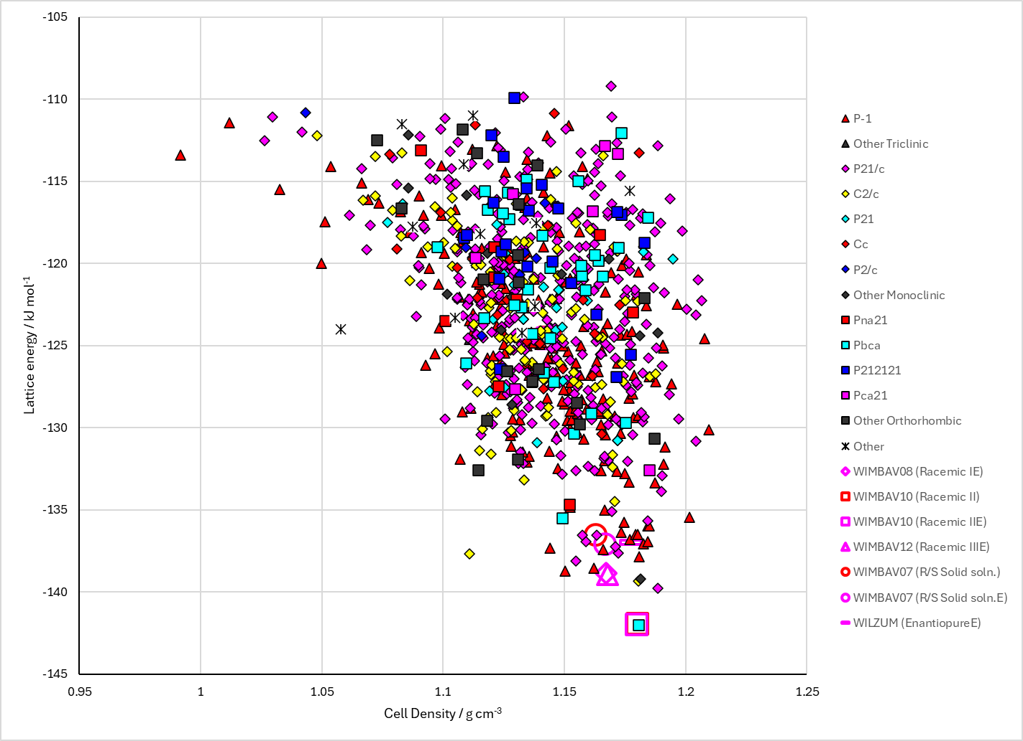
Figure 2. Crystal energy landscape of Tazofelone from previous work. Energy model A2.

CSD structures (CSD version 6.01)

Table 1. Crystallographic information for CSD entries for Tazofelone. Different polymorphs are coloured differently.
REFCODE | space group | Z’ | a / Å | b / Å | c / Å | α / ° | β / ° | γ / ° | density / g cm⁻³ | Form
WILZUM | P21 | 2.0 | 9.392 | 10.962 | 17.823 | 90.0 | 94.29 | 90.0 | 1.1669 | None
WIMBAV | Pbca | 1.0 | 17.204 | 11.287 | 18.86 | 90.0 | 90.0 | 90.0 | 1.1661 | polymorph I
WIMBAV01 | P21/c | 2.0 | 11.313 | 17.082 | 19.324 | 90.0 | 101.11 | 90.0 | 1.1654 | polymorph II
WIMBAV06 | P21/n | 1.0 | 9.38820 | 10.9503 | 17.855 | 90.0 | 93.766 | 90.0 | 1.1658 | polymorph III
WIMBAV07 | P21/n | 1.0 | 9.21060 | 10.9363 | 17.6476 | 90.0 | 93.331 | 90.0 | 1.2032 | polymorph III
WIMBAV08 | P21/c | 2.0 | 11.0992 | 16.9748 | 19.2201 | 90.0 | 100.5695 | 90.0 | 1.1996 | metastable RCI polymorph
WIMBAV09 | P21/c | 2.0 | 11.3103 | 17.0578 | 19.3296 | 90.0 | 101.029 | 90.0 | 1.1667 | metastable RCI polymorph
WIMBAV10 | Pbca | 1.0 | 17.1102 | 11.0958 | 18.6504 | 90.0 | 90.0 | 90.0 | 1.2061 | RCII polymorph
WIMBAV11 | Pbca | 1.0 | 17.1967 | 11.2756 | 18.8057 | 90.0 | 90.0 | 90.0 | 1.1711 | RCII polymorph
WIMBAV12 | P-1 | 2.0 | 11.105 | 11.8502 | 14.9408 | 77.672 | 75.185 | 71.44 | 1.1975 | metastable RCIII polymorph
WIMBAV13 | P-1 | 2.0 | 11.2917 | 11.9167 | 14.9597 | 77.827 | 75.208 | 71.585000 | 1.1681 | metastable RCIII polymorph

The names of forms in Table 1 are misleading. The original patent had a mixture of forms at “Form 1” and Form 2 was the only neat polymorph. Hence WIMBAV and WIMBAV01 are misnamed. WIMBAV06 and WIMBAV07 are actually a solid solution of the R and S enantiomers. WIMBAC08-13 are from our paper, so I want to go with that naming. The colors are from a Crystal Packing Similarity search in Mercury, so are valid.
Table 2. Experimental information for CSD entries for Tazofelone.
REFCODE | space group | R factor | T / K | Year | Comments
WILZUM | P21 | 5.54 | at 293 K | 2000 | 10.1039/a909259e
WIMBAV | Pbca | 4.94 | None | 2000 | 10.1039/a909259e
WIMBAV01 | P21/c | 6.36 | at 293 K | 2000 | 10.1039/a909259e
WIMBAV06 | P21/n | 12.08 | at 296 K | 2006 | 10.1021/ja063450l
WIMBAV07 | P21/n | 6.310 | at 100 K | 2006 | 10.1021/ja063450l
WIMBAV08 | P21/c | 5.47 | 100 K | 2014 | 10.1016/j.molstruc.2014.01.014
WIMBAV09 | P21/c | 7.12 | 296 K | 2014 | 10.1016/j.molstruc.2014.01.014
WIMBAV10 | Pbca | 4.520 | 100 K | 2014 | 10.1016/j.molstruc.2014.01.014
WIMBAV11 | Pbca | 5.520 | 296 K | 2014 | 10.1016/j.molstruc.2014.01.014
WIMBAV12 | P-1 | 7.71 | 100 K | 2014 | 10.1016/j.molstruc.2014.01.014
WIMBAV13 | P-1 | 8.74 | 115 K | 2014 | 10.1016/j.molstruc.2014.01.014

Make this table include whether polymorphs are solution-grown, sublimation grown, templated or otherwise. Add references.

Other notes

