Tetrachlorobenzene
(Last updated April 2026)
Figure 1. The molecular diagram of Tetrachlorobenzene.

CSP studies
REFCODE | TCLBEN
Formula | C6 H2 Cl4
Common Name | Tetrachloeobenzene
IUPAC Systematic Name | 1,2,4,5-tetrachlorobenzene
Other Names | Tetrachlorobenzene
CSD Refcodes | TCLBEN03, TCLBEN02
Search Identifier | A
Scientist | Sarah Barnett
Date | 2004
Publication | Barnett, S. A., Broder, C. K., Shankland, K., David, W. I. F., Ibberson, R. M., Tocher, D. A., Acta Crystallogr. B, 62(2), 287-295 (2006).
Energy model | 1
Study_ID | 0
Programs | MOLPAK, DMAREL (4.1.1)
Location on S Drive | \CHEMISTRY_CPOSS\0-EarlySearches\home\louise_price.eminerals\tetrachlorobenzene
Potential Description | Anisotropic Day potential
Intramolecular Description | MP2/6-31G(d,p)

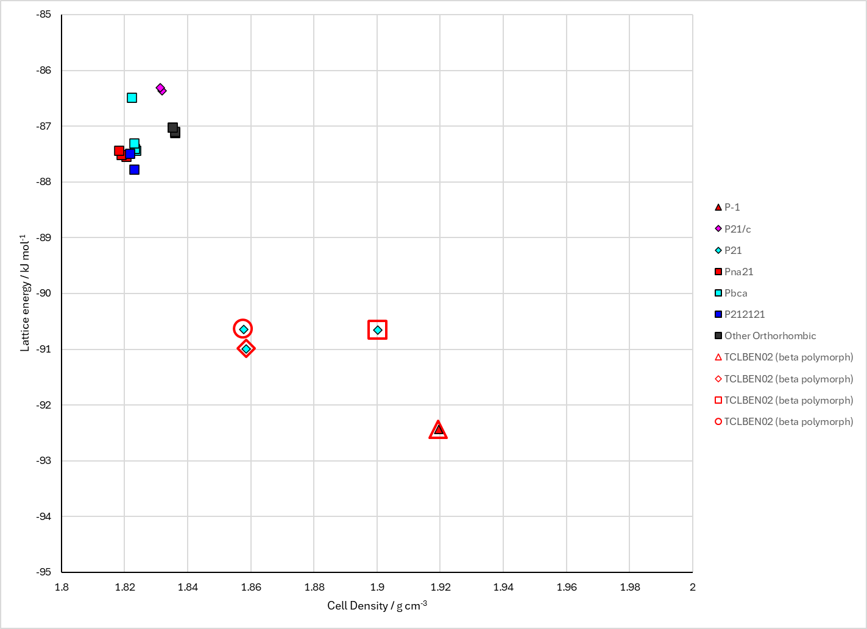
Figure 2. Crystal energy landscape of Tetrachlorobenzene from previous work.

CSD structures (CSD version 6.01 with Feb 2026 update)

Table 1. Crystallographic information for CSD entries for Tetrachlorobenzene. Different polymorphs are coloured differently.
REFCODE | space group | Z’ | a / Å | b / Å | c / Å | α / ° | β / ° | γ / ° | density / g cm⁻³ | Form
TCLBEN | P21/c | 0.5 | 3.85 | 10.602 | 9.725 | 90.0 | 103.28 | 90.0 | 0.0 | beta polymorph
TCLBEN01 | Unknown | 0.0 | 9.52 | 10.59 | 3.76000 | 95.0 | 100.18 | 85.5 | None | alpha polymorph
TCLBEN02 | P21/n | 0.5 | 3.79560 | 10.5175 | 9.5648 | 90.0 | 99.723 | 90.0 | 1.9051 | beta polymorph
TCLBEN03 | P-1 | 1.0 | 3.8016 | 10.6369 | 9.48660 | 92.072 | 98.966000 | 96.52 | 3.8147 | alpha polymorph
TCLBEN04 | P-1 | 1.0 | 3.76062 | 10.5879 | 9.44562 | 92.4066 | 98.697800 | 97.589300 | 3.8990 | alpha polymorph
TCLBEN05 | P-1 | 1.0 | 3.79900 | 10.6258 | 9.47938 | 91.978000 | 99.058 | 96.234000 | 5.7339 | alpha polymorph
TCLBEN06 | P21/n | 0.5 | 3.78988 | 10.5032 | 9.56244 | 90.0 | 99.7184 | 90.0 | 1.9110 | beta polymorph
TCLBEN07 | P21/n | 0.5 | 3.81117 | 10.5386 | 9.57198 | 90.0 | 99.708800 | 90.0 | 1.8920 | beta polymorph
TCLBEN08 | P21/n | 0.5 | 3.85595 | 10.6147 | 9.59283 | 90.0 | 99.6884 | 90.0 | 1.8525 | beta polymorph

Table 2. Experimental information for CSD entries for Tetrachlorobenzene.
REFCODE | space group | R factor | T / K | Year | Comments
TCLBEN | P21/c | 20.0 | None | 1958 | 10.1107/S0365110X58001900
TCLBEN01 | Unknown | None | None | 1965 | 10.1107/S0365110X65002426
TCLBEN02 | P21/n | 3.74 | at 173 K | 1991 | 10.3891/acta.chem.scand.45-0158
TCLBEN03 | P-1 | 3.48 | at 150 K | 2006 | 10.1107/S0108768105042102
TCLBEN04 | P-1 | 5.7 | at 2.0 K | 2006 | 10.1107/S0108768105042102
TCLBEN05 | P-1 | None | at 150 K | 2006 | 10.1107/S0108768105042102
TCLBEN06 | P21/n | 4.600 | at 150 K | 2006 | 10.1107/S0108768105042102
TCLBEN07 | P21/n | 5.3 | at 200 K | 2006 | 10.1107/S0108768105042102
TCLBEN08 | P21/n | 5.67 | at 295 K | 2006 | 10.1107/S0108768105042102

Make this table include whether polymorphs are solution-grown, sublimation grown, templated or otherwise. Add references.

Other notes

