1,3-Dibromo-2-chloro-5-fluorobenzene (Blind Test XIII)
(Last updated February 2026)
Figure 1. The molecular diagram of Dibromo-2-chloro-5-fluorobenzene.

CSP studies
It was a MOLPAK search, but I’m not sure what xx packing type referred to.
REFCODE | SOXLEX
Formula | C6 H2 Br2 Cl1 F1
Common Name | Blind Test XIII
IUPAC Systematic Name | 1,3-Dibromo-2-chloro-5-fluorobenzene
Other Names
CSD Refcodes | SOXLEX
Search Identifier | A
Scientist | Gareth Welch, Alston Misquitta
Date | 2008
Publication | Day GM, 2009. Acta Crystallogr, Sect B 65, 107-125; Misquitta AJ, Welch GWA, Stone AJ, Price SL 2008. Chem Phys Lett 456, 105-109.
Energy model | 1
Study_ID | 0
Programs | MOLPAK, DMAREL (4.1.1)
Location on S Drive | \CHEMISTRY_CPOSS\0-EarlySearches\home\louise_price.eminerals\BlindTestXIII
Potential Description | Specific PBE0/Sadlej GDMA2 DMA +dispersion, SAPT fitted anisotropic Repulsion 8a_5
Intramolecular Description | MP2 6-31G(d,p)

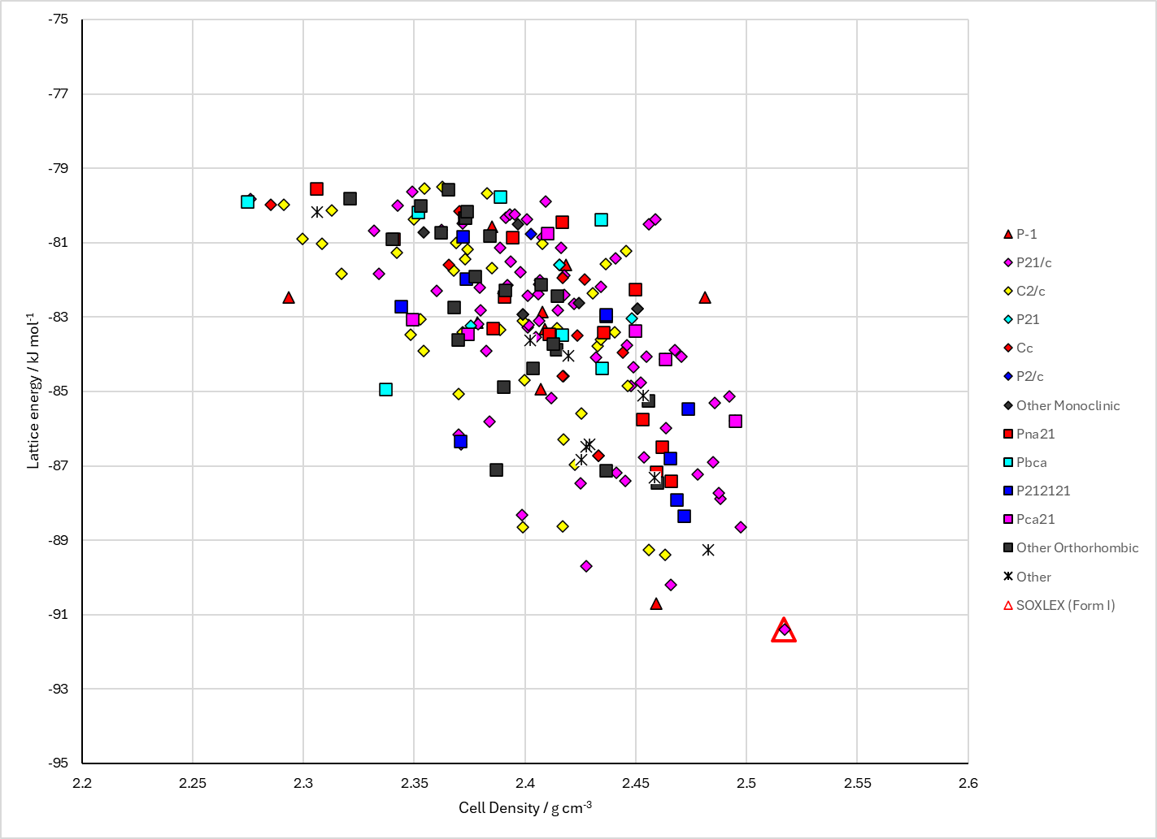
Figure 2. Crystal energy landscape of Dibromo-2-chloro-5-fluorobenzene from previous work.

CSD structures (CSD version 6.01)

Table 1. Crystallographic information for CSD entries for Dibromo-2-chloro-5-fluorobenzene. Different polymorphs are coloured differently.
REFCODE | space group | Z’ | a / Å | b / Å | c / Å | α / ° | β / ° | γ / ° | density / g cm⁻³ | Form
SOXLEX | P21/c | 1.0 | 3.89280 | 13.5064 | 14.422 | 90.0 | 93.688 | 90.0 | 2.5309 | None
SOXLEX01 | P21/c | 1.0 | 3.89430 | 13.5109 | 14.4296 | 90.0 | 93.636 | 90.0 | 2.5276 | None

Table 2. Experimental information for CSD entries for Dibromo-2-chloro-5-fluorobenzene.
REFCODE | space group | R factor | T / K | Year | Comments
SOXLEX | P21/c | 2.82 | at 173 K | 2008 | None
SOXLEX01 | P21/c | 3.6 | 173 K | 2009 | 10.1107/S0108768109004066

Make this table include whether polymorphs are solution-grown, sublimation grown, templated or otherwise. Add references.

Other notes

