3,5-Dinitrobenzoic acid - 2,8-Dimethyl-6H,12H-5,11-methanodibenzo[b,f][1,5]diazocine cocrystal (Blind Test XXV)
(Last updated February 2026)
Figure 1. The molecular diagram of 3,5-Dinitrobenzoic acid and 2,8-Dimethyl-6H,12H-5,11-methanodibenzo[b,f][1,5]diazocine.

CSP studies
Search A was for 1,000,000 structures, and search B followed for a second 1,000,000 structures.
REFCODE | XAFQAZ
Formula | C7 H4 N2 O6 - C17 H18 N2
Common Name | 3,5-Dinitrobenzoic acid - Troger's Base cocrystal
IUPAC Systematic Name | 3,5-Dinitrobenzoic acid - 2,8-Dimethyl-6H,12H-5,11-methanodibenzo[b,f][1,5]diazocine cocrystal
Other Names
CSD Refcodes | XAFQAZ01
Search Identifier | A
Scientist | Rona Watson
Date | 2015
Publication | Reilly, AM et al, Acta Cryst. B, (2016) 72, 439-459 (List 1)
Energy model | 2
Study_ID | 10
Programs | Study_ID=20, CrystalOptimizer, DMACRYS (2.0.8RC1)
Location on S Drive | \CHEMISTRY_CPOSS\BlindTest2015\XAFQAZ\CrystOpt
Potential Description | CrystalOptimizer with GDMA2.2(PBE1PBE/6-31+G(d)) + FIT
Intramolecular Description | PBE1PBE/6-31+G(d)
Energy model | 3
Study_ID | 30
Programs | Study_ID=10, DMACRYS (2.0.8RC1)
Location on S Drive | \CHEMISTRY_CPOSS\BlindTest2015\XAFQAZ\PCM
Potential Description | GDMA2.2(PCMdielectric3(PBE1PBE/6-31+G(d))) + FIT
Intramolecular Description | PCM3(PBE0/6-31+G(d))
Energy model | 1
Study_ID | 20
Programs | Rigid CrystalPredictor, DMACRYS (2.0.8)
Location on S Drive | \CHEMISTRY_CPOSS\BlindTest2015\XAFQAZ\CrystPred
Potential Description | CrystalPredictor + DMACRYS with GDMA2.2(PBE1PBE/6-31G+(d)) + FIT
Intramolecular Description | PBE1PBE/6-31G+(d)

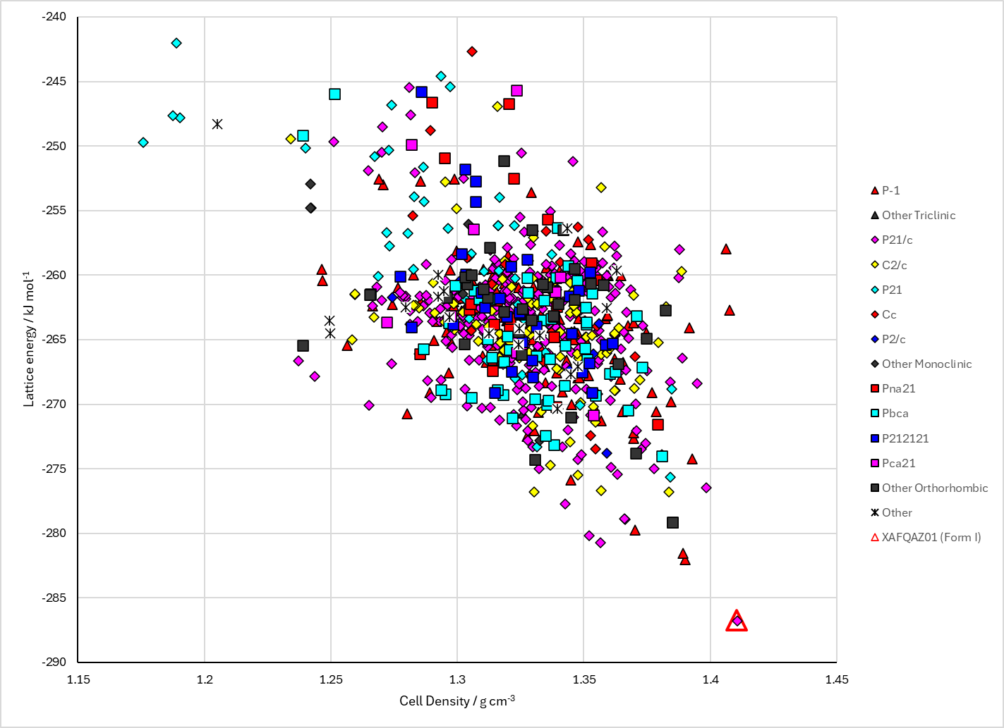
Figure 2. Crystal energy landscape of 3,5-Dinitrobenzoic acid - 2,8-Dimethyl-6H,12H-5,11-methanodibenzo[b,f][1,5]diazocine cocrystal from previous work.

CSD structures (CSD version 6.01)

Table 1. Crystallographic information for CSD entries for 3,5-Dinitrobenzoic acid - 2,8-Dimethyl-6H,12H-5,11-methanodibenzo[b,f][1,5]diazocine cocrystal. Different polymorphs are coloured differently.
REFCODE | space group | Z’ | a / Å | b / Å | c / Å | α / ° | β / ° | γ / ° | density / g cm⁻³ | Form
XAFQAZ | P21/c | 1.0 | 10.4240 | 27.5781 | 8.1258 | 90.0 | 109.56400 | 90.0 | 1.3955 | None
XAFQAZ01 | P21/c | 1.0 | 10.3784 | 27.1647 | 8.0627 | 90.0 | 109.92800 | 90.0 | 1.4373 | None

Table 2. Experimental information for CSD entries for 3,5-Dinitrobenzoic acid - 2,8-Dimethyl-6H,12H-5,11-methanodibenzo[b,f][1,5]diazocine cocrystal.
REFCODE | space group | R factor | T / K | Year | Comments
XAFQAZ | P21/c | 4.58 | 298 K | 2016 | Private communication
XAFQAZ01 | P21/c | 3.94 | 100 K | 2016 | Private communication, disordered

Make this table include whether polymorphs are solution-grown, sublimation grown, templated or otherwise. Add references.

Other notes

