3-Oxauracil
(Last updated May 2026)
Figure 1. The molecular diagram of 3-Oxauracil.

CSP studies
REFCODE | QARVOV
Formula | C4 H3 N1 O3
Common Name | 3-Oxauracil
IUPAC Systematic Name | 3H-[1,3]Oxazine-2,6-dione
Other Names
CSD Refcodes | QARVOV
Search Identifier | A
Scientist | Tom Lewis
Date | 2005
Publication | Copley, R. C. B., Deprez, L. S., Lewis, T. C., Price, S. L., CrystEngComm, 7(69), 421-428 (2005)
Energy model | 1
Study_ID | 0
Programs | MOLPAK, DMAREL (3.0)
Location on S Drive | \CHEMISTRY_CPOSS\0-EarlySearches\home\louise_price.eminerals\3-oxauracil
Potential Description | FIT
Intramolecular Description | MP2/6-31G(d,p)

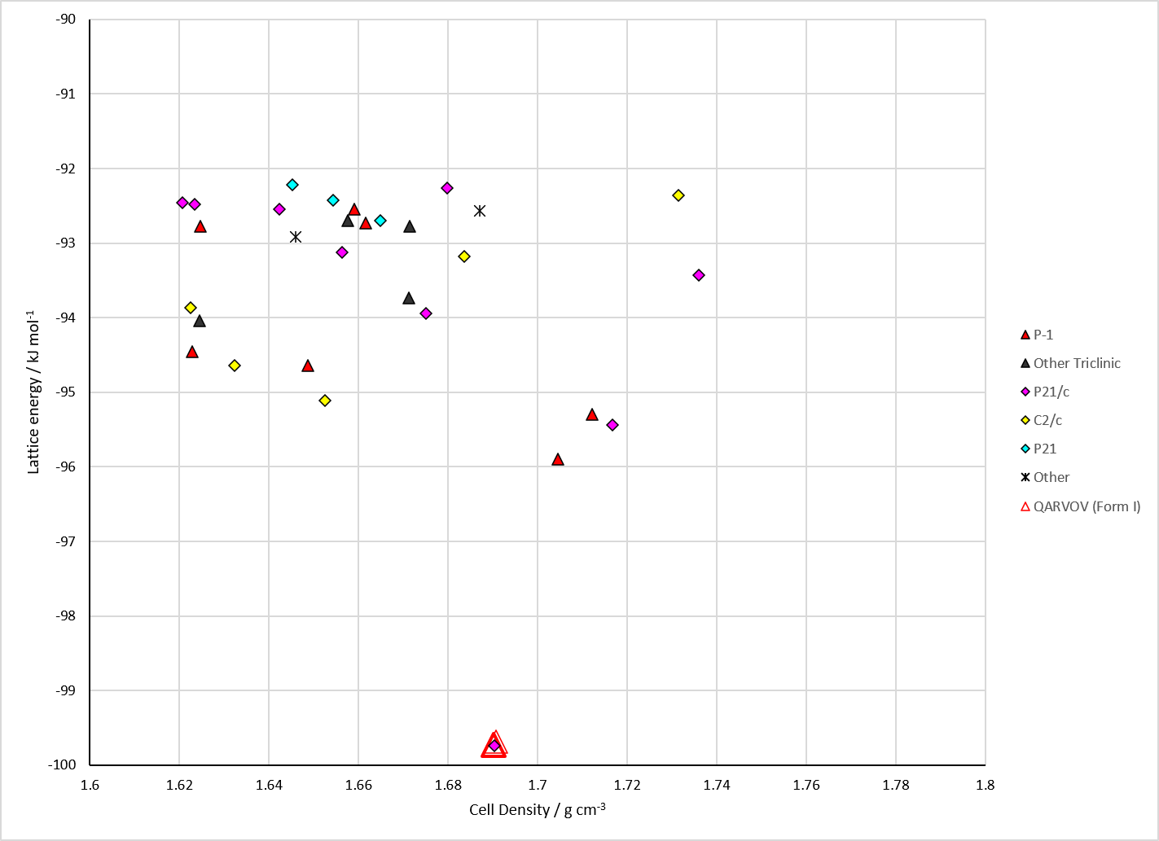
Figure 2. Crystal energy landscape of 3-Oxauracil from previous work.

CSD structures (CSD version 6.01 with Feb 2026 update)

Table 1. Crystallographic information for CSD entries for 3-Oxauracil. Different polymorphs are coloured differently.
REFCODE | space group | Z’ | a / Å | b / Å | c / Å | α / ° | β / ° | γ / ° | density / g cm⁻³ | Form
QARVOV | P21/c | 1.0 | 7.7407 | 5.54050 | 10.4926 | 90.0 | 103.64300 | 90.0 | 1.7174 | None

Table 2. Experimental information for CSD entries for 3-Oxauracil.
REFCODE | space group | R factor | T / K | Year | Comments
QARVOV | P21/c | 2.99 | at 150 K | 2005 | 10.1039/b504756k

Make this table include whether polymorphs are solution-grown, sublimation grown, templated or otherwise. Add references.

Other notes

