3-deazauracil
(Last updated April 2026)
Figure 1. The molecular diagram of 3-deazauracil.

CSP studies
REFCODE | CAXKOB
Formula | C5 H5 N1 O2
Common Name | 3-Deazauracil
IUPAC Systematic Name | 2-hydrozy-4-pyridone
Other Names
CSD Refcodes | CAXKOB12
Search Identifier | A (Taut3)
Scientist | Tom Lewis
Date | 2005
Publication | No publication planned.
Energy model | 1
Study_ID | 0
Programs | MOLPAK, DMAREL (4.1.1)
Location on S Drive | \CHEMISTRY_CPOSS\0-EarlySearches\home\louise_price.eminerals\deazauracil\Taut3-4h2p
Potential Description | DMA + FIT
Intramolecular Description | 6-311g**/B3PW91
Search Identifier | B (Taut2)
Scientist | Tom Lewis
Date | 2005
Publication | No publication planned.
Energy model | 1
Study_ID | 1
Programs | MOLPAK, DMAREL (4.1.1)
Location on S Drive | \CHEMISTRY_CPOSS\0-EarlySearches\home\louise_price.eminerals\deazauracil\Taut2-24hh
Potential Description | DMA + FIT
Intramolecular Description | 6-311g**/B3PW91
Search Identifier | C (Taut1)
Scientist | Tom Lewis
Date | 2005
Publication | No publication planned.
Energy model | 1
Study_ID | 2
Programs | MOLPAK, DMAREL (4.1.1)
Location on S Drive | \CHEMISTRY_CPOSS\0-EarlySearches\home\louise_price.eminerals\deazauracil\Taut1-2h4p
Potential Description | DMA + FIT
Intramolecular Description | 6-311g**/B3PW91

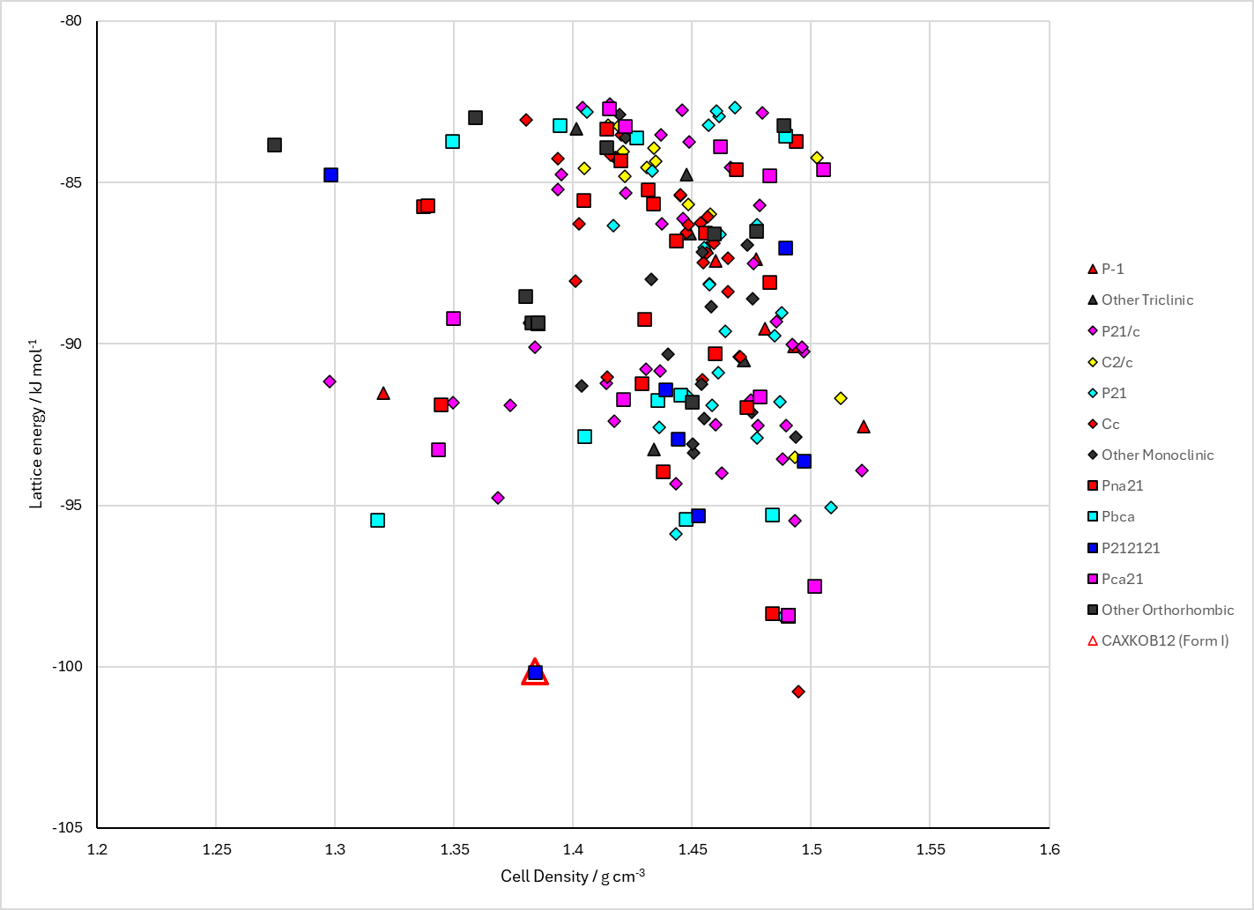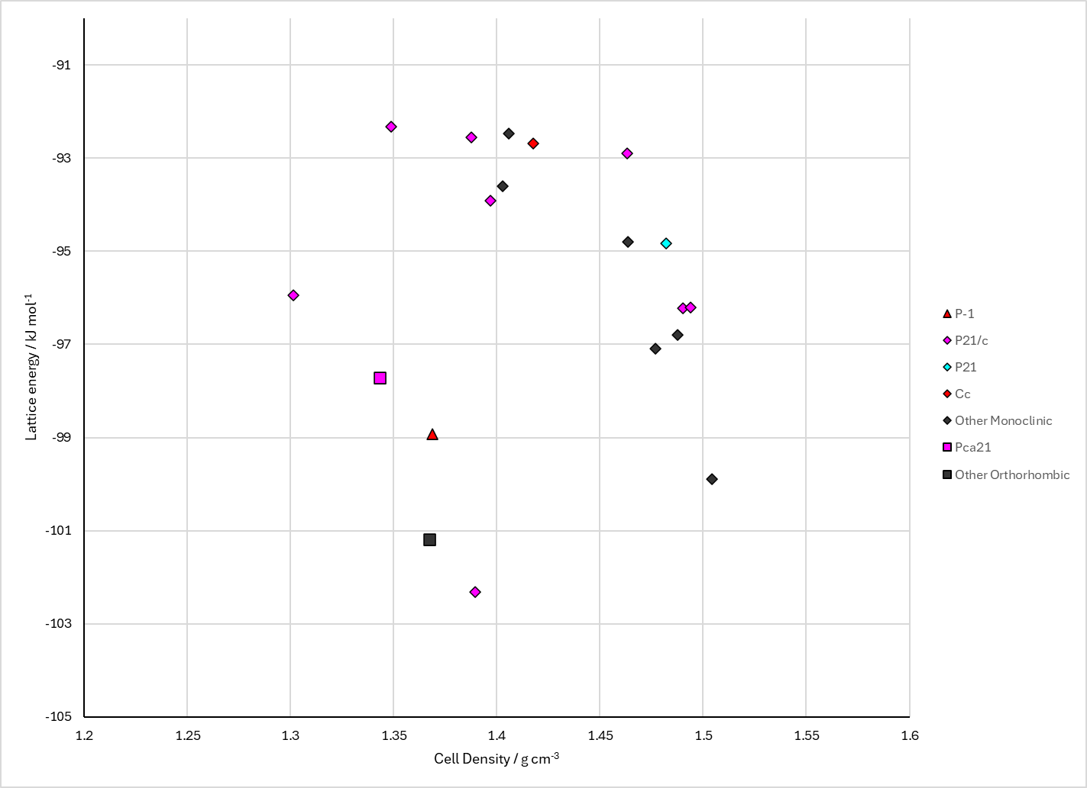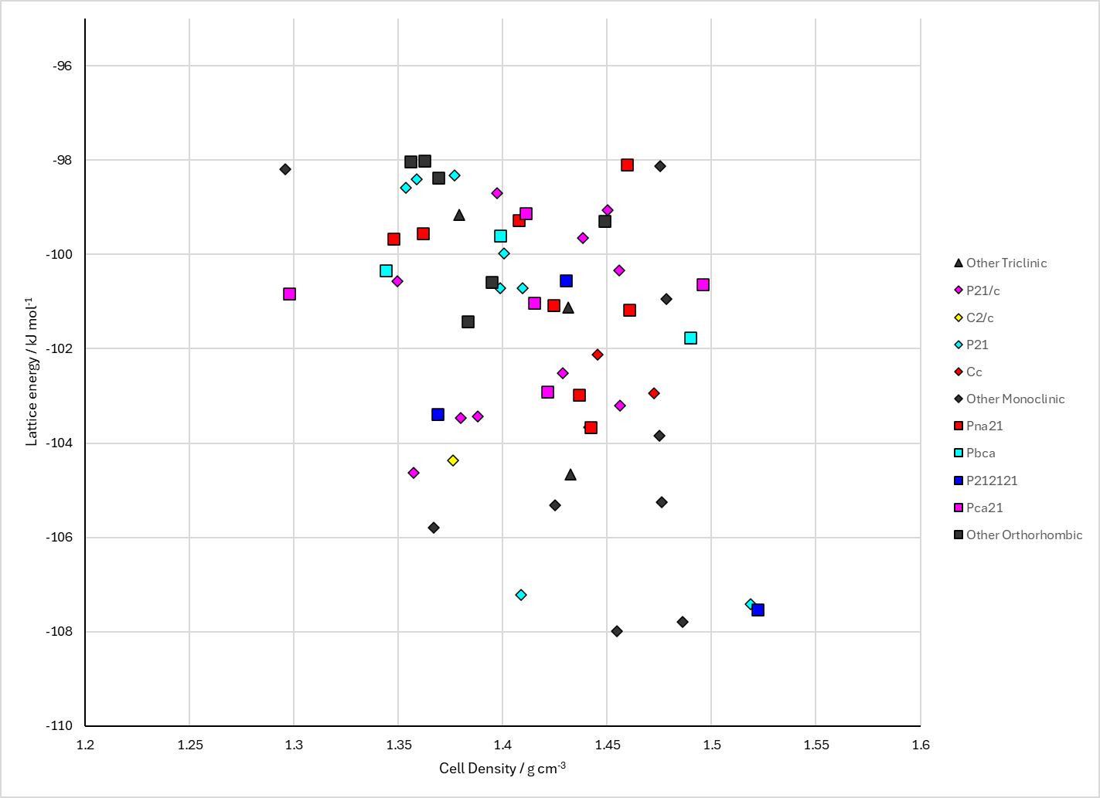
Figure 2. Crystal energy landscape of 3-deazauracil from previous work. Top: Taut3 search (Energy model A1). Bottom left: Taut2 search (Energy model B1). Bottom right: Taut1 search (Energy model C1).

CSD structures (CSD version 6.01 with Feb 2026 update)

Table 1. Crystallographic information for CSD entries for 3-deazauracil. Different polymorphs are coloured differently.
REFCODE | space group | Z’ | a / Å | b / Å | c / Å | α / ° | β / ° | γ / ° | density / g cm⁻³ | Form
CAXKOB | P212121 | 1.0 | 8.638 | 5.279 | 11.22 | 90.0 | 90.0 | 90.0 | 1.4423 | None
CAXKOB01 | P212121 | 1.0 | 8.638 | 5.279 | 11.22 | 90.0 | 90.0 | 90.0 | 1.4815 | None
CAXKOB11 | P212121 | 1.0 | 8.638 | 5.315 | 11.221 | 90.0 | 90.0 | 90.0 | 1.4324 | None
CAXKOB12 | P212121 | 1.0 | 5.33930 | 8.6454 | 11.2652 | 90.0 | 90.0 | 90.0 | 1.4190 | None

Table 2. Experimental information for CSD entries for 3-deazauracil.
REFCODE | space group | R factor | T / K | Year | Comments
CAXKOB | P212121 | 6.5 | None | 1983 | 10.1107/S0108270183009762
CAXKOB01 | P212121 | 7.020 | None | 1992 | 10.1039/c39920001160
CAXKOB11 | P212121 | 6.5 | None | 1994 | 10.1007/BF01665887
CAXKOB12 | P212121 | 3.83 | at 298 K | 2008 | 10.1107/S1600536808014578

Make this table include whether polymorphs are solution-grown, sublimation grown, templated or otherwise. Add references.

Other notes

