Cyanuric Acid
(Last updated April 2026)
Figure 1. The molecular diagram of Cyanuric acid.

CSP studies
REFCODE | CYURAC
Formula | C3 H3 N3 O3
Common Name | Cyanuric acid
IUPAC Systematic Name | 1,3,5-Triazinane-2,4,6-trione
Other Names
CSD Refcodes | CYURAC12
Search Identifier | A
Scientist | Tom Lewis
Date | 2005
Publication | Lewis, T. C., Tocher, D. A., Price, S. L., Cryst. Growth Des., 5(3), 983-993 (2005)
Energy model | 1
Study_ID | 0
Programs | MOLPAK, DMAREL (3.0)
Location on S Drive | \CHEMISTRY_CPOSS\0-EarlySearches\home\louise_price.eminerals\cyanuric
Potential Description | DMA + adjusted FIT
Intramolecular Description | Ab initio MP2 631G
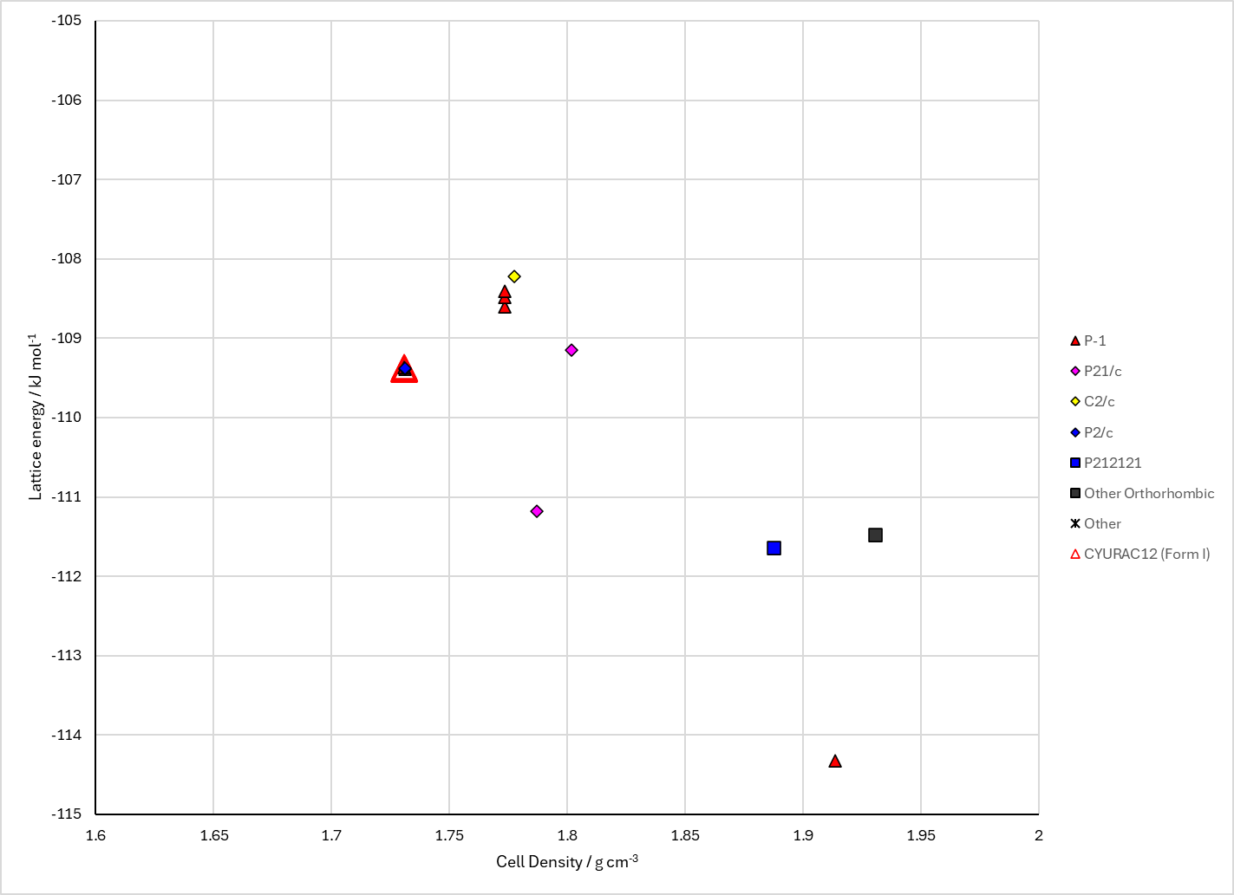
Figure 2. Crystal energy landscape of Cyanuric acid from previous work.

CSD structures (CSD version 6.01 with Feb 2026 update)

Table 1. Crystallographic information for CSD entries for Cyanuric acid. Different polymorphs are coloured differently.
REFCODE | space group | Z’ | a / Å | b / Å | c / Å | α / ° | β / ° | γ / ° | density / g cm⁻³ | Form
CYURAC03 | C2/n | 0.5 | 7.74900 | 6.736 | 11.912 | 90.0 | 130.69 | 90.0 | 1.8184 | None
CYURAC04 | C2/n | 0.5 | 7.74900 | 6.736 | 11.912 | 90.0 | 130.69 | 90.0 | 1.8184 | None
CYURAC05 | C2/n | 0.5 | 7.74900 | 6.736 | 11.912 | 90.0 | 130.69 | 90.0 | 1.8184 | None
CYURAC10 | C2/n | 0.5 | 7.9 | 6.732 | 11.951 | 90.0 | 130.67000 | 90.0 | 1.7784 | None
CYURAC12 | C2/n | 0.5 | 7.74900 | 6.736 | 11.912 | 90.0 | 130.69 | 90.0 | 1.8184 | None
CYURAC13 | C2/c | 0.5 | 7.916 | 6.7366 | 9.07800 | 90.0 | 90.737000 | 90.0 | 1.7711 | None
CYURAC14 | C2/c | 0.5 | 7.764 | 6.7302 | 9.0256 | 90.0 | 90.095000 | 90.0 | 1.8178 | None
CYURAC15 | C2/c | 0.5 | 7.764 | 6.746 | 9.045 | 90.0 | 90.09 | 90.0 | 1.8097 | None
CYURAC16 | C2/c | 0.5 | 7.87160 | 6.7431 | 9.07570 | 90.0 | 90.423 | 90.0 | 1.7797 | None

Table 2. Experimental information for CSD entries for Cyanuric acid.
REFCODE | space group | R factor | T / K | Year | Comments
CYURAC03 | C2/n | 3.800 | at 100 K | 1971 | 10.1107/S0567740871001791
CYURAC04 | C2/n | 3.800 | at 100 K | 1978 | 10.1107/S0567740878006160
CYURAC05 | C2/n | 3.25 | at 100 K | 1979 | 10.1107/S0567740879005860
CYURAC10 | C2/n | 4.5 | None | 1971 | 10.1107/S0567740871001791
CYURAC12 | C2/n | 2.7 | at 100 K | 1971 | 10.1107/S0567740871001808
CYURAC13 | C2/c | 3.130 | 293 K | 2015 | 10.1021/cm504200q
CYURAC14 | C2/c | 3.790 | 100 K | 2018 | None
CYURAC15 | C2/c | 3.08 | 100 K | 2020 | None
CYURAC16 | C2/c | 6.02 | 240 K | 2024 | None

Make this table include whether polymorphs are solution-grown, sublimation grown, templated or otherwise. Add references.

Other notes

