3,4-dinitrochlorobenzene
(Last updated April 2026)
Figure 1. The molecular diagram of 3,4-dinitrochlorobenzene.

CSP studies
REFCODE | DEFDUN
Formula | C6 H3 N2 O4 Cl1
Common Name | 3,4-Dinitrochlorobenzene
IUPAC Systematic Name | 4-Chloro-1,2-dinitrobenzene
Other Names | 1-Chloro-3,4-dinitrobenzene
CSD Refcodes | DEFDUN02, DEFDUN03
Search Identifier | A
Scientist | Juliette Pradon / Sarah Barnett
Date | 2005
Publication | See related Barnett, S.A.; Johnston, A.; Florence, A.J.; Price, S.L.; Tocher, D.A. 2008. Cryst. Growth Des. 8, 24-36.
Energy model | 1
Study_ID | 0
Programs | MOLPAK, DMAREL (4.1.1)
Location on S Drive | \CHEMISTRY_CPOSS\0-EarlySearches\home\louise_price.eminerals\3,4-dinitrochlorobenzene\DEFDUN_aniso
Potential Description | Anisotropic DayRice potential. All parameters taken from the Day potential, including anisotropic chlorine parameters. Nitro parameters from Rice potential added.
Intramolecular Description | MP2/6-31G(d,p)
Search Identifier | B
Scientist | Juliette Pradon / Sarah Barnett
Date | 2005
Publication | See related Barnett, S.A.; Johnston, A.; Florence, A.J.; Price, S.L.; Tocher, D.A. 2008. Cryst. Growth Des. 8, 24-36.
Energy model | 1
Study_ID | 1
Programs | MOLPAK, DMAREL (4.1.1)
Location on S Drive | \CHEMISTRY_CPOSS\0-EarlySearches\home\louise_price.eminerals\3,4-dinitrochlorobenzene\DEFDUN_iso
Potential Description | Isotropic RiceDay potential. All parameters taken from the Rice potential. Isotropic chlorine parameters from Day potential added.
Intramolecular Description | MP2/6-31G(d,p)
Search Identifier | C
Scientist | Sarah Barnett
Date | 2007
Publication | See related Barnett, S.A.; Johnston, A.; Florence, A.J.; Price, S.L.; Tocher, D.A. 2008. Cryst. Growth Des. 8, 24-36.
Energy model | 1
Study_ID | 2
Programs | MOLPAK, DMAREL (4.1.1)
Location on S Drive | \CHEMISTRY_CPOSS\0-EarlySearches\home\louise_price.eminerals\3,4-dinitrochlorobenzene\Sarah_search
Potential Description | Isotropic RiceDay potential. All parameters taken from the Rice potential. Isotropic chlorine parameters from Day potential added.
Intramolecular Description | MP2/6-31G(d,p)

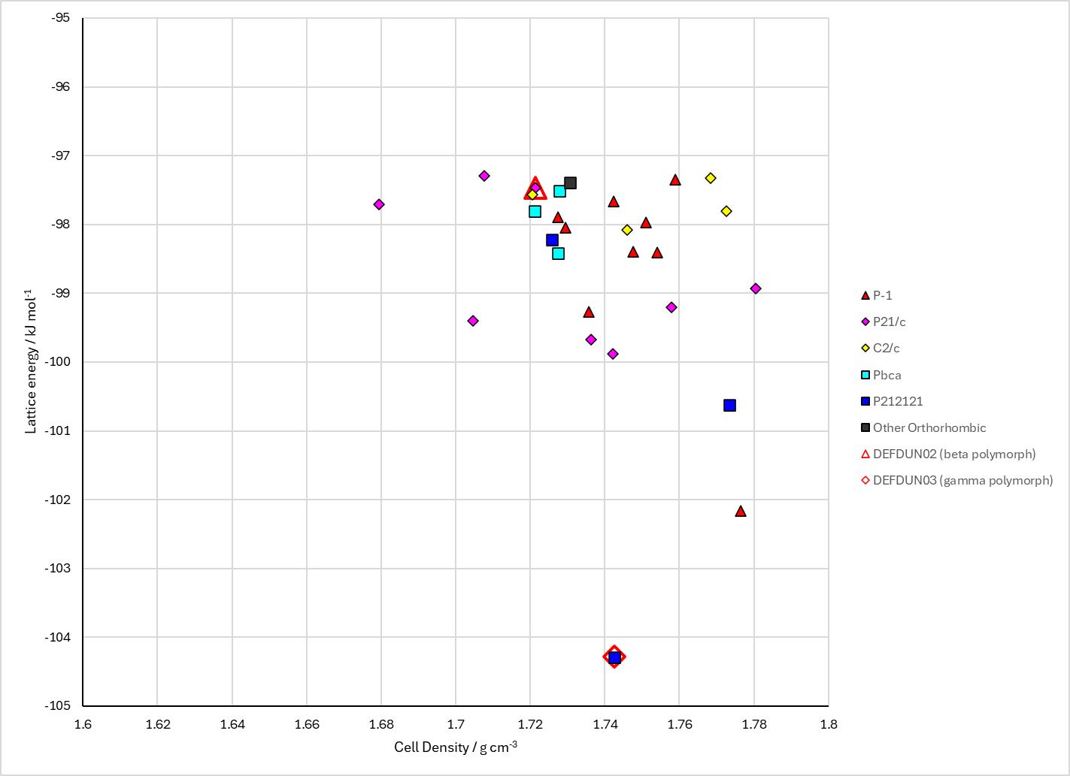
Figure 2. Crystal energy landscape of 3,4-dinitrochlorobenzene from previous work.

CSD structures (CSD version 6.01 with Feb 2026 update)

Table 1. Crystallographic information for CSD entries for 3,4-dinitrochlorobenzene. Different polymorphs are coloured differently.
REFCODE | space group | Z’ | a / Å | b / Å | c / Å | α / ° | β / ° | γ / ° | density / g cm⁻³ | Form
DEFDUN | P21/c | 1.0 | 7.64000 | 7.82 | 14.82 | 90.0 | 114.00000 | 90.0 | 1.6632 | monoclinic beta polymorph
DEFDUN01 | P212121 | 1.0 | 12.11 | 5.57 | 11.94 | 90.0 | 90.0 | 90.0 | 1.6704 | orthorhombic gamma polymorph
DEFDUN02 | P21/n | 1.0 | 7.554 | 7.821 | 13.453 | 90.0 | 96.307000 | 90.0 | 1.7030 | beta polymorph
DEFDUN03 | P212121 | 1.0 | 5.52450 | 11.778 | 11.939 | 90.0 | 90.0 | 90.0 | 1.7318 | gamma polymorph

Table 2. Experimental information for CSD entries for 3,4-dinitrochlorobenzene.
REFCODE | space group | R factor | T / K | Year | Comments
DEFDUN | P21/c | 6.5 | None | 1985 | 10.1107/S0108270185008356
DEFDUN01 | P212121 | 3.300 | None | 1985 | 10.1107/S0108270185008356
DEFDUN02 | P21/n | 6.060 | at 150 K | 2008 | 10.1021/cg070131c
DEFDUN03 | P212121 | 2.36 | at 150 K | 2008 | 10.1021/cg070131c

Make this table include whether polymorphs are solution-grown, sublimation grown, templated or otherwise. Add references.

Other notes

