Naphthyridinium fumarate (Blind Test XIX)
(Last updated March 2026)
Figure 1. The molecular diagram of Naphthyridinium fumarate.

CSP studies
REFCODE | XATJOT
Formula | C8 H7 N2+ - C4 H3 O4-
Common Name | Naphthyridinium fumarate
IUPAC Systematic Name | Naphthyridinium fumarate
Other Names | Blind Test molecule XIX
CSD Refcodes | XATJOT
Search Identifier | A
Scientist | Sharmarke Mohamed
Date | 2010
Publication | Bardwell DA, et al. 2011. Acta Crystallogr , Sect B 67, 535-551
Energy model | 2
Study_ID | 10
Programs | Study_ID=20, CrystalOptimizer. DMACRYS (2.0.4)
Location on S Drive | CHEMISTRY_CPOSS\BlindTest2010\XATJOT\XATJOT_CO
Potential Description | CrystalOptimizer + DMA + FIT with Coombes H(N) and Beyer H(O) parameters
Intramolecular Description | MP2/6-31G(d,p)
Energy model | 1
Study_ID | 20
Programs | Rigid CrystalPredictor, DMACRYS (2.0.4)
Location on S Drive | CHEMISTRY_CPOSS\BlindTest2010\XATJOT\XATJOT
Potential Description | Crystal predictor + DMA + FIT with Coombes H(N) and Beyer H(O) parameters
Intramolecular Description | MP2/6-31G(d,p)

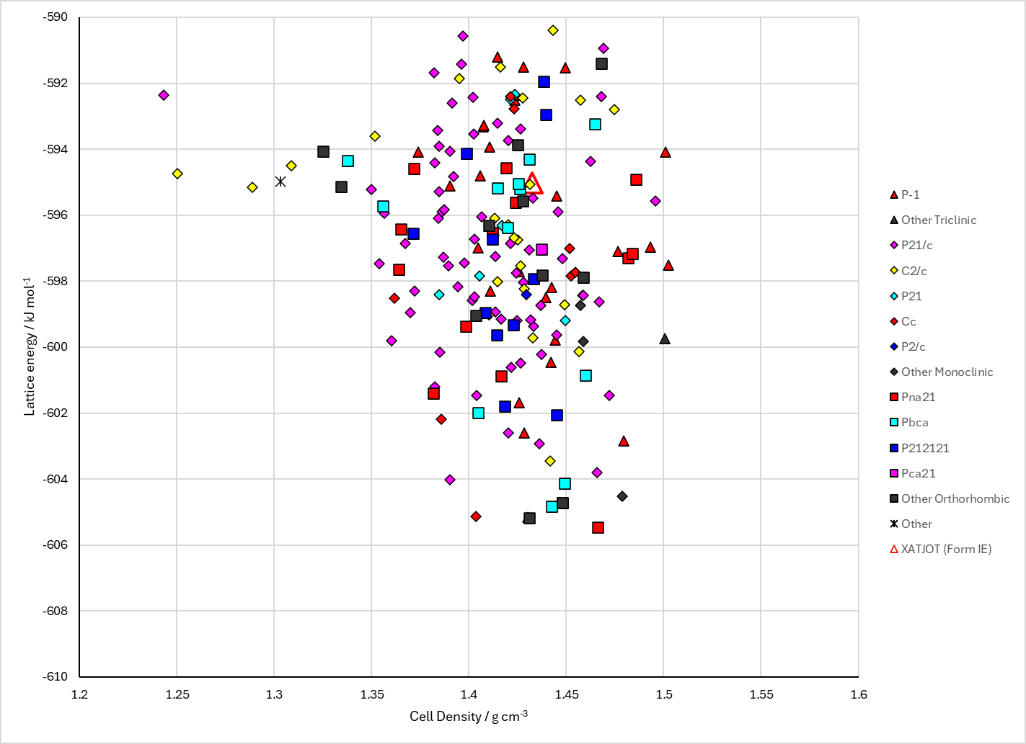
Figure 2. Crystal energy landscape of Naphthyridinium fumarate from previous work.

CSD structures (CSD version 6.01)

Table 1. Crystallographic information for CSD entries for Naphthyridinium fumarate. Different polymorphs are coloured differently.
REFCODE | space group | Z’ | a / Å | b / Å | c / Å | α / ° | β / ° | γ / ° | density / g cm⁻³ | Form
XATJOT | Pca21 | 1.0 | 23.501 | 3.7141 | 12.6535 | 90.0 | 90.0 | 90.0 | 1.4807 | None

Table 2. Experimental information for CSD entries for Naphthyridinium fumarate.
REFCODE | space group | R factor | T / K | Year | Comments
XATJOT | Pca21 | 3.15 | at 200 K | 2011 | None

Make this table include whether polymorphs are solution-grown, sublimation grown, templated or otherwise. Add references.

Other notes

