3-azabicyclo[3.3.1]nonane-2,4-dione (Blind Test IV)
(Last updated March 2026)
Figure 1. The molecular diagram of 3-azabicyclononanedione.
This was not carried out as part of the Blind Test, but as part of an experimental project to rationalize the Blind Test’s results.

CSP studies
REFCODE | BOQQUT
Formula | C8 H11 N1 O2
Common Name | 3-azabicyclo[3.3.1]nonane-2,4-dione
IUPAC Systematic Name | 3-azabicyclo[3.3.1]nonane-2,4-dione
Other Names | Blind Test IV
CSD Refcodes | BOQQUT
Search Identifier | A
Scientist | Ashley Hulme
Date | pre-2010
Publication | Hulme, A. T.; Johnston, A.; Florence, A. J.; Fernandes, P.; Shankland, K.; Bedford, C. T.; Welch, G. W. A.; Sadiq, G.; Haynes, D. A.; Motherwell, W. D. S.; Tocher, D. A.; Price, S. L. J.Am.Chem.Soc. 2007, 129(12), 3649-3657.
Energy model | 1
Study_ID | 1
Programs | Molpak, DMAREL (4.1.1)
Location on S Drive | \CHEMISTRY_CPOSS\0-EarlySearches\home\louise_price.eminerals\3-azabicyclononanedione\BOQQUTMP2
Potential Description | DMA + FIT
Intramolecular Description | MP2/6-31G(d,p)
Search Identifier | B
Scientist | Ashley Hulme
Date | pre-2010
Publication | See Study_ID=1
Energy model | 1
Study_ID | 0
Programs | Molpak, DMAREL (4.1.1)
Location on S Drive | \CHEMISTRY_CPOSS\0-EarlySearches\home\louise_price.eminerals\3-azabicyclononanedione\BOQQUTpolarisation
Potential Description | DMA + FIT with PBE0/Sadlej
Intramolecular Description | MP2/6-31G(d,p)

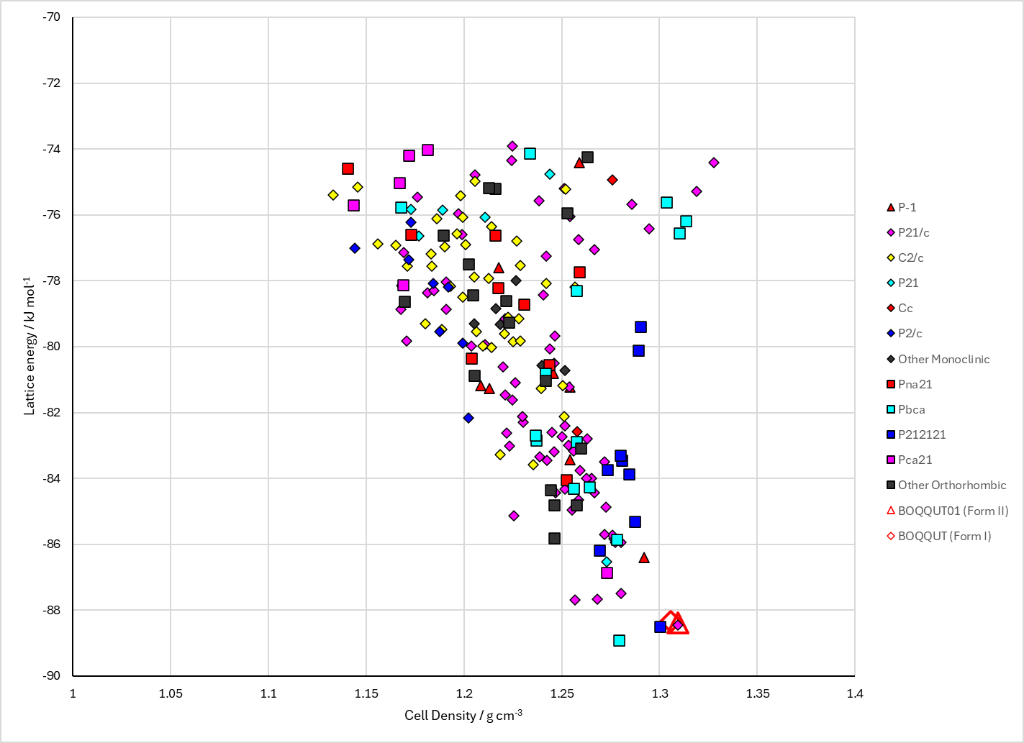
Figure 2. Crystal energy landscape of 3-azabicyclononanedione from previous work.

CSD structures (CSD version 6.01)

Table 1. Crystallographic information for CSD entries for 3-azabicyclononanedione. Different polymorphs are coloured differently.
REFCODE | space group | Z’ | a / Å | b / Å | c / Å | α / ° | β / ° | γ / ° | density / g cm⁻³ | Form
BOQQUT | P21/a | 1.0 | 7.7046 | 10.6062 | 9.3384 | 90.0 | 95.033 | 90.0 | 1.3384 | Form I
BOQQUT01 | P21/c | 2.0 | 7.67102 | 10.5483 | 18.8867 | 90.0 | 95.58 | 90.0 | 1.3378 | Form II
BOQQUT02 | P21/c | 1.0 | 9.3214 | 10.5932 | 7.6988 | 90.0 | 95.059000 | 90.0 | 1.3435 | Form I
BOQQUT03 | P21/c | 1.0 | 8.868 | 10.2833 | 7.7016 | 90.0 | 95.880000 | 90.0 | 1.4563 | Form I
BOQQUT04 | P21/c | 1.0 | 8.564 | 10.0876 | 7.64190 | 90.0 | 96.38 | 90.0 | 1.5507 | Form I
BOQQUT05 | P21/c | 1.0 | 8.367 | 9.93170 | 7.5667 | 90.0 | 96.490000 | 90.0 | 1.6285 | Form I
BOQQUT06 | P21/c | 1.0 | 8.254 | 9.8542 | 7.52450 | 90.0 | 96.63 | 90.0 | 1.6736 | Form I
BOQQUT07 | P21/c | 1.0 | 8.054 | 9.782 | 7.50430 | 90.0 | 96.8 | 90.0 | 1.7330 | Form I
BOQQUT08 | P21/c | 1.0 | 7.938 | 9.754 | 7.481 | 90.0 | 97.03 | 90.0 | 1.7698 | Form I

Table 2. Experimental information for CSD entries for 3-azabicyclononanedione.
REFCODE | space group | R factor | T / K | Year | Comments
BOQQUT | P21/a | 4.4 | at 297 K | 2001 | 10.1107/S1600536801012818
BOQQUT01 | P21/c | 3.06 | at 250 K | 2006 | 10.1107/S1600536806023312
BOQQUT02 | P21/c | 5.53 | at 298 K | 2008 | 10.1021/cg0705815
BOQQUT03 | P21/c | 5.45 | at 298 K | 2008 | 10.1021/cg0705815
BOQQUT04 | P21/c | 5.310 | at 298 K | 2008 | 10.1021/cg0705815
BOQQUT05 | P21/c | 4.97 | at 298 K | 2008 | 10.1021/cg0705815
BOQQUT06 | P21/c | 4.4 | at 298 K | 2008 | 10.1021/cg0705815
BOQQUT07 | P21/c | 5.89 | at 298 K | 2008 | 10.1021/cg0705815
BOQQUT08 | P21/c | 7.61 | at 298 K | 2008 | 10.1021/cg0705815

Make this table include whether Forms are solution-grown, sublimation grown, templated or otherwise. Add references.

Other notes

