Cyclopentane
(Last updated January 2026)
Figure 1. The molecular diagram of Cyclopentane.

CSP studies
REFCODE | ZZZVYE
Formula | C5 H10
Common Name | Cyclopentane
IUPAC Systematic Name | Cyclopentane
Other Names | Cyclopentane
CSD Refcodes | ZZZVYE01
Search Identifier | A
Scientist | Antonio Torrisi
Date | 2008
Publication | See Study_ID=1
Energy model | 1
Study_ID | 0
Programs | MOLPAK, DMAREL (4.1.1)
Location on S Drive | \CHEMISTRY_CPOSS\0-EarlySearches\home\louise_price.eminerals\cyclopentane_charges
Potential Description | FIT with point charges
Intramolecular Description | MP2/6-31G(d,p)
Search Identifier | B
Scientist | Antonio Torrisi
Date | 2008
Publication | Torrisi A, Leech CK, Shankland K, David WIF, Ibberson RM, Benet-Buchholz J, Boese R, Leslie M, Catlow CRA, Price SL 2008. J Phys Chem B 112 3746-3758.
Energy model | 1
Study_ID | 1
Programs | MOLPAK, DMAREL (3.0)
Location on S Drive | \CHEMISTRY_CPOSS\0-EarlySearches\home\louise_price.eminerals\cyclopentane_dma
Potential Description | DMA + FIT
Intramolecular Description | MP2/6-31G(d,p)

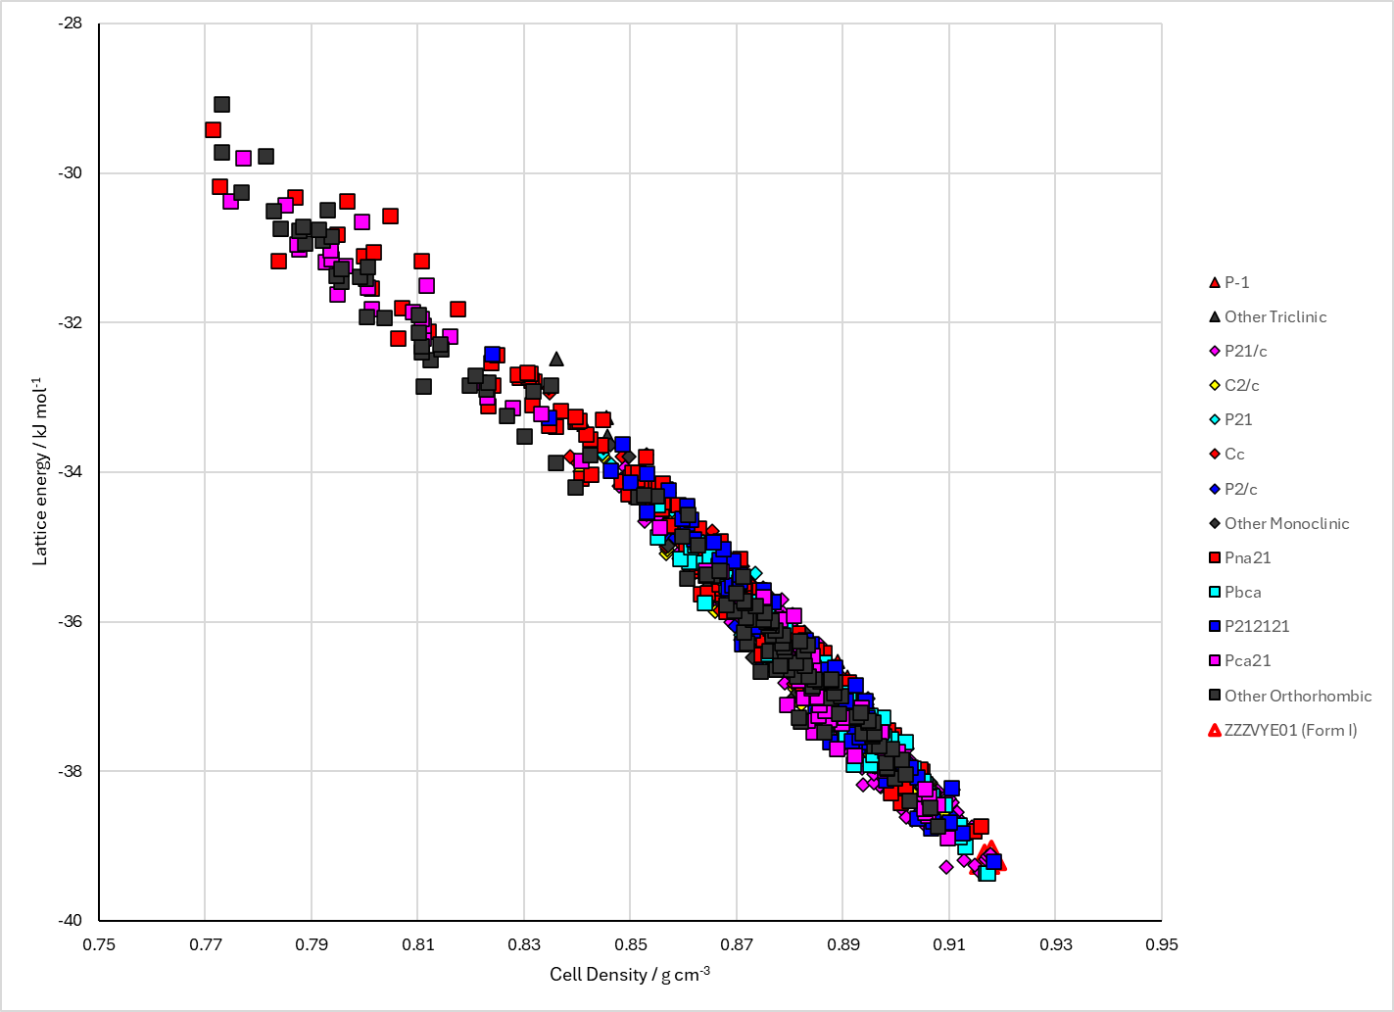
Figure 2. Crystal energy landscape of Cyclopentane from previous work.

CSD structures (CSD version 5.43 with Mar, Jun, Sep and Nov 2022 updates)

Table 1. Crystallographic information for CSD entries for Cyclopentane. Different polymorphs are coloured differently.
REFCODE | space group | Z’ | a / Å | b / Å | c / Å | α / ° | β / ° | γ / ° | density / g cm⁻³ | Form
ZZZVYE01 | P21/c | 1.0 | 9.578 | 5.328 | 10.018 | 90.0 | 113.12000 | 90.0 | 0.9907 | monoclinic polymorph

Table 2. Experimental information for CSD entries for Cyclopentane.
REFCODE | space group | R factor | T / K | Year | Comments
ZZZVYE01 | P21/c | 6.78 | 93 K | 2008 | 10.1021/jp710017y

Make this table include whether polymorphs are solution-grown, sublimation grown, templated or otherwise. Add references.

Other notes

