7-hydroxycoumarin
(Last updated May 2026)
Figure 1. The molecular diagram of 7-hydroxycoumarin.

CSP studies
REFCODE | DETFOX
Formula | C9 H6 O3
Common Name | 7-hydroxycoumarin
IUPAC Systematic Name | 7-hydroxy-chrmoen-2-one
Other Names | Umbelliferone
CSD Refcodes | DETFOX
Search Identifier | A
Scientist | Ashley Hulme
Date | pre-2010
Publication | No publication planned.
Energy model | 1
Study_ID | 0
Programs | MOLPAK, DMAREL (4.1.1)
Location on S Drive | \CHEMISTRY_CPOSS\0-EarlySearches\home\louise_price.eminerals\7-hydroxycoumarin
Potential Description | DMA + FIT
Intramolecular Description | MP2/6-31G(d,p)

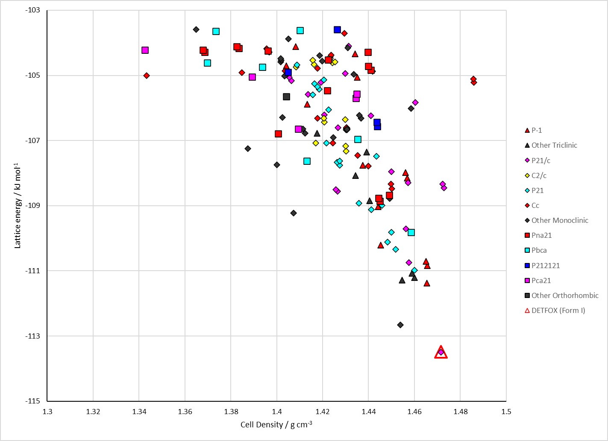
Figure 2. Crystal energy landscape of 7-hydroxycoumarin from previous work.

CSD structures (CSD version 6.01 with Feb 2026 update)

Table 1. Crystallographic information for CSD entries for 7-hydroxycoumarin. Different polymorphs are coloured differently.
REFCODE | space group | Z’ | a / Å | b / Å | c / Å | α / ° | β / ° | γ / ° | density / g cm⁻³ | Form
DETFOX | P21/c | 1.0 | 3.892 | 11.022 | 16.722 | 90.0 | 90.58 | 90.0 | 1.5014 | None
DETFOX01 | P21/c | 1.0 | 3.9034 | 11.007 | 16.707 | 90.0 | 90.333 | 90.0 | 1.5003 | None
DETFOX02 | P21/c | 1.0 | 3.8515 | 11.0399 | 16.7731 | 90.0 | 90.489 | 90.0 | 1.5101 | None

Table 2. Experimental information for CSD entries for 7-hydroxycoumarin.
REFCODE | space group | R factor | T / K | Year | Comments
DETFOX | P21/c | 4.2 | None | 1985 | 10.1107/S0108270185009453
DETFOX01 | P21/c | 5.66 | at 293 K | 2007 | None
DETFOX02 | P21/c | 5.7 | 173.2 K | 2024 | 10.1039/D4ME00006D

Make this table include whether polymorphs are solution-grown, sublimation grown, templated or otherwise. Add references.

Other notes

