Quinolinium Fumarate
(Last updated June 2026)
Figure 1. The molecular diagram of Quinolinium Fumarate.

CSP studies
REFCODE | RABYID
Formula | C9 H8 N1 - C4 H4 O4
Common Name | Quinolinium fumarate
IUPAC Systematic Name | Quinolin-1-ium (2E)-3-carboxyprop-2-enoate
Other Names | Similar to Blind Test molecule XIX
CSD Refcodes | RABYID
Search Identifier | A
Scientist | Sharmarke Mohamed
Date | 2010
Publication | No publication planned.
Energy model | 1
Study_ID | 20
Programs | Rigid CrystalPredictor, DMACRYS (2.0.2)
Location on S Drive | \CHEMISTRY_CPOSS\BlindTest2010\XATJOT\RABYID
Potential Description | Crystal predictor + DMA + FIT with Coombes H(N) and Beyer H(O) parameters
Intramolecular Description | MP2/6-31G(d,p)

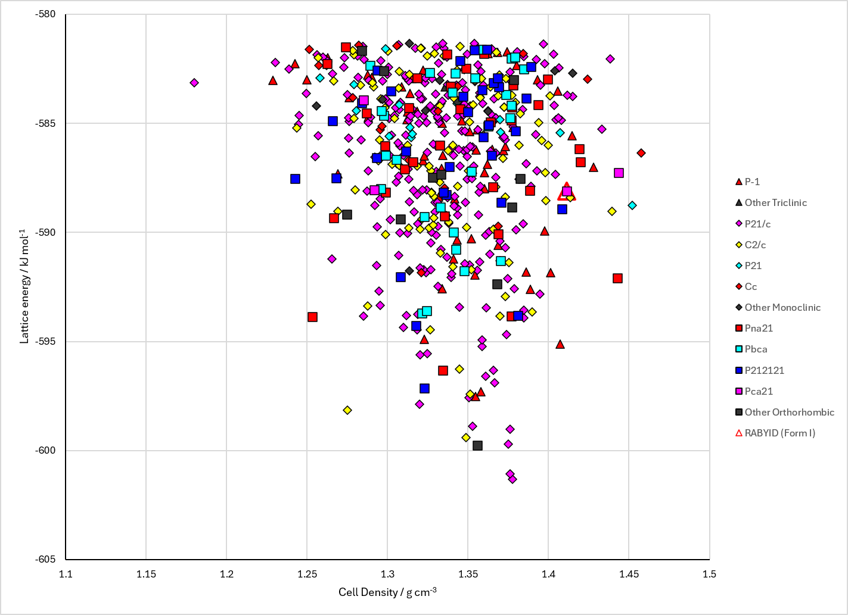
Figure 2. Crystal energy landscape of Quinolinium Fumarate from previous work.

CSD structures (CSD version 6.01 with Feb 2026 update)

Table 1. Crystallographic information for CSD entries for Quinolinium Fumarate. Different polymorphs are coloured differently.
REFCODE | space group | Z’ | a / Å | b / Å | c / Å | α / ° | β / ° | γ / ° | density / g cm⁻³ | Form
RABYID | Pca21 | 1.0 | 22.5838 | 3.72730 | 13.2912 | 90.0 | 90.0 | 90.0 | 1.4558 | None

Table 2. Experimental information for CSD entries for Quinolinium Fumarate.
REFCODE | space group | R factor | T / K | Year | Comments
RABYID | Pca21 | 3.41 | at 140 K | 2003 | 10.1107/S1600536803004446

Make this table include whether polymorphs are solution-grown, sublimation grown, templated or otherwise. Add references.

Other notes

