Tetrazol pyrazine
(Last updated April 2026)
Figure 1. The molecular diagram of TetrazolePyrazine.

CSP studies
REFCODE | UCLLIA
Formula | C8 N18 H4
Common Name | Tetrazol-pyrazine
IUPAC Systematic Name | 2,3,5,6-tetrakis(1H-tetrazol-5-yl)pyrazine
Other Names
CSD Refcodes
Search Identifier | A
Scientist | Luca Iuzzolino
Date | 2016
Publication | No publication planned.
Energy model | 3
Study_ID | 30
Programs | Study_ID=10, DMACRYS (2.2.0.1)
Location on S Drive | \CHEMISTRY_CPOSS\Tetrazol\Tetrazol-pyrazine\PCM
Potential Description | GDMA2.2(PCMdielectric3(PBE0/6-31G(d,p)) + FIT
Intramolecular Description | PCM3(PBE1PBE/6-31G(d,p))
Energy model | 1
Study_ID | 10
Programs | CrystalPredictor, CrystalOptimizer, DMACRYS (2.2.0.1)
Location on S Drive | \CHEMISTRY_CPOSS\Tetrazol\Tetrazol-pyrazine\CrystOpt
Potential Description | CrystalOptimizer with GDMA2.2(PBE1PBE/6-31G(d,p)) + FIT
Intramolecular Description | PBE1PBE/6-31G(d,p)
Energy model | 2
Study_ID | 11
Programs | Study_ID=10, CrystalOptimizer, DMACRYS (2.2.0.1)
Location on S Drive | \CHEMISTRY_CPOSS\Tetrazol\Tetrazol-pyrazine\CrystOpt_will
Potential Description | CrystalOptimizer with GDMA2.2(PBE1PBE/6-31G(d,p)) + Will
Intramolecular Description | PBE1PBE/6-31G(d,p)

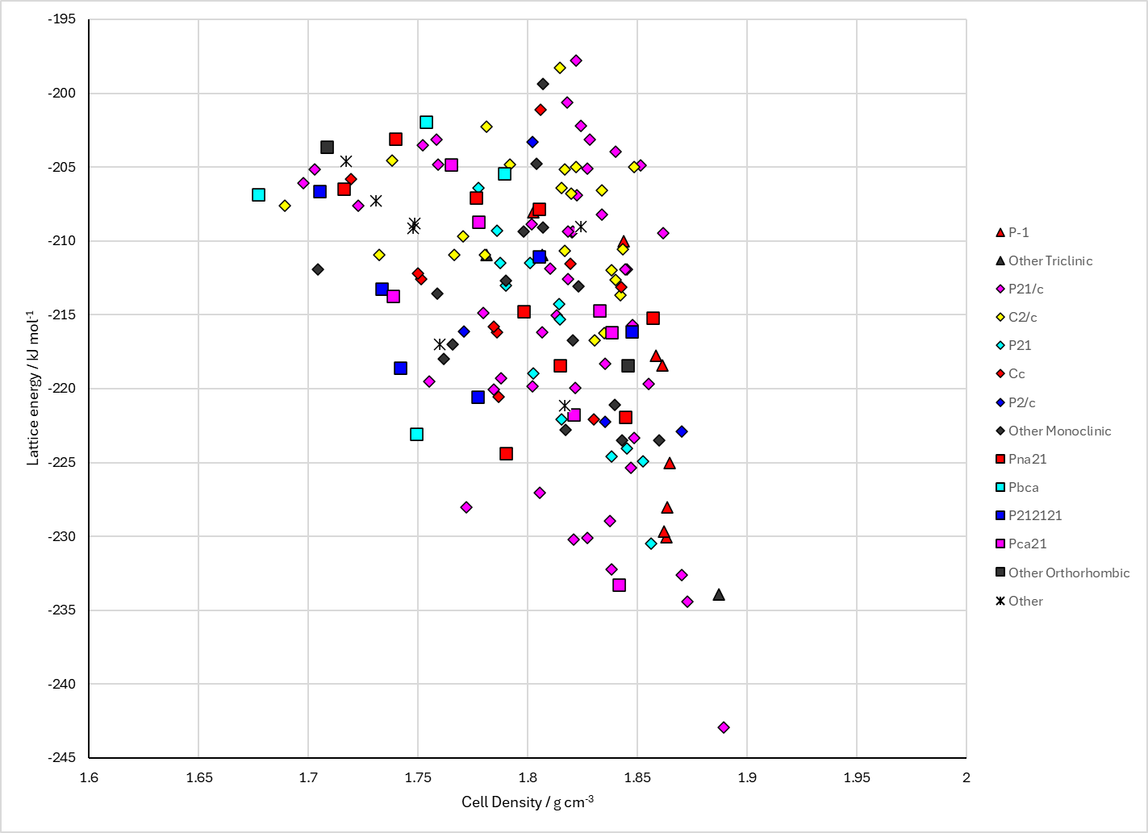
Figure 2. Crystal energy landscape of TetrazolePyrazine from previous work.

CSD structures (CSD version 6.01 with Feb 2026 update)
Not on CSD.

Other notes

