Xylenes
(Last updated December 2025)
This work was done with Joe Ridout.
Figure 1. The molecular diagrams of o-xylene, m-xylene and p-xylene.

CSP studies
REFCODE | ZZZRTI
Formula | C8 H10
Common Name | o-xylene
IUPAC Systematic Name | 1,2-dimethylbenzene
Other Names | 2-methyltoluene
CSD Refcodes | ZZZRTI07
Search Identifier | A
Scientist | Joe Ridout
Date | 2013
Publication | No publication planned.
Energy model | 1
Study_ID | 0
Programs | MOLPAK, DMACRYS (2.0.8b4)
Location on S Drive | CHEMISTRY_CPOSS\JoeRidout\o-xylene
Potential Description | GDMA2.2(MP2/6-31G(d,p)) + FIT
Intramolecular Description | MP2/6-31G(d,p)
REFCODE | ZZZSPY
Formula | C8 H10
Common Name | m-xylene
IUPAC Systematic Name | 1,3-dimethylbenzene
Other Names | 3-methyltoluene
CSD Refcodes | ZZZSPY01
Search Identifier | A
Scientist | Joe Ridout
Date | 2013
Publication | No publication planned.
Energy model | 1
Study_ID | 0
Programs | MOLPAK, DMACRYS (2.0.8b4)
Location on S Drive | CHEMISTRY_CPOSS\JoeRidout\m-xylene
Potential Description | GDMA2.2(MP2/6-31G(d,p)) + FIT
Intramolecular Description | MP2/6-31G(d,p)
REFCODE | ZZZITY
Formula | C8 H10
Common Name | p-xylene
IUPAC Systematic Name | 1,4-dimethylbenzene
Other Names | 4-methyltoluene
CSD Refcodes | ZZZITY02
Search Identifier | A
Scientist | Joe Ridout
Date | 2013
Publication | No publication planned.
Energy model | 1
Study_ID | 0
Programs | MOLPAK, DMACRYS (2.0.8b4)
Location on S Drive | CHEMISTRY_CPOSS\JoeRidout\p-xylene
Potential Description | GDMA2.2(MP2/6-31G(d,p)) + FIT
Intramolecular Description | MP2/6-31G(d,p)

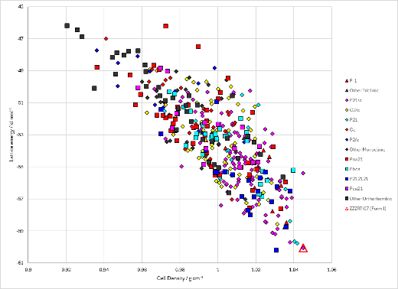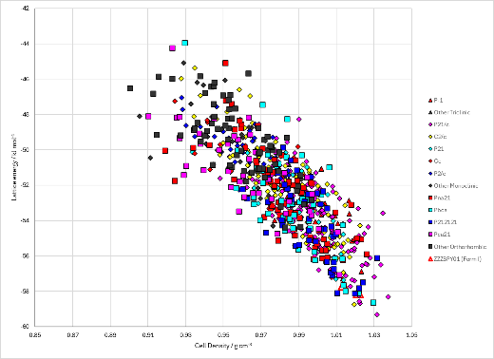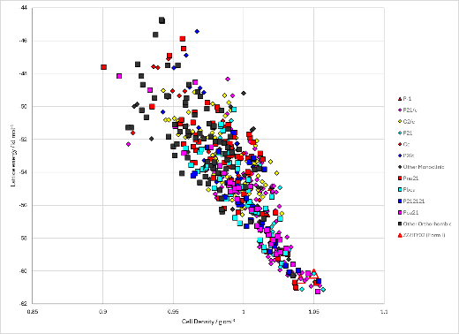
Figure 2. Crystal energy landscapes of the xylenes from previous work.

CSD structures (CSD version 6.01)

Table 1. Crystallographic information for CSD entries for the xylenes. Different polymorphs are coloured differently.
REFCODE | space group | Z’ | a / Å | b / Å | c / Å | α / ° | β / ° | γ / ° | density / g cm⁻³ | Form
ZZZRTI | Pmmm | 1 | 10.2 | 14.55 | 8.77 | 90 | 90 | 90 | 1.084
ZZZRTI02 | P21/c | 1 | 8.959 | 5.4564 | 12.03 | 90 | 110.36 | 90 | 1.279
ZZZRTI03 | P21/c | 1 | 8.87 | 5.3864 | 11.924 | 90 | 110.22 | 90 | 1.319
ZZZRTI04 | P21/c | 1 | 9.023 | 5.7343 | 12.39 | 90 | 110.51 | 90 | 1.174
ZZZRTI05 | P21/c | 1 | 9.035 | 6.1501 | 12.8242 | 90 | 109.394 | 90 | 1.049
ZZZRTI06 | P21/c | 1 | 9.0256 | 5.8095 | 12.4586 | 90 | 110.223 | 90 | 1.15
ZZZRTI07 | P21/c | 1 | 8.9579 | 6.1191 | 12.7071 | 90 | 109.104 | 90 | 1.071
ZZZRTI08 | P21/c | 1 | 9.059 | 6.0369 | 12.7167 | 90 | 109.73 | 90 | 1.077
ZZZRTI09 | P21/c | 1 | 9.205 | 5.7145 | 12.439 | 90 | 110.32 | 90 | 1.149
ZZZRTI10 | P21/c | 1 | 9.001 | 5.6717 | 12.306 | 90 | 110.34 | 90 | 1.197
ZZZRTI11 | P21/c | 1 | 9.063 | 5.5528 | 12.249 | 90 | 110.68 | 90 | 1.223
ZZZRTI12 | P21/c | 1 | 8.9657 | 5.534 | 12.167 | 90 | 110.49 | 90 | 1.247
ZZZRTI13 | P21/c | 1 | 8.9878 | 6.1337 | 12.7485 | 90 | 109.186 | 90 | 1.062
ZZZRTI14 | P21/c | 1 | 9.0957 | 5.8676 | 12.5756 | 90 | 110.203 | 90 | 1.12
ZZZRTI15 | P21/c | 1 | 9.045 | 5.4707 | 12.141 | 90 | 110.68 | 90 | 1.255
ZZZRTI16 | P21/c | 1 | 9.0116 | 6.1427 | 12.783 | 90 | 109.293 | 90 | 1.056
ZZZSPY | P21221 | 1.0 | 8.45 | 10.47 | 7.77000 | 90.0 | 90.0 | 90.0 | 0.0
ZZZSPY01 | Pbca | 1.0 | 10.516 | 7.596 | 16.8680 | 90.0 | 90.0 | 90.0 | 1.0466
ZZZSPY02 | Pbca | 1.0 | 10.1550 | 7.4649 | 16.8814 | 90.0 | 90.0 | 90.0 | 1.1020 | Deuterated
ZZZITY | P21/m | 1.0 | 11.11 | 8.45 | 7.56000 | 90.0 | 98.95 | 90.0 | 0.0
ZZZITY01 | P21/n | 0.5 | 5.806 | 5.023 | 11.215 | 90.0 | 100.48 | 90.0 | 1.0962
ZZZITY02 | P21/n | 0.5 | 5.73367 | 4.94847 | 11.1384 | 90.0 | 100.71300 | 90.0 | 1.1354 | Deuterated
ZZZITY03 | P21/n | 0.5 | 5.6229 | 4.93139 | 10.8388 | 90 | 100.375 | 90 | 1.193 | Deuterated
ZZZITY04 | P21/n | 0.5 | 5.57 | 4.89201 | 10.7308 | 90 | 100.373 | 90 | 1.226 | Deuterated
ZZZITY05 | P21/n | 0.5 | 5.5676 | 4.88918 | 10.7201 | 90 | 100.369 | 90 | 1.228 | Deuterated
ZZZITY06 | P21/n | 0.5 | 5.5 | 4.8397 | 10.5784 | 90 | 100.393 | 90 | 1.273 | Deuterated
ZZZITY07 | P21/n | 0.5 | 5.4655 | 4.815 | 10.505 | 90 | 100.392 | 90 | 1.297 | Deuterated
ZZZITY08 | P21/n | 0.5 | 5.4398 | 4.7951 | 10.4481 | 90 | 100.398 | 90 | 1.315 | Deuterated
ZZZITY09 | P21/n | 0.5 | 5.4159 | 4.7787 | 10.4003 | 90 | 100.39 | 90 | 1.332 | Deuterated
ZZZITY10 | P21/n | 0.5 | 5.3916 | 4.7636 | 10.3503 | 90 | 100.367 | 90 | 1.348 | Deuterated
ZZZITY11 | P21/n | 0.5 | 5.384 | 4.7556 | 10.326 | 90 | 100.376 | 90 | 1.356 | Deuterated
ZZZITY12 | P21/n | 0.5 | 5.6517 | 4.9382 | 10.867 | 90 | 100.436 | 90 | 1.182

Table 2. Experimental information for CSD entries for the xylenes.
REFCODE | space group | R factor | T / K | Year | Comments
ZZZRTI | Pmmm | 0 | 295 | 1960 | Indian J. Physics, 34, 263, (1960)
ZZZRTI02 | P21/c | 6.33 | 296 | 2017 | 2.45 GPa, 10.1021/acs.jpcc.7b03543
ZZZRTI03 | P21/c | 3.61 | 296 | 2017 | 3.50 GPa, 10.1021/acs.jpcc.7b03543
ZZZRTI04 | P21/c | 6.24 | 293 | 2017 | 1.00 GPa, 10.1021/acs.jpcc.7b03543
ZZZRTI05 | P21/c | 5.85 | 240 | 2017 | no P, 10.1021/acs.jpcc.7b03543
ZZZRTI06 | P21/c | 4.19 | 293 | 2017 | 0.82 GPa, 10.1021/acs.jpcc.7b03543
ZZZRTI07 | P21/c | 3.97 | 169 | 2017 | no P, 10.1021/acs.jpcc.7b03543
ZZZRTI08 | P21/c | 5.77 | 296 | 2017 | 0.31 GPa, 10.1021/acs.jpcc.7b03543
ZZZRTI09 | P21/c | 6.39 | 296 | 2017 | 0.8 GPa, 10.1021/acs.jpcc.7b03543
ZZZRTI10 | P21/c | 3.74 | 293 | 2017 | 1.28 GPa, 10.1021/acs.jpcc.7b03543
ZZZRTI11 | P21/c | 4.78 | 296 | 2017 | 1.63 GPa, 10.1021/acs.jpcc.7b03543
ZZZRTI12 | P21/c | 4.01 | 293 | 2017 | 1.96 GPa, 10.1021/acs.jpcc.7b03543
ZZZRTI13 | P21/c | 4.28 | 199 | 2017 | no P, 10.1021/acs.jpcc.7b03543
ZZZRTI14 | P21/c | 4.57 | 293 | 2017 | 0.54 GPa, 10.1021/acs.jpcc.7b03543
ZZZRTI15 | P21/c | 4.11 | 296 | 2017 | 2.10 GPa, 10.1021/acs.jpcc.7b03543
ZZZRTI16 | P21/c | 3.82 | 219 | 2017 | no P, 10.1021/acs.jpcc.7b03543
ZZZSPY | P21221 | None | None | 1960 | None
ZZZSPY01 | Pbca | 5.29 | at 200 K | 2000 | 10.1016/S0022-2860(99)00448-2
ZZZSPY02 | Pbca | 3.98 | at 4.5K | 2000 | 10.1016/S0022-2860(99)00448-2
ZZZITY | P21/m | None | None | 1960 | None
ZZZITY01 | P21/n | 4.5 | at 180 K | 1986 | 10.1107/S0108768186097847
ZZZITY02 | P21/n | 3.0 | at 4.5K | 2000 | neutron, powder, 10.1016/S0022-2860(99)00448-2
ZZZITY03 | P21/n | 3.98 | 293 | 2022 | neutron, powder, 1.05 GPa, 10.1021/acs.cgd.2c00249
ZZZITY04 | P21/n | 5.29 | 293 | 2022 | neutron, powder, 1.44 GPa, 10.1021/acs.cgd.2c00249
ZZZITY05 | P21/n | 5.26 | 293 | 2022 | neutron, powder, 1.53 GPa, 10.1021/acs.cgd.2c00249
ZZZITY06 | P21/n | 5.44 | 293 | 2022 | neutron, powder, 2.20 GPa, 10.1021/acs.cgd.2c00249
ZZZITY07 | P21/n | 5.58 | 293 | 2022 | neutron, powder, 2.77 GPa, 10.1021/acs.cgd.2c00249
ZZZITY08 | P21/n | 5.58 | 293 | 2022 | neutron, powder, 3.04 GPa, 10.1021/acs.cgd.2c00249
ZZZITY09 | P21/n | 5.8 | 293 | 2022 | neutron, powder, 3.34 GPa, 10.1021/acs.cgd.2c00249
ZZZITY10 | P21/n | 5.97 | 293 | 2022 | neutron, powder, 3.72 GPa, 10.1021/acs.cgd.2c00249
ZZZITY11 | P21/n | 6.09 | 293 | 2022 | neutron, powder, 3.90 GPa, 10.1021/acs.cgd.2c00249
ZZZITY12 | P21/n | 5.79 | 290 | 2022 | 10.1021/acs.cgd.2c00249

Make this table include whether polymorphs are solution-grown, sublimation grown, templated or otherwise. Add references.

Other notes

