3-Chloromandelic Acid
(Last updated May 2026)
Figure 1. The molecular diagram of (S)-3-Chloromandelic Acid.

CSP studies
REFCODE | TUYBIA
Formula | C8 H7 O3 Cl1
Common Name | S-3-Chloromandelic Acid
IUPAC Systematic Name | S-(3-chlorophenyl)(hydroxy)acetic acid
Other Names
CSD Refcodes | FIZPEL, FIZPEL01, FIZPEL03, FIZPEL04, TUYBIA, TUYBIA01
Search Identifier | A
Scientist | Rebecca Hylton
Date | 2015
Publication | Hylton RK, Tizzard GJ, Threlfall TL, Ellis AL, Coles SJ, Seaton CC, Schulze E, Lorenz H, Seidel-Morgenstern A, Stein M, Price SL, Journal of the American Chemical Society 2015, 137, 11095-11104.
Energy model | 3
Study_ID | 30
Programs | Study_ID=10, DMACRYS (2.0.8beta4)
Location on S Drive | \CHEMISTRY_CPOSS\3chloromandelicacid\3ChloromandelicAcid_PCM
Potential Description | GDMA2.2(PCMdielectric3(MP2/6-31G(d,p))) + FIT
Intramolecular Description | PCMdielectric=3(MP2/6-31G(d,p))
Energy model | 2
Study_ID | 10
Programs | Study_ID=20, CrystalOptimizer, DMACRYS (2.0.8beta3)
Location on S Drive | \CHEMISTRY_CPOSS\3chloromandelicacid\3ChloromandelicAcid_co
Potential Description | CrystalOptimizer with GDMA2.2(MP2/6-31G(d,p)) + FIT
Intramolecular Description | MP2/6-31G(d,p)
Energy model | 1
Study_ID | 20
Programs | Flexible CrystalPredictor, limited CrystalOptimizer, DMACRYS (2.0.8beta3)
Location on S Drive | \CHEMISTRY_CPOSS\3chloromandelicacid\3ChloromandelicAcid_cp
Potential Description | CrystalPredictor / Single step CrystalOptimizer with GDMA2.2(MP2/6-31G(d,p)) + FIT
Intramolecular Description | MP2/6-31G(d,p)
Search Identifier | B
Scientist | Rebecca Hylton
Date | 2015
Publication | See Study_ID=30
Energy model | 1
Study_ID | 0
Programs | MOLPAK, DMACRYS (2.0.8beta3)
Location on S Drive | \CHEMISTRY_CPOSS\3chloromandelicacid\3ChloromandelicAcid_molpak
Potential Description | GDMA2.2(MP2/6-31G(d,p)) + FIT
Intramolecular Description | MP2/6-31G(d,p)

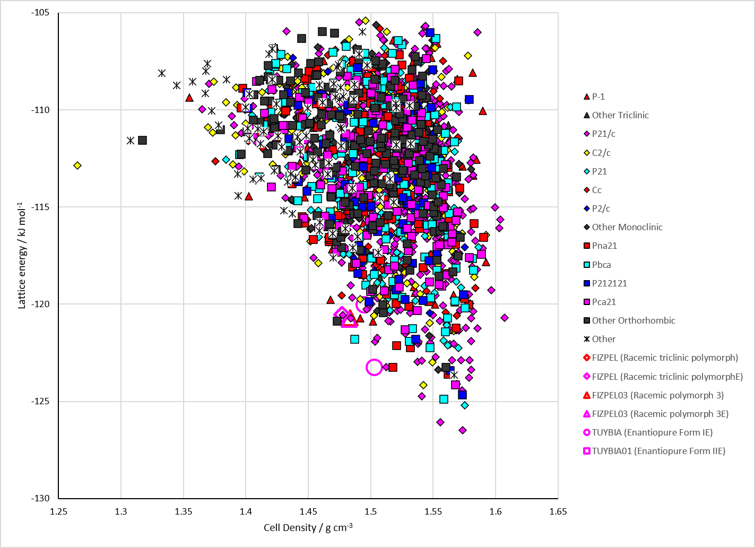
Figure 2. Crystal energy landscape of 3-Chloromandelic Acid from previous work.

CSD structures (CSD version 6.01 with Feb 2026 update)
FIZPEL are the racemic structures and TUYBIA the enantiopure.
Table 1. Crystallographic information for CSD entries for 3-Chloromandelic Acid. Different polymorphs are coloured differently.
REFCODE | space group | Z’ | a / Å | b / Å | c / Å | α / ° | β / ° | γ / ° | density / g cm⁻³ | Form
FIZPEL | P-1 | 2.0 | 8.571 | 9.23730 | 10.3612 | 91.818 | 90.226 | 93.118 | 1.5138 | triclinic polymorph
FIZPEL01 | P21/c | 1.0 | 8.61010 | 10.4552 | 9.3914 | 90.0 | 93.69 | 90.0 | 1.4690 | monoclinic polymorph
FIZPEL02 | P21/c | 1.0 | 8.6521 | 8.91950 | 10.7309 | 90.0 | 90.9 | 90.0 | 1.4967 | polymorph 3
FIZPEL03 | P21/c | 1.0 | 8.675 | 8.9404 | 10.7831 | 90.0 | 90.99 | 90.0 | 1.4821 | None
FIZPEL04 | P21/c | 2.0 | 16.6605 | 9.1572 | 11.4407 | 90.0 | 109.81 | 90.0 | 1.5094 | None
TUYBIA | P21 | 2.0 | 8.316 | 11.855 | 8.4526 | 90.0 | 93.82 | 90.0 | 1.4906 | None
TUYBIA01 | P21 | 4.0 | 9.8701 | 5.4344 | 30.6560 | 90.0 | 95.26 | 90.0 | 1.5138 | None
Although FIZPEL and FIZPEL01 are different polymorphs, they overlay 20 out of 20 molecules in Mercury. FIZPEL01 is higher temperature and higher symmetry.

Table 2. Experimental information for CSD entries for 3-Chloromandelic Acid.
REFCODE | space group | R factor | T / K | Year | Comments
FIZPEL | P-1 | 3.81 | 100 K | 2014 | 10.1021/cg401655h
FIZPEL01 | P21/c | 6.76 | 293 K | 2014 | 10.1021/cg401655h
FIZPEL02 | P21/c | 5.54 | 100 K | 2014 | 10.1039/C4CE01832J
FIZPEL03 | P21/c | 3.280 | 100 K | 2015 | 10.1021/jacs.5b05938
FIZPEL04 | P21/c | 6.850 | 297 K | 2023 | 10.1039/D3CE00226H
TUYBIA | P21 | 5.600 | 293 K | 2015 | 10.1021/jacs.5b05938
TUYBIA01 | P21 | 4.34 | 100 K | 2015 | 10.1021/jacs.5b05938

Make this table include whether polymorphs are solution-grown, sublimation grown, templated or otherwise. Add references.

Other notes

