Gallic Acid
(Last updated May 2026)
Figure 1. The molecular diagram of Gallic Acid.

CSP studies
REFCODE | IJUMEG
Formula | C7 H6 O5
Common Name | Gallic Acid
IUPAC Systematic Name | 3,4,5-trihydroxybenzoic acid
Other Names
CSD Refcodes | IJUMEG06, IJUMEG, IJUMEG04
Search Identifier | A
Scientist | Doris Braun
Date | 2011
Publication | No publication planned.
Energy model | 2
Study_ID | 30
Programs | Study_ID=0, DMACRYS (2.0.4)
Location on S Drive | \CHEMISTRY_CPOSS\GallicAcid\MOLPAKsearch_PCM
Potential Description | PCMdielectric=3(PBE0/aug-cc-pVTz) + GDMA2 + FIT
Intramolecular Description | PCMdielectric=3(PBE0/6-31G(d,p))
Energy model | 1
Study_ID | 0
Programs | MOLPAK, DMACRYS (2.0.4)
Location on S Drive | \CHEMISTRY_CPOSS\GallicAcid\MOLPAKsearch
Potential Description | DMA(PBE0/aug-cc-pVTz) + GDMA2 + FIT
Intramolecular Description | PBE0/6-31G(d,p)

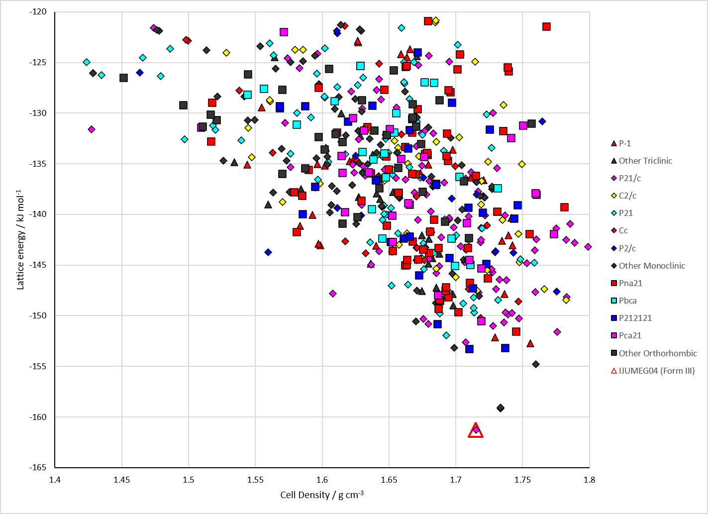
Figure 2. Crystal energy landscape of Gallic Acid from previous work. Energy model A2.

CSD structures (CSD version 6.01 with Feb 2026 update)

Table 1. Crystallographic information for CSD entries for Gallic Acid. Different polymorphs are coloured differently.
REFCODE | space group | Z’ | a / Å | b / Å | c / Å | α / ° | β / ° | γ / ° | density / g cm⁻³ | Form
IJUMEG | C2/c | 1.0 | 25.69 | 4.89460 | 11.097 | 90.0 | 105.746 | 90.0 | 1.6827 | Form II
IJUMEG01 | C2/c | 1.0 | 25.629 | 4.9211 | 11.2217 | 90.0 | 106.251 | 90.0 | 1.6632 | Form II
IJUMEG02 | C2/c | 1.0 | 25.6504 | 4.9221 | 11.2304 | 90.0 | 106.284 | 90.0 | 1.6604 | Form II
IJUMEG03 | C2/c | 1.0 | 25.675 | 4.9047 | 11.115 | 90.0 | 105.77 | 90.0 | 1.6777 | Form II
IJUMEG04 | P21/c | 1.0 | 5.23030 | 5.26495 | 24.7927 | 90.0 | 102.1116 | 90.0 | 1.6927 | Form III
IJUMEG05 | C2/c | 1.0 | 25.6850 | 4.92730 | 11.2508 | 90.0 | 106.234 | 90.0 | 1.6530 | Form II
IJUMEG06 | P-1 | 2.0 | 7.31853 | 8.2536 | 11.7148 | 100.4719 | 90.2335 | 90.984400 | 1.6241 | Form I
IJUMEG07 | P-1 | 2.0 | 7.37 | 8.24 | 11.73 | 79.49 | 89.55 | 89.28 | 1.6134 | Form I

Table 2. Experimental information for CSD entries for Gallic Acid.
REFCODE | space group | R factor | T / K | Year | Comments
IJUMEG | C2/c | 3.4 | at 90 K | 2011 | 10.1107/S1600536811000262
IJUMEG01 | C2/c | 3.18 | at 293 K | 2011 | 10.1107/S1600536811007471
IJUMEG02 | C2/c | 3.73 | at 298K | 2011 | 10.1021/cg2001865
IJUMEG03 | C2/c | 4.0 | at 100 K | 2012 | 10.1002/hlca.201200017
IJUMEG04 | P21/c | 2.586 | 298 K | 2013 | 10.1021/cg301506x
IJUMEG05 | C2/c | 3.56 | 293 K | 2013 | 10.1021/cg301506x
IJUMEG06 | P-1 | 4.818 | 298 K | 2013 | 10.1021/cg301506x
IJUMEG07 | P-1 | 8.82 | 363 K | 2023 | 10.1039/D2CE01149B

Make this table include whether polymorphs are solution-grown, sublimation grown, templated or otherwise. Add references.

Other notes

