5-substituted uracils
(Last updated January 2026)
This is all the molecules covered in Sarah Barnett’s paper, Barnett SA, Hulme AT, Issa N, Lewis TC, Price LS, Tocher DA, Price SL 2008. New J Chem 32, 1761-1775.:1761-1775. 5-fluorouracil is also covered in a separate file. 5-eniluracil’s search was not covered in that paper as it was covered in Copley RCB, Barnett SA, Karamertzanis PG, Harris KDM, Kariuki BM, Xu MC, Nickels EA, Lancaster RW, Price SL 2008. Cryst Growth Des 8
Figure 1. The molecular diagram of 5-aminouracil, 5-chlorouracil, 5-cyanouracil, 5-ethyluracil, 5-ethynyluracil (eniluracil), 5-fluorouracil, 5-hydroxyuracil (isobarbituric acid), 5-iodouracil, 5-methyluracil (thymine), 5-nitrouracil, 5-vinyluracil, uracil.

CSP studies
REFCODE | UCLAUR
Formula | C4 H5 N3 O2
Common Name | 5-aminouracil
IUPAC Systematic Name | 5-aminouracil
Other Names | 5-aminouracil
CSD Refcodes
Search Identifier | A
Scientist | Nizar Issa (Louise Price)
Date | 2008
Publication | Barnett SA, Hulme AT, Issa N, Lewis TC, Price LS, Tocher DA, Price SL 2008. New J Chem 32, 1761-1775.,1761-1775.
Energy model | 1
Study_ID | 0
Programs | MOLPAK, DMAREL (4.1.1)
Location on S Drive | \CHEMISTRY_CPOSS\0-EarlySearches\home\louise_price.eminerals\5-aminouracil
Potential Description | DMA + FIT
Intramolecular Description | MP2/6-31G(d,p)
REFCODE | CLURAC
Formula | C4 H3 N2 O2 Cl
Common Name | 5-chlorouracil
IUPAC Systematic Name | 5-chloropyrimidine-2,4(1H,3H)-dione
Other Names | 5-chlorouracil
CSD Refcodes | CLURAC11
Search Identifier | A
Scientist | Ashley Hulme
Date | 2005-7
Publication | Barnett SA, Hulme AT, Issa N, Lewis TC, Price LS, Tocher DA, Price SL 2008. New J Chem 32, 1761-1775.
Energy model | 1
Study_ID | 0
Programs | MOLPAK, DMAREL (4.1.1)
Location on S Drive | \CHEMISTRY_CPOSS\0-EarlySearches\home\louise_price.eminerals\chlorouracil
Potential Description | DMA + FIT with anisotropic chlorine potential
Intramolecular Description | MP2/6-31G(d,p)
REFCODE | BOLLOE
Formula | C5 H3 N3 O2
Common Name | 5-cyanouracil
IUPAC Systematic Name | 5-cyanouracil
Other Names | 5-cyanouracil
CSD Refcodes | BOLLOE
Search Identifier | A
Scientist | Nizar Issa
Date | 2005-7
Publication | Barnett SA, Hulme AT, Issa N, Lewis TC, Price LS, Tocher DA, Price SL 2008. New J Chem 32, 1761-1775.
Energy model | 1
Study_ID | 0
Programs | MOLPAK, DMAREL (4.1.1)
Location on S Drive | \CHEMISTRY_CPOSS\0-EarlySearches\home\louise_price.eminerals\5-cyanouracil
Potential Description | DMA + FIT
Intramolecular Description | MP2/6-31G(d,p)
REFCODE | BOLLIY
Formula | C6 H8 N2 O2
Common Name | 5-Ethyluracil
IUPAC Systematic Name | 5-Ethyluracil
Other Names | 5-Ethyluracil
CSD Refcodes
Search Identifier | A
Scientist | Nizar Issa (Weijia Zhu)
Date | 2005-7
Publication | Barnett SA, Hulme AT, Issa N, Lewis TC, Price LS, Tocher DA, Price SL 2008. New J Chem 32, 1761-1775.-1761-1775.
Energy model | 1
Study_ID | 0
Programs | MOLPAK, DMAREL (4.1.1)
Location on S Drive | \CHEMISTRY_CPOSS\0-EarlySearches\home\louise_price.eminerals\5-ethyluracil
Potential Description | DMA + FIT
Intramolecular Description | MP2/6-31G(d,p)
REFCODE | DOHFEM
Formula | C6 H4 N2 O2
Common Name | Eniluracil
IUPAC Systematic Name | 5-ethynylpyrimidine-2,4(1H,3H)-dione
Other Names | 5-ethynyluracil
CSD Refcodes | DOHFEM01
Search Identifier | A
Scientist | Sarah Barnett
Date | 2005-7
Publication | Copley RCB, Barnett SA, Karamertzanis PG, Harris KDM, Kariuki BM, Xu MC, Nickels EA, Lancaster RW, Price SL 2008. Cryst Growth Des 8
Energy model | 1
Study_ID | 0
Programs | MOLPAK, DMAREL (4.1.1)
Location on S Drive | \CHEMISTRY_CPOSS\0-EarlySearches\home\louise_price.eminerals\eniluracil
Potential Description | DMA + FIT
Intramolecular Description | MP2/6-31G(d,p)
Search Identifier | B
Scientist | Louise Price
Date | 2007
Publication | Barnett SA, Hulme AT, Issa N, Lewis TC, Price LS, Tocher DA, Price SL 2008. New J Chem 32, 1761-1775.
Energy model | 1
Study_ID | 1
Programs | MOLPAK, DMAREL (4.1.1)
Location on S Drive | \CHEMISTRY_CPOSS\0-EarlySearches\home\louise_price.eminerals\eniluracil_revisited
Potential Description | DMA + FIT
Intramolecular Description | MP2/6-31G(d,p)
REFCODE | QARWAI
Formula | C4 H4 N2 03
Common Name | Isobarbituric acid
IUPAC Systematic Name | 5-hydroxy-1H-pyrimidine-2,4-dione
Other Names | 5-hydroxyuracil
CSD Refcodes | QARWAI
Search Identifier | A
Scientist | Tom Lewis
Date | 2005
Publication | Copley, R. C. B., Deprez, L. S., Lewis, T. C., Price, S. L., CrystEngComm, 7(69), 421-428 (2005)
Energy model | 1
Study_ID | 0
Programs | MOLPAK, DMAREL (3.0)
Location on S Drive | \CHEMISTRY_CPOSS\0-EarlySearches\home\louise_price.eminerals\isobarbituric_acid
Potential Description | MP2 6-31G(d,p) DMA + 25% reduced Carbon repulsion FIT
Intramolecular Description | B3LYP/6-31G(d,p)
Search Identifier | B
Scientist | Louise Price
Date | 2005-7
Publication | Barnett SA, Hulme AT, Issa N, Lewis TC, Price LS, Tocher DA, Price SL 2008. New J Chem 32, 1761-1775.
Energy model | 1
Study_ID | 1
Programs | MOLPAK, DMAREL (4.1.1)
Location on S Drive | \CHEMISTRY_CPOSS\0-EarlySearches\home\louise_price.eminerals\isobarbituric_acid_revisited
Potential Description | DMA + FIT
Intramolecular Description | MP2/6-31G(d,p)
REFCODE | THYMIN
Formula | C5 H6 N2 O2
Common Name | Thymine
IUPAC Systematic Name | 5-methyl-2,4(1H,3H)-pyrimidinedione
Other Names | 2,4-dihydroxy-5-methylpyrimidine, 5-methyluracil
CSD Refcodes | THYMIN01, THYMIN03
Search Identifier | A
Scientist | Tom Lewis
Date | 2005
Publication | See Study_ID=1
Energy model | 1
Study_ID | 0
Programs | MOLPAK, DMAREL (4.1.1)
Location on S Drive | \CHEMISTRY_CPOSS\0-EarlySearches\home\louise_price.eminerals\thymine
Potential Description | MP2 6-31G(d,p) DMA + 25% reduced Carbon repulsion FIT
Intramolecular Description | MP2/6-31G(d,p)
Search Identifier | B
Scientist | Louise Price
Date | 2005-7
Publication | Barnett SA, Hulme AT, Issa N, Lewis TC, Price LS, Tocher DA, Price SL 2008. New J Chem 32, 1761-1775.
Energy model | 1
Study_ID | 1
Programs | MOLPAK, DMAREL (4.1.1)
Location on S Drive | \CHEMISTRY_CPOSS\0-EarlySearches\home\louise_price.eminerals\thymine_revisited
Potential Description | DMA + FIT
Intramolecular Description | MP2/6-31G(d,p)
REFCODE | NIMFOE
Formula | C4 H3 N3 O4
Common Name | 5-nitrouracil
IUPAC Systematic Name | 5-nitro-1H-pyrimidine-2,4-dione
Other Names
CSD Refcodes | NIMFOE, NIMFOE01, NIMFOE02, many solvates
Search Identifier | A
Scientist | Nizar Issa
Date | 2005-7
Publication | Barnett SA, Hulme AT, Issa N, Lewis TC, Price LS, Tocher DA, Price SL 2008. New J Chem 32, 1761-1775.
Energy model | 1
Study_ID | 0
Programs | MOLPAK, DMAREL (4.1.1)
Location on S Drive | \CHEMISTRY_CPOSS\0-EarlySearches\home\louise_price.eminerals\5-nitrouracil\OptSearch
Potential Description | DMA + FIT
Intramolecular Description | MP2/6-31G(d,p)
Search Identifier | B
Scientist | Nizar Issa
Date | 2005-7
Publication | Barnett SA, Hulme AT, Issa N, Lewis TC, Price LS, Tocher DA, Price SL 2008. New J Chem 32, 1761-1775.
Energy model | 1
Study_ID | 1
Programs | MOLPAK, DMAREL (4.1.1)
Location on S Drive | \CHEMISTRY_CPOSS\0-EarlySearches\home\louise_price.eminerals\5-nitrouracil\PlanSearch
Potential Description | DMA + FIT
Intramolecular Description | MP2/6-31G(d,p)
REFCODE | UCLVUR
Formula | C6 H6 N2 O2
Common Name | 5-vinyluracil
IUPAC Systematic Name | 5-vinyl-1H-pyrimidine-2,4-dione
Other Names
CSD Refcodes
Search Identifier | A
Scientist | Tom Lewis
Date | 2005-7
Publication | Barnett SA, Hulme AT, Issa N, Lewis TC, Price LS, Tocher DA, Price SL 2008. New J Chem 32, 1761-1775.
Energy model | 1
Study_ID | 0
Programs | MOLPAK, DMAREL (4.1.1)
Location on S Drive | \CHEMISTRY_CPOSS\0-EarlySearches\home\louise_price.eminerals\5-vinyluracil
Potential Description | DMA + FIT
Intramolecular Description | MP2/6-31G(d,p)
REFCODE | URACIL
Formula | C4 H4 N2 O2
Common Name | Uracil
IUPAC Systematic Name | 2,4-pyrimidine dione
Other Names
CSD Refcodes | URACIL
Search Identifier | A
Scientist | Tom Lewis
Date | 2005-7
Publication | Barnett SA, Hulme AT, Issa N, Lewis TC, Price LS, Tocher DA, Price SL 2008. New J Chem 32, 1761-1775.
Energy model | 1
Study_ID | 0
Programs | MOLPAK, DMAREL (4.1.1)
Location on S Drive | \CHEMISTRY_CPOSS\0-EarlySearches\home\louise_price.eminerals\uracil
Potential Description | DMA + FIT
Intramolecular Description | MP2/6-31G(d,p)

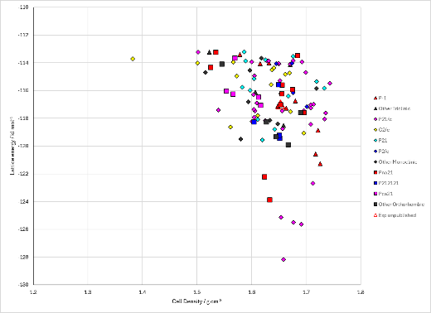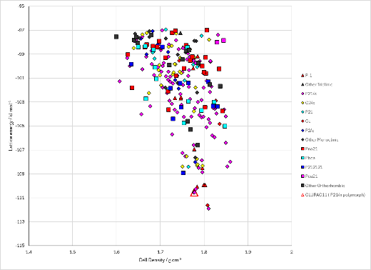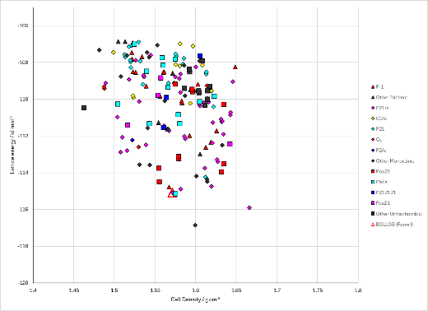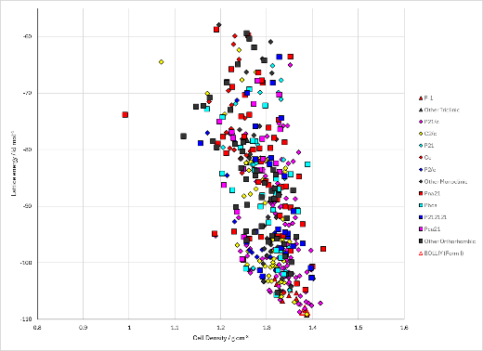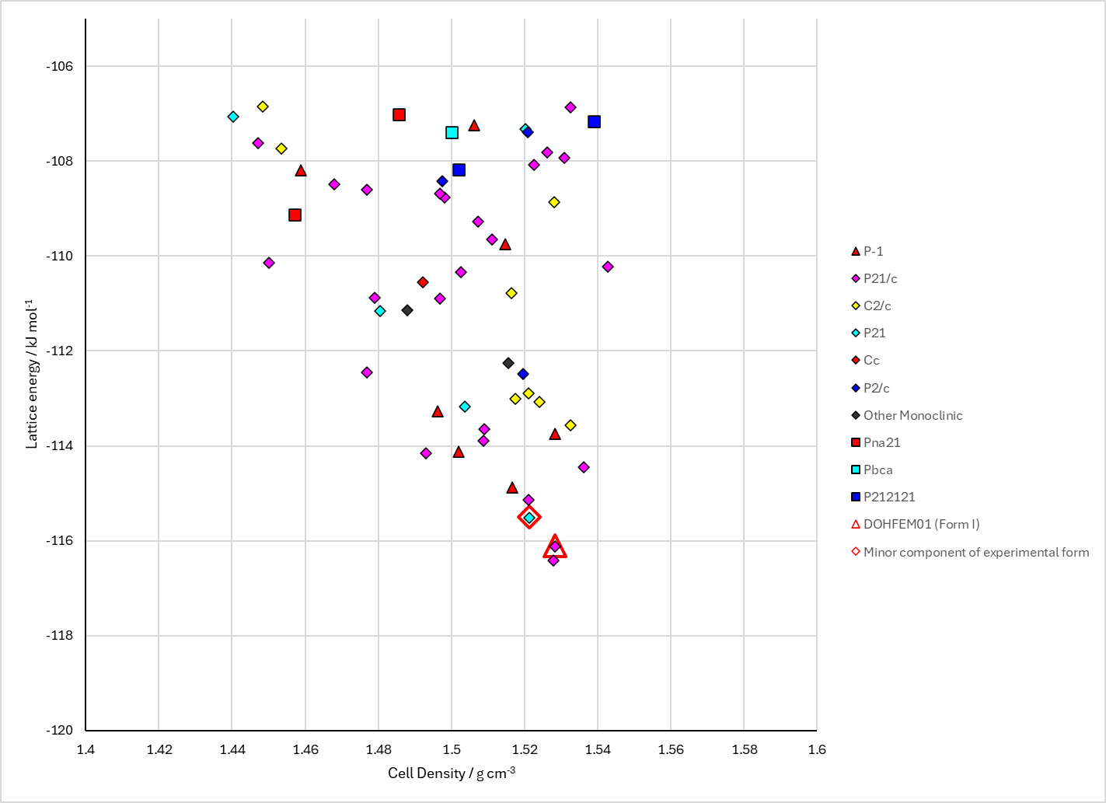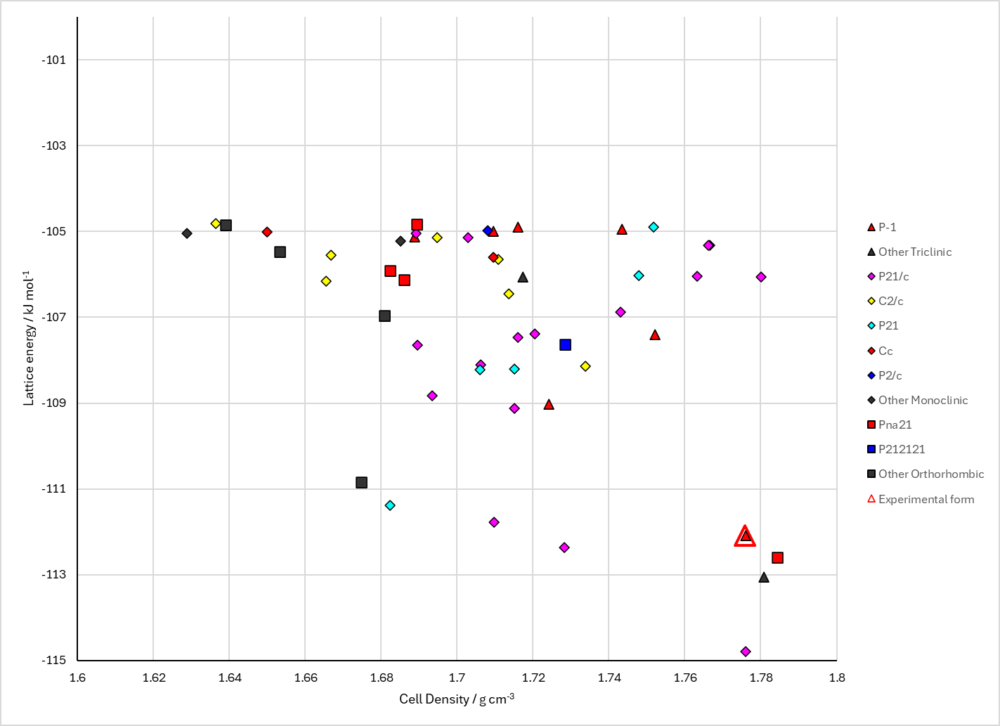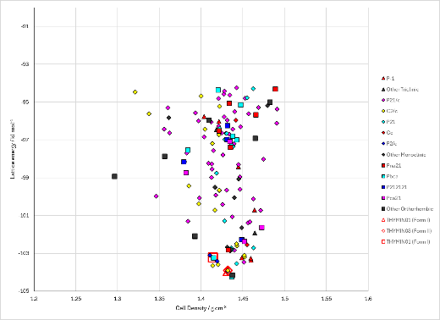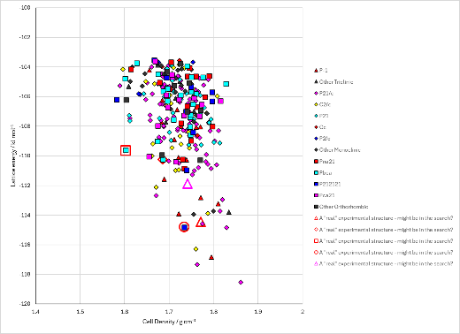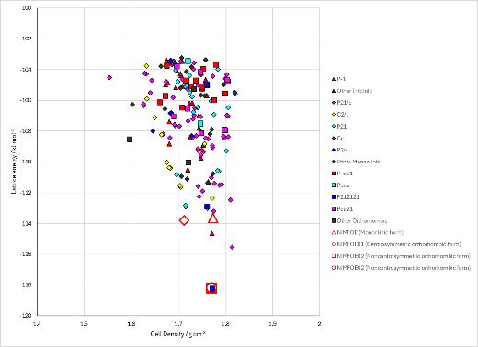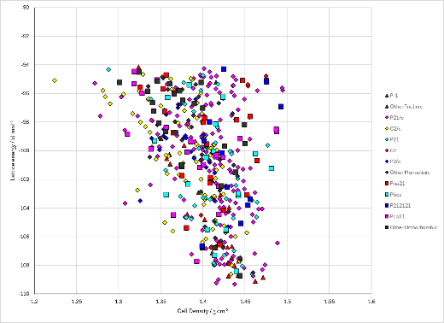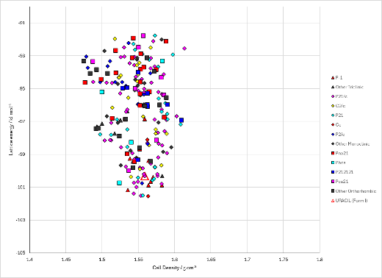
Figure 2. Crystal energy landscape of 5-substituted uracils from previous work. From top left to bottom right, 5-aminouracil, 5-chlorouracil, 5-cyanouracil, 5-ethyluracil, 5-ethynyluracil_B1 (eniluracil), 5-hydroxyuracil_B1 (isobarbituric acid), 5-methyluracil_B1 (thymine), 5-nitrouracil_A1 and _B1, 5-vinyluracil, uracil.

CSD structures (CSD version 6.01)
Table 1. Crystallographic information for CSD entries for 5-substituted uracils. Different polymorphs are coloured differently.
REFCODE | space group | Z’ | a / Å | b / Å | c / Å | α / ° | β / ° | γ / ° | density / g cm⁻³ | Form
CLURAC10 | P21/c | 1.0 | 8.45 | 6.84200 | 11.0720 | 90.0 | 123.53 | 90.0 | 1.6122 | P21/c polymorph
CLURAC11 | P21/n | 1.0 | 8.43930 | 6.84120 | 9.3679 | 90.0 | 104.20100 | 90.0 | 1.8562 | P21/n polymorph
CLURAC12 | P21/m | 0.5 | 5.532 | 6.841 | 7.152 | 90.0 | 97.31 | 90.0 | 1.8002 | P21/m polymorph
CLURAC14 | P21/m | 0.5 | 5.51500 | 6.8639 | 7.126 | 90.0 | 96.92 | 90.0 | 1.8110 | P21/m polymorph
BOLLOE | P21/n | 1.0 | 9.0098 | 6.6035 | 9.1805 | 90.0 | 98.124 | 90.0 | 1.6840 | None
BOLLIY | P-1 | 1.0 | 3.91930 | 5.75400 | 14.366 | 100.027 | 96.109000 | 92.374 | 1.4699 | None
DOHFEM | P21/n | 1.0 | 9.0169 | 6.8086 | 9.3777 | 90.0 | 101.2085 | 90.0 | 1.6008 | None
DOHFEM01 | P21 | 2.0 | 9.0188 | 6.8105 | 9.3622 | 90.0 | 101.18870 | 90.0 | 1.6025 | None
QARWAI | P-1 | 1.0 | 4.6195 | 7.04930 | 7.3452 | 88.169000 | 81.504 | 86.245 | 1.8024 | None
THYMIN | P21/c | 1.0 | 12.8700 | 6.83 | 6.7 | 90.0 | 105.00000 | 90.0 | 1.4724 | None
THYMIN01 | P21/c | 1.0 | 12.8890 | 6.852 | 6.784 | 90.0 | 104.92 | 90.0 | 1.4469 | None
THYMIN02 | C2/c | 1.0 | 25.107 | 6.84620 | 6.715 | 90.0 | 90.529 | 90.0 | 1.4515 | None
THYMIN03 | C2/c | 1.0 | 24.919 | 6.83850 | 6.6132 | 90.0 | 90.081 | 90.0 | 1.4866 | None
NIMFOE | P21/n | 1.0 | 5.873 | 9.693 | 10.4561 | 90.0 | 104.07000 | 90.0 | 1.8070 | monoclinic polymorph
NIMFOE01 | Pbca | 1.0 | 8.308 | 10.426 | 13.363 | 90.0 | 90.0 | 90.0 | 1.8028 | centrosymmetric orthorhombic polymorph
NIMFOE02 | P212121 | 1.0 | 5.43420 | 9.8406 | 10.3659 | 90.0 | 90.0 | 90.0 | 1.8822 | noncentrosymmetric orthorhombic polymorph
URACIL | P21/a | 1.0 | 11.938 | 12.3760 | 3.65520 | 90.0 | 120.9 | 90.0 | 1.6066 | None

Table 2. Experimental information for CSD entries for 5-substituted uracils.
REFCODE | space group | R factor | T / K | Year | Comments
CLURAC10 | P21/c | 5.8 | None | 1975 | 10.1016/0005-2787(75)90130-6
CLURAC11 | P21/n | 3.300 | at 150 K | 2008 | 10.1039/b806763e
CLURAC12 | P21/m | 4.100 | 296 K | 2014 | None
CLURAC14 | P21/m | 3.500 | 298 K | 2019 | 10.3390/cryst9090467
BOLLOE | P21/n | 3.98 | at 150 K | 2008 | 10.1039/b806763e
BOLLIY | P-1 | 6.09 | at 150 K | 2008 | 10.1039/b806763e
DOHFEM | P21/n | 4.55 | at 150 K | 2008 | 10.1021/cg800517h
DOHFEM01 | P21 | 3.67 | at 150 K | 2008 | 10.1021/cg800517h
QARWAI | P-1 | 4.09 | at 150 K | 2005 | 10.1039/b504756k
THYMIN | P21/c | 14.9 | None | 1969 | 10.1107/S0567740869003505
THYMIN01 | P21/c | 4.58 | None | 1999 | 10.3891/acta.chem.scand.53-0057
THYMIN02 | C2/c | 8.82 | 293 K | 2016 | 10.1016/j.molstruc.2016.05.014
THYMIN03 | C2/c | 4.24 | 183 K | 2016 | 10.1021/acs.cgd.6b00459
NIMFOE | P21/n | 3.63 | None | 1998 | 10.1107/S0108270197016521
NIMFOE01 | Pbca | 7.810 | at 130 K | 2000 | 10.1002/1439-7641(20001103)1:3<127::AID-CPHC127>3.3.CO;2-T
NIMFOE02 | P212121 | 7.59 | at 130 K | 2000 | 10.1002/1439-7641(20001103)1:3<127::AID-CPHC127>3.3.CO;2-TVinil
URACIL | P21/a | 4.5 | None | 1967 | 10.1107/S0365110X67004360

Make this table include whether polymorphs are solution-grown, sublimation grown, templated or otherwise. Add references.

Other notes

