4,5-dichloro-1,2-dinitrobenzene (Blind Test XVII)
(Last updated March 2026)
Figure 1. The molecular diagram of 4,5-dichloro-1,2-dinitrobenzene.

CSP studies
REFCODE | OBEQOD
Formula | C6 H2 N2 O4 Cl2
Common Name | Blind Test molecule XVII
IUPAC Systematic Name | 4,5-Chloro-1,2-dinitrobenzene
Other Names
CSD Refcodes | OBEQOD
Search Identifier | A
Scientist | Matthew Habgood
Date | 2010
Publication | See Study_ID=10
Energy model | 1
Study_ID | 0
Programs | MOLPAK, DMACRYS (2.0.1)
Location on S Drive | CHEMISTRY_CPOSS\BlindTest2010\OBEQOD\Molpak_Rigid
Potential Description | DMA + Will01 with GMD anis Cl
Intramolecular Description | MP2/6-31G(d,p)
Search Identifier | B
Scientist | Matthew Habgood
Date | 2010
Publication | Bardwell DA, et al. 2011. Acta Crystallogr , Sect B 67
Energy model | 1
Study_ID | 10
Programs | Rigid CrystalPredictor, CrystalOptimizer, DMACRYS (2.0.4)
Location on S Drive | CHEMISTRY_CPOSS\BlindTest2010\OBEQOD\CP_CO
Potential Description | DMA + Will01 with GMD anis Cl
Intramolecular Description | PBE0

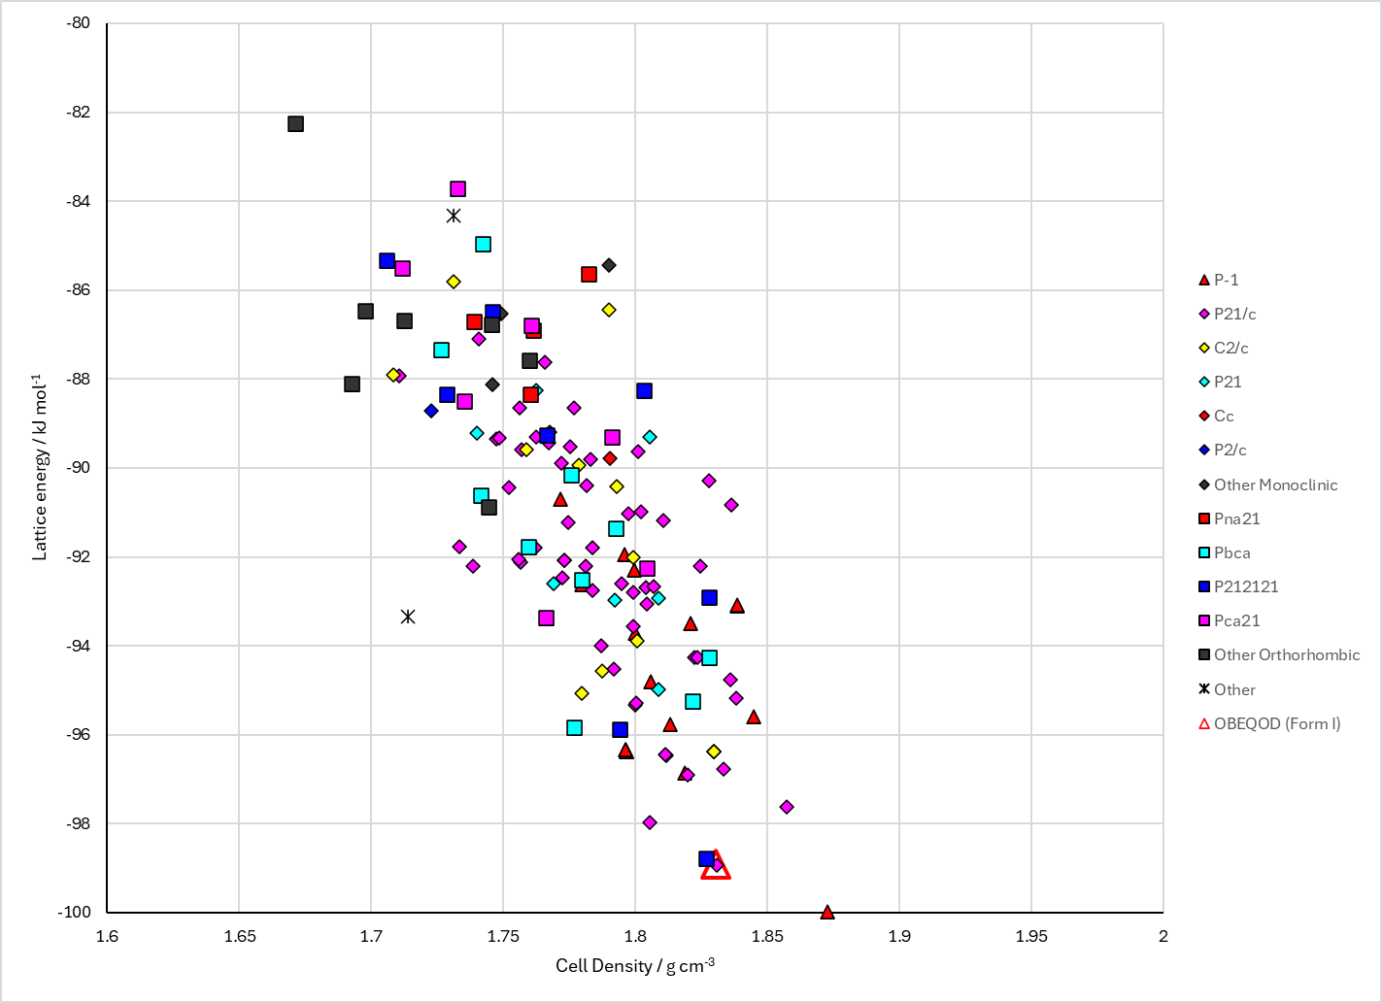
Figure 2. Crystal energy landscape of 4,5-dichloro-1,2-dinitrobenzene from previous work (Study_ID=10).

CSD structures (CSD version 6.01)

Table 1. Crystallographic information for CSD entries for 4,5-dichloro-1,2-dinitrobenzene. Different polymorphs are coloured differently.
REFCODE | space group | Z’ | a / Å | b / Å | c / Å | α / ° | β / ° | γ / ° | density / g cm⁻³ | Form
OBEQOD | P21/c | 1.0 | 12.6386 | 5.9794 | 11.422 | 90.0 | 96.807 | 90.0 | 1.8366 | None

Table 2. Experimental information for CSD entries for 4,5-dichloro-1,2-dinitrobenzene.
REFCODE | space group | R factor | T / K | Year | Comments
OBEQOD | P21/c | 2.56 | at 174 K | 2011 | None

Make this table include whether polymorphs are solution-grown, sublimation grown, templated or otherwise. Add references.

Other notes

