Salsalate
(Last updated June 2026)
Figure 1. The molecular diagram of Salsalate.

CSP studies
REFCODE | WOQDAH
Formula | C14 H10 O5
Common Name | Salicyl salicylate
IUPAC Systematic Name | 2-Hydroxybenzoic acid 2-carboxyphenyl ester
Other Names | Salsalate
CSD Refcodes | WOQDAH
Search Identifier | A
Scientist | Matthew Habgood
Date | 2013
Publication | Habgood M, Lancaster RW, Gateshki M, Kenwright AM 2013. Cryst Growth Des 13, 1771-1779.
Energy model | 2
Study_ID | 30
Programs | Study_ID=10, DMACRYS (2.0.4)
Location on S Drive | \CHEMISTRY_CPOSS\Salsalate\PCM
Potential Description | GDMA2.2(PCMdielectric3(PBE0/6-31G(d,p))) + FIT
Intramolecular Description | PCMdielectric=3(PBE0/6-31G(d,p))
Energy model | 1
Study_ID | 10
Programs | Rigid CrystalPredictor (v1.6), DMAFEX-quick, CrystalOptimizer (v2.1), DMACRYS (v2.0.4)
Location on S Drive | \CHEMISTRY_CPOSS\Salsalate\CrystOpt
Potential Description | CrystalOptimizer with 6 degrees of freedom, GDMA2.2(PBE0/6-31G(d,p)) + FIT
Intramolecular Description | HF/6-31G(d,p)

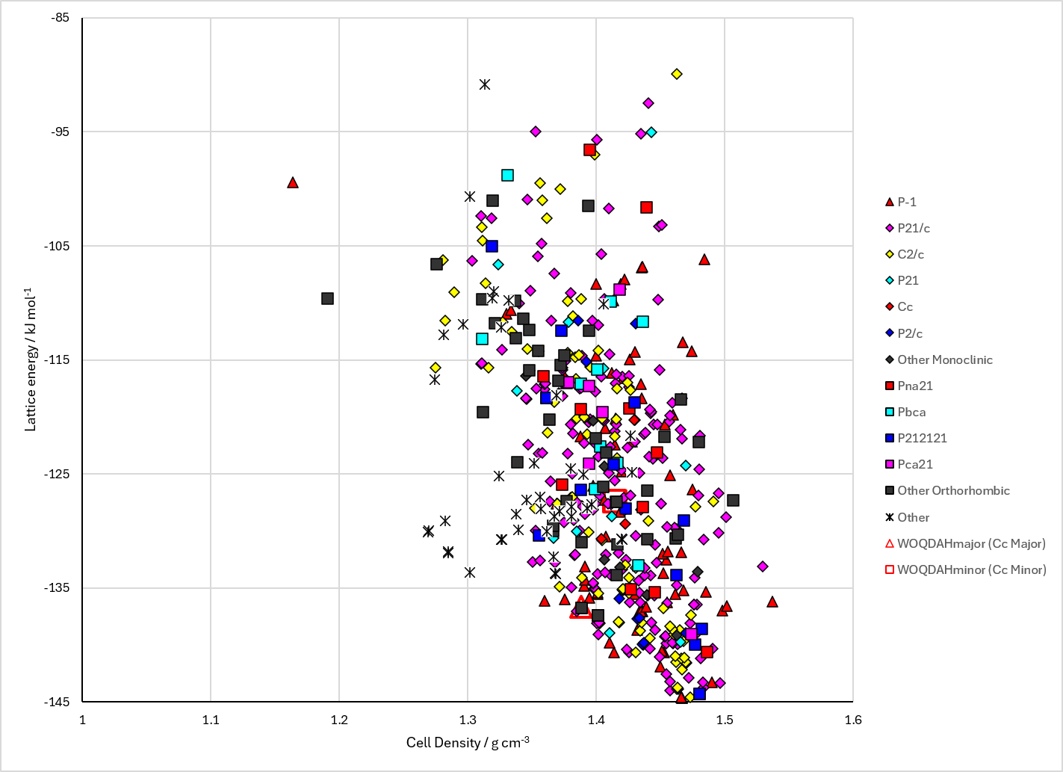
Figure 2. Crystal energy landscape of Salsalate from previous work. Energy model A2.

CSD structures (CSD version 6.01 with Feb and May 2026 updates)

Table 1. Crystallographic information for CSD entries for Salsalate. Different polymorphs are coloured differently.
REFCODE | space group | Z’ | a / Å | b / Å | c / Å | α / ° | β / ° | γ / ° | density / g cm⁻³ | Form
WOQDAH | Cc | 2.0 | 12.965 | 12.9820 | 15.5300 | 90.0 | 114.039 | 90.0 | 1.4369 | None
WOQDAH01 | Fdd2 | 1.0 | 12.961 | 28.323 | 12.941 | 90.0 | 90.0 | 90.0 | 1.4441 | None

Table 2. Experimental information for CSD entries for Salsalate.
REFCODE | space group | R factor | T / K | Year | Comments
WOQDAH | Cc | 3.41 | at 150 K | 2000 | 10.1002/1521-3773(20001016)39:20<3601::AID-ANIE3601>3.3.CO;2-I
WOQDAH01 | Fdd2 | 3.92 | at 150 K | 2000 | 10.1016/S0378-5173(00)00495-6

Make this table include whether polymorphs are solution-grown, sublimation grown, templated or otherwise. Add references.

Other notes

