2-Diazo-3,5-cyclohexadiene-1-one (Blind Test XVI)
(Last updated March 2026)
Figure 1. The molecular diagram of 2-Diazo-3,5-cyclohexadiene-1-one.

CSP studies
REFCODE | OBEQUJ
Formula | C6 H4 N2 O1
Common Name | 5th blind test XVI
IUPAC Systematic Name | 2-diazo-3,5-cyclohexadiene-1-one
Other Names
CSD Refcodes | OBEQUJ
Search Identifier | A
Scientist | Alston Misquitta
Date | 2010
Publication | Bardwell DA, et al. 2011. Acta Crystallogr , Sect B 67, 535-551.
Energy model | 3
Study_ID | 50
Programs | Study_ID=20, DMACRYS (2.0.4)
Location on S Drive | \CHEMISTRY_CPOSS\BlindTest2010\OBEQUJ\CNIRInd
Potential Description | DMA(asym PBE0 Sadlej pVTZ) + CamNoInd + Induction(sp
Intramolecular Description | PBE0 Sadlej Opt
Energy model | 1
Study_ID | 20
Programs | Rigid CrystalPredictor, DMACRYS (2.0.4)
Location on S Drive | \CHEMISTRY_CPOSS\BlindTest2010\OBEQUJ\CamNoInddbase
Potential Description | DMA(asym PBE0 Sadlej pVTZ) + CamNoInd
Intramolecular Description | PBE0 Sadlej Opt
Energy model | 2
Study_ID | 21
Programs | Study_ID=20, DMACRYS (2.0.4)
Location on S Drive | \CHEMISTRY_CPOSS\BlindTest2010\OBEQUJ\CamwithCTdbase
Potential Description | DMA(asym PBE0 Sadlej pVTZ) + CamwithCT
Intramolecular Description | PBE0 Sadlej Opt
Energy model | 4
Study_ID | 10
Programs | Study_ID=20, CrystalOptimizer, DMACRYS (2.0.4)
Location on S Drive | \CHEMISTRY_CPOSS\BlindTest2010\OBEQUJ\OBEQUJ_CrystOpt
Potential Description | DMA(PBE0 aug-cc-pVTZ ) + CamNoInd CryOpt
Intramolecular Description | PBE1PBE/6-311++G(d,p)

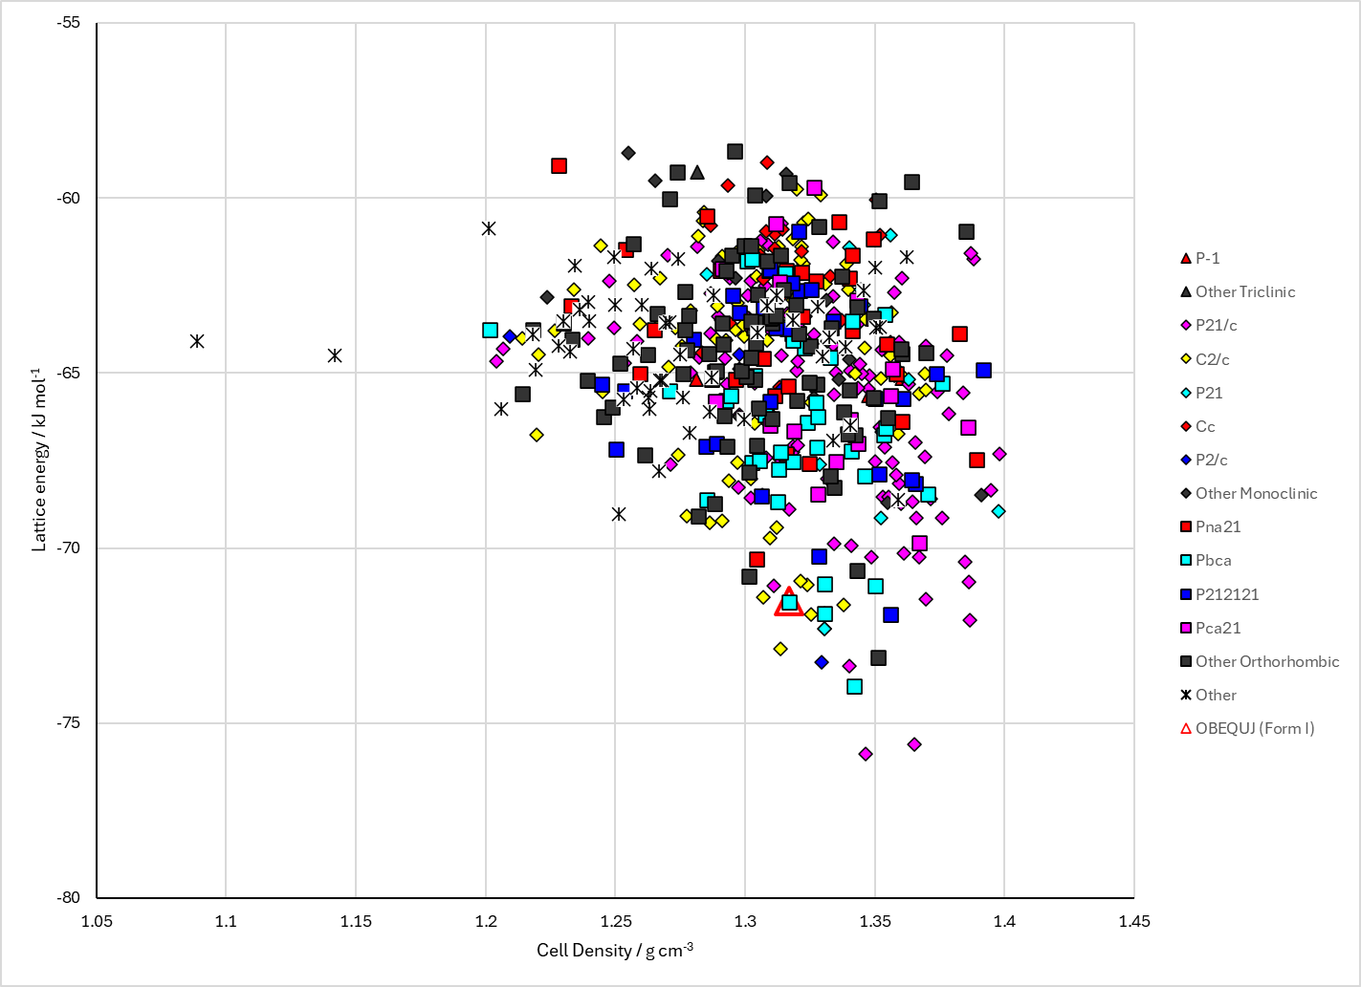
Figure 2. Crystal energy landscape of 2-Diazo-3,5-cyclohexadiene-1-one from previous work.

CSD structures (CSD version 6.01)

Table 1. Crystallographic information for CSD entries for 2-Diazo-3,5-cyclohexadiene-1-one. Different polymorphs are coloured differently.
REFCODE | space group | Z’ | a / Å | b / Å | c / Å | α / ° | β / ° | γ / ° | density / g cm⁻³ | Form
OBEQUJ | Pbca | 1.0 | 9.64510 | 7.381 | 16.185 | 90.0 | 90.0 | 90.0 | 1.3847 | None

Table 2. Experimental information for CSD entries for 2-Diazo-3,5-cyclohexadiene-1-one.
REFCODE | space group | R factor | T / K | Year | Comments
OBEQUJ | Pbca | 4.14 | at 174 K | 2011 | None

Make this table include whether polymorphs are solution-grown, sublimation grown, templated or otherwise. Add references.

Other notes
There was one search done with CrystalPredictor (Study_ID=20). The conformation was created with no induction. The structures were then reminimized:
- “withCT” which had the same conformation but different packing and energy (Study_ID=21)
- with induction, which had the same conformation and packing but different energy (Study_ID=50)
- with CrystalOptimizer, which allowed the conformation and packing to change (Study_ID=10)

