Diclofenac
(Last updated January 2026)
Figure 1. The molecular diagram of Diclofenac.

CSP studies
REFCODE | SIKLIH
Formula | C14 H11 N1 O2 Cl2
Common Name | Diclofenac
IUPAC Systematic Name | [2-(2,6-dichloroanilino)phenyl]acetic acid
Other Names | Cataflam, Voltaren
CSD Refcodes | SIKLIH04, SIKLIH09, SIKLIH10
Search Identifier | A
Scientist | Louise Price
Date | 2017
Publication | No publication planned.
Energy model | 4
Study_ID | 40
Programs | DMACRYS (2.2.1.0)
Location on S Drive | \CHEMISTRY_CPOSS\MagnaPharm\Diclofenac\PCM_BZa
Potential Description | BZ-averaged GDMA2.2(PCMdielectric3(PBE1PBE/6-31G(d,p))) + FIT
Intramolecular Description | PCM3(PBE1PBE/6-31G(d,p))
Energy model | 3
Study_ID | 30
Programs | DMACRYS (2.2.1.0)
Location on S Drive | \CHEMISTRY_CPOSS\MagnaPharm\Diclofenac\PCM
Potential Description | GDMA2.2(PCMdielectric3(PBE1PBE/6-31G(d,p))) + FIT
Intramolecular Description | PCM3(PBE1PBE/6-31G(d,p))
Energy model | 2
Study_ID | 10
Programs | CrystalOptimizer (2.4.5), DMACRYS (2.2.1.0)
Location on S Drive | \CHEMISTRY_CPOSS\MagnaPharm\Diclofenac\CrystalOptimizer
Potential Description | CrystalOptimizer PBE1PBE/6-31G(d,p) intramolecular + GDMA2.2(PBE1PBE/6-31G(d,p)) DMA + FIT
Intramolecular Description | PBE1PBE/6-31G(d,p)
Energy model | 1
Study_ID | 20
Programs | Flexible CrystalPredictor (2.x), DMACRYS (2.2.1.0)
Location on S Drive | \CHEMISTRY_CPOSS\MagnaPharm\Diclofenac\CrystalPredictor
Potential Description | CrystalPredictor + DMACRYS with GDMA2.2(PBE1PBE/6-31G(d,p)) + FIT
Intramolecular Description | PBE1PBE/6-31G(d,p)

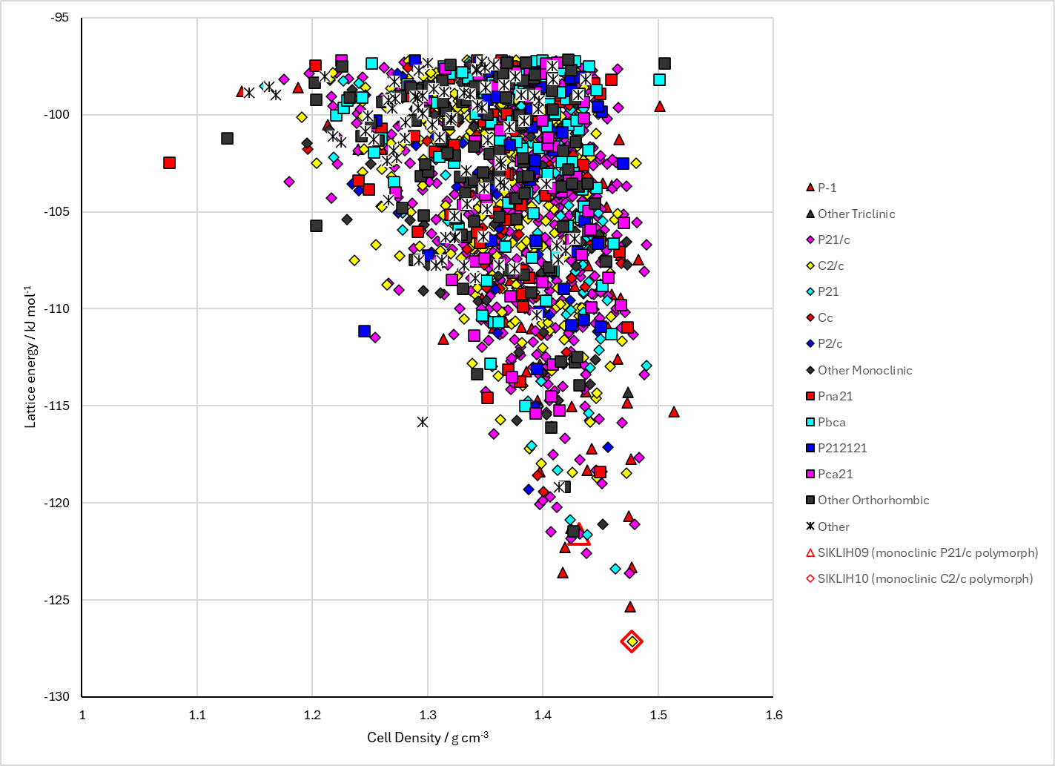
Figure 2. Crystal energy landscape of Diclofenac from Study_ID=40 from previous work.

CSD structures (CSD version 6.01)

Table 1. Crystallographic information for CSD entries for Diclofenac. Different polymorphs are coloured differently.
REFCODE | space group | Z’ | a / Å | b / Å | c / Å | α / ° | β / ° | γ / ° | density / g cm⁻³ | Form
SIKLIH | C2/c | 1.0 | 20.278 | 6.987 | 23.265 | 90.0 | 125.54 | 90.0 | 1.4667 | monoclinic C2/c polymorph
SIKLIH01 | C2/c | 1.0 | 20.263 | 7.005 | 20.111 | 90.0 | 109.578 | 90.0 | 1.4627 | monoclinic C2/c polymorph
SIKLIH02 | P21/c | 1.0 | 8.384 | 10.898 | 14.8220 | 90.0 | 92.76 | 90.0 | 1.4541 | monoclinic P21/c polymorph
SIKLIH03 | C2/c | 1.0 | 20.226 | 6.971 | 20.061 | 90.0 | 109.64 | 90.0 | 1.4767 | monoclinic C2/c polymorph
SIKLIH04 | Pcan | 1.0 | 7.08240 | 17.2565 | 23.6065 | 90.0 | 90.0 | 90.0 | 1.3635 | orthorhombic polymorph
SIKLIH05 | C2/c | 1.0 | 20.2906 | 6.99520 | 20.1137 | 90.0 | 109.66300 | 90.0 | 1.4633 | monoclinic C2/c polymorph
SIKLIH06 | C2/c | 1.0 | 20.2980 | 6.993 | 20.107 | 90.0 | 109.60000 | 90.0 | 1.4632 | monoclinic C2/c polymorph
SIKLIH07 | C2/c | 1.0 | 20.2370 | 6.977 | 20.071 | 90.0 | 109.67 | 90.0 | 1.4742 | monoclinic C2/c polymorph
SIKLIH08 | P21/c | 1.0 | 8.3809 | 10.881 | 14.835 | 90.0 | 92.764 | 90.0 | 1.4557 | monoclinic P21/c polymorph
SIKLIH09 | P21/c | 1.0 | 8.3229 | 10.7529 | 14.717 | 90.0 | 92.872 | 90.0 | 1.4953 | monoclinic P21/c polymorph
SIKLIH10 | C2/c | 1.0 | 20.0965 | 6.8944 | 19.8443 | 90.0 | 109.739 | 90.0 | 1.5201 | monoclinic C2/c polymorph
SIKLIH12 | C2/c | 1.0 | 20.2338 | 6.9908 | 20.0551 | 90.0 | 109.53700 | 90.0 | 1.4715 | monoclinic C2/c polymorph

Table 2. Experimental information for CSD entries for Diclofenac.
REFCODE | space group | R factor | T / K | Year | Comments
SIKLIH | C2/c | 3.300 | None | 1990 | 10.1021/jm00171a008
SIKLIH01 | C2/c | 5.17 | None | 1993 | 10.1016/S0277-5387(00)84327-2
SIKLIH02 | P21/c | 3.97 | None | 1997 | 10.1107/S0108270197002126
SIKLIH03 | C2/c | 3.74 | None | 1997 | 10.1107/S0108270197002126
SIKLIH04 | Pcan | 13.6 | at 293 K | 2001 | 10.2116/analsci.17.1465
SIKLIH05 | C2/c | 3.38 | at 293 K | 2004 | 10.1107/S0021889804002353
SIKLIH06 | C2/c | 5.96 | at 293 K | 2004 | 10.1107/S0021889804002353
SIKLIH07 | C2/c | 2.82 | at 298 K | 2007 | 10.1002/jps.20936
SIKLIH08 | P21/c | 3.54 | at 298 K | 2007 | 10.1002/jps.20936
SIKLIH09 | P21/c | 5.020 | at 99 K | 2011 | 10.1021/ac2001934
SIKLIH10 | C2/c | 3.030 | at 98 K | 2011 | 10.1021/ac2001934
SIKLIH12 | C2/c | 4.5 | 293 K | 2021 | 10.1016/j.chemphys.2021.111119

Make this table include whether polymorphs are solution-grown, sublimation grown, templated or otherwise. Add references.

Other notes

