Chloroform
(Last updated April 2026)
Figure 1. The molecular diagram of chloroform.

CSP studies
REFCODE | CLFORM
Formula | C1 H1 Cl3
Common Name | Chloroform
IUPAC Systematic Name | trichloromethane
Other Names
CSD Refcodes | CLFORM02, CLFORM03
Search Identifier | A
Scientist | Not sure
Date | pre-2010
Publication | No publication planned.
Energy model | 1
Study_ID | 2
Programs | MOLPAK, DMACRYS (2.0.1)
Location on S Drive | \CHEMISTRY_CPOSS\0-EarlySearches\home\louise_price.eminerals\Chloroform_aniso
Potential Description | MP2 6-31G(d,p) DMA+ANISO (c.f. GMD)
Intramolecular Description | MP2 6-31G(d,p)
Search Identifier | B
Scientist | Not sure
Date | pre-2010
Publication | No publication planned.
Energy model | 1
Study_ID | 1
Programs | MOLPAK, DMACRYS (2.0.1)
Location on S Drive | \CHEMISTRY_CPOSS\0-EarlySearches\home\louise_price.eminerals\Chloroform_charges
Potential Description | MP2 6-31G(d,p) Charges+ FIT
Intramolecular Description | MP2 6-31G(d,p)

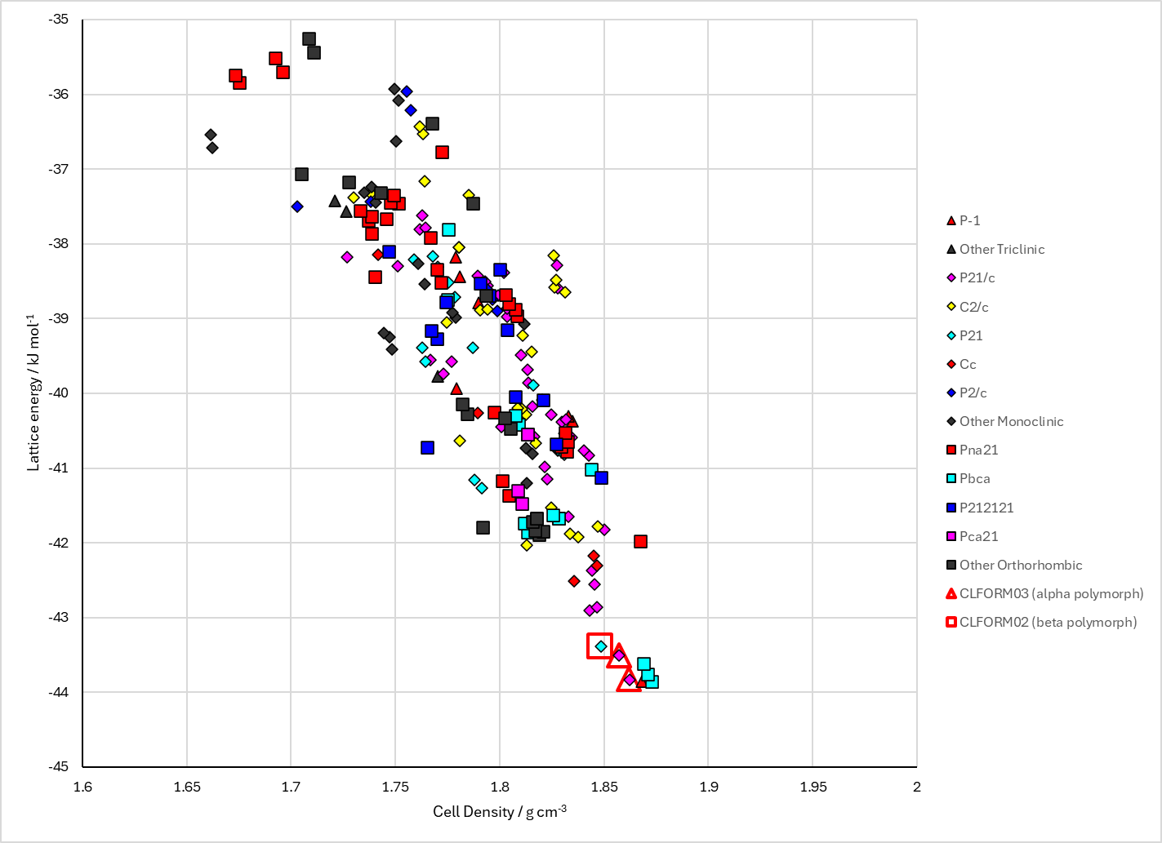
Figure 2. Crystal energy landscape of chloroform from previous work.

CSD structures (CSD version 6.01 with Feb 2026 update)

Table 1. Crystallographic information for CSD entries for chloroform. Different polymorphs are coloured differently.
REFCODE | space group | Z’ | a / Å | b / Å | c / Å | α / ° | β / ° | γ / ° | density / g cm⁻³ | Form
CLFORM | Pnma | 0.5 | 7.485 | 9.497 | 5.841 | 90.0 | 90.0 | 90.0 | 1.9097 | alpha polymorph
CLFORM01 | Pnma | 0.5 | 7.4081 | 9.40340 | 5.75400 | 90.0 | 90.0 | 90.0 | 1.9782 | alpha polymorph
CLFORM02 | P63 | 0.33 | 5.8868 | 5.8868 | 6.65410 | 90.0 | 90.0 | 120 | 1.9852 | beta polymorph
CLFORM03 | Pnma | 0.5 | 7.44220 | 9.4578 | 5.8025 | 90.0 | 90.0 | 90.0 | 1.9414 | alpha polymorph

Table 2. Experimental information for CSD entries for chloroform.
REFCODE | space group | R factor | T / K | Year | Comments
CLFORM | Pnma | 11.0 | at 185 K | 1966 | None
CLFORM01 | Pnma | 3.550 | at 293 K | 2008 | 10.1021/jp8020134
CLFORM02 | P63 | 2.95 | at 295 K | 2008 | 10.1021/jp8020134
CLFORM03 | Pnma | 1.72 | at 120 K | 2010 | 10.1039/b914851e

Make this table include whether polymorphs are solution-grown, sublimation grown, templated or otherwise. Add references.

Other notes

