Paracetamol
(Last updated April 2026)
Figure 1. The molecular diagram of Paracetamol.

CSP studies
REFCODE | HXACAN
Formula | C8 H9 N1 O2
Common Name | Paracetamol
IUPAC Systematic Name | N-(4-hydroxyphenyl)acetamide
Other Names | Acetaminophen
CSD Refcodes | HXACAN28, HXACAN31, HXACAN40, HXACAN39, HXACAN47
Search Identifier | A
Scientist | Tinoziva Sango
Date | 2017
Publication | No publication planned.
Energy model | 1
Study_ID | 10
Programs | Flexible CrystalPredictor (2), CrystalOptimizer, DMACRYS (2.2.1.0)
Location on S Drive | \CHEMISTRY_CPOSS\Paracetamol\CrystOpt
Potential Description | CrystalOptimizer with GDMA2.2(PBE1PBE/6-31G(d,p)) + FIT
Intramolecular Description | PBE0/6-31G(d,p)
Search Identifier | B
Scientist | Louise Price
Date | pre-2010
Publication | No publication planned.
Energy model | 1
Study_ID | 0
Programs | MOLPAK, DMAREL (3.11)
Location on S Drive | \CHEMISTRY_CPOSS\0-EarlySearches\home\louise_price.eminerals\paracetamol
Potential Description | DMA + FIT
Intramolecular Description | MP2/6-31G(d,p)

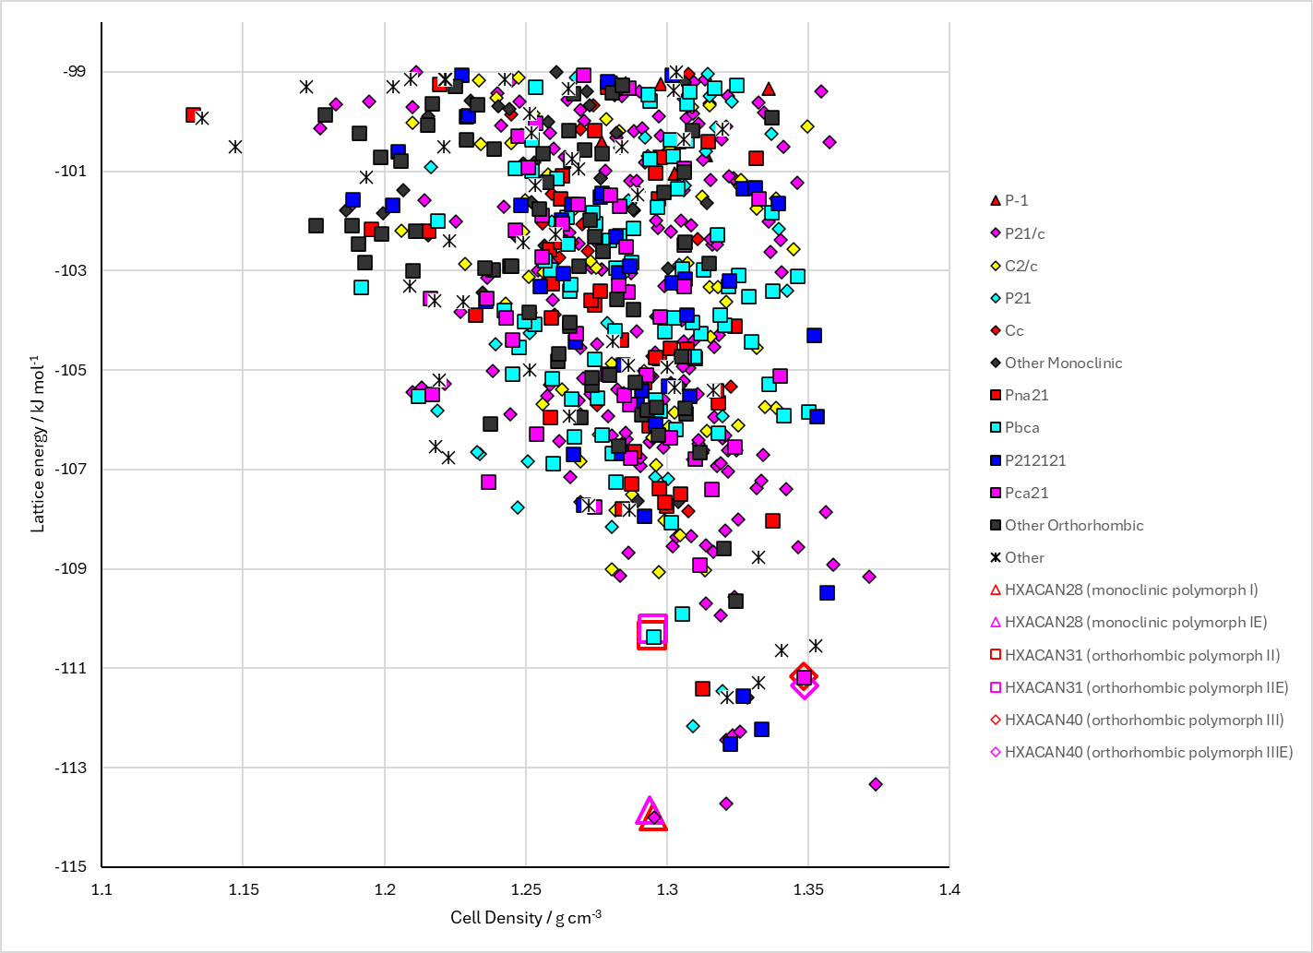
Figure 2. Crystal energy landscape of Paracetamol from previous work. Energy model = A1.

CSD structures (CSD version 6.01 with Feb 2026 update)

Table 1. Crystallographic information for CSD entries for Paracetamol. Different polymorphs are coloured differently.
REFCODE | space group | Z’ | a / Å | b / Å | c / Å | α / ° | β / ° | γ / ° | density / g cm⁻³ | Form
HXACAN | Pcab | 1.0 | 11.805 | 17.164 | 7.393 | 90.0 | 90.0 | 90.0 | 1.3405 | orthorhombic polymorph II
HXACAN01 | P21/a | 1.0 | 12.93 | 9.4 | 7.10000 | 90.0 | 115.90000 | 90.0 | 1.2934 | monoclinic polymorph I
HXACAN04 | P21/n | 1.0 | 7.09390 | 9.26250 | 11.657 | 90.0 | 97.672 | 90.0 | 1.3226 | monoclinic polymorph I
HXACAN06 | P21/a | 1.0 | 12.763 | 9.25 | 7.082 | 90.0 | 115.52 | 90.0 | 1.3307 | monoclinic polymorph I
HXACAN07 | P21/n | 1.0 | 7.0941 | 9.2322 | 11.6196 | 90.0 | 97.821 | 90.0 | 1.3317 | monoclinic polymorph I
HXACAN08 | Pbca | 1.0 | 17.1657 | 11.7773 | 7.212 | 90.0 | 90.0 | 90.0 | 1.3772 | orthorhombic polymorph II
HXACAN09 | P21/n | 1.0 | 6.98 | 8.91500 | 11.566 | 90.0 | 98.54 | 90.0 | 1.4106 | monoclinic polymorph I
HXACAN10 | P21/n | 1.0 | 6.88500 | 8.58190 | 11.519 | 90.0 | 99.12 | 90.0 | 1.4940 | monoclinic polymorph I
HXACAN11 | P21/n | 1.0 | 6.82 | 8.374 | 11.5590 | 90.0 | 99.320000 | 90.0 | 1.5412 | monoclinic polymorph I
HXACAN12 | P21/n | 1.0 | 6.625 | 7.985 | 11.916 | 90.0 | 99.41 | 90.0 | 1.6145 | monoclinic polymorph I
HXACAN13 | P21/a | 1.0 | 12.667 | 9.166 | 7.073 | 90.0 | 115.51000 | 90.0 | 1.3546 | monoclinic polymorph I
HXACAN14 | P21/a | 1.0 | 12.698 | 9.173 | 7.073 | 90.0 | 115.51000 | 90.0 | 1.3503 | monoclinic polymorph I
HXACAN15 | P21/a | 1.0 | 12.709 | 9.173 | 7.077 | 90.0 | 115.57000 | 90.0 | 1.3491 | monoclinic polymorph I
HXACAN16 | P21/a | 1.0 | 12.769 | 9.24 | 7.079 | 90.0 | 115.54000 | 90.0 | 1.3323 | monoclinic polymorph I
HXACAN17 | P21/a | 1.0 | 12.815 | 9.278 | 7.08400 | 90.0 | 115.57000 | 90.0 | 1.3214 | monoclinic polymorph I
HXACAN18 | P21/a | 1.0 | 12.833 | 9.315 | 7.086 | 90.0 | 115.60000 | 90.0 | 1.3143 | monoclinic polymorph I
HXACAN19 | P21/a | 1.0 | 12.872 | 9.37000 | 7.085 | 90.0 | 115.62 | 90.0 | 1.3030 | monoclinic polymorph I
HXACAN21 | Pcab | 1.0 | 7.19860 | 11.782 | 17.183 | 90.0 | 90.0 | 90.0 | 1.3778 | orthorhombic polymorph II
HXACAN22 | Pcab | 1.0 | 7.2927 | 11.8060 | 17.169 | 90.0 | 90.0 | 90.0 | 1.3584 | orthorhombic polymorph II
HXACAN23 | Pcab | 1.0 | 7.4057 | 11.837 | 17.162 | 90.0 | 90.0 | 90.0 | 1.3347 | orthorhombic polymorph II
HXACAN24 | Pcab | 1.0 | 7.48070 | 11.853 | 17.16 | 90.0 | 90.0 | 90.0 | 1.3197 | orthorhombic polymorph II
HXACAN25 | Pbca | 1.0 | 11.7636 | 7.28630 | 17.1041 | 90.0 | 90.0 | 90.0 | 1.3697 | orthorhombic polymorph II
HXACAN26 | P21/a | 1.0 | 12.8855 | 9.38013 | 7.10096 | 90.0 | 115.70020 | 90.0 | 1.2982 | monoclinic polymorph I
HXACAN27 | P21/n | 1.0 | 7.0915 | 9.2149 | 11.6015 | 90.0 | 97.865000 | 90.0 | 1.3369 | monoclinic polymorph I
HXACAN28 | P21/n | 1.0 | 7.077 | 9.173 | 11.574 | 90.0 | 97.9 | 90.0 | 1.3491 | monoclinic polymorph I
HXACAN29 | Pca21 | 2.0 | 11.8352 | 8.5601 | 14.8199 | 90.0 | 90.0 | 90.0 | 1.3374 | orthorhombic polymorph III
HXACAN30 | P21/n | 1.0 | 7.09070 | 9.21140 | 11.5972 | 90.0 | 97.844000 | 90.0 | 1.3380 | monoclinic polymorph I
HXACAN31 | Pbca | 1.0 | 11.7652 | 7.1877 | 17.1679 | 90.0 | 90.0 | 90.0 | 1.3831 | orthorhombic polymorph II
HXACAN32 | Pcab | 1.0 | 7.20280 | 11.7764 | 17.1677 | 90.0 | 90.0 | 90.0 | 1.3789 | orthorhombic polymorph II
HXACAN33 | Pbca | 1.0 | 11.8237 | 7.3971 | 17.1526 | 90.0 | 90.0 | 90.0 | 1.3385 | orthorhombic polymorph II
HXACAN34 | P21/n | 1.0 | 11.7143 | 9.38544 | 7.10166 | 90.0 | 82.587854 | 90.0 | 1.2967 | monoclinic polymorph I
HXACAN35 | P21/n | 1.0 | 7.06610 | 9.3366 | 11.6508 | 90.0 | 97.410000 | 90.0 | 1.3172 | monoclinic polymorph I
HXACAN36 | P21/n | 1.0 | 7.0842 | 9.1734 | 11.547 | 90.0 | 97.988 | 90.0 | 1.3511 | monoclinic polymorph I
HXACAN37 | Pbca | 1.0 | 11.7552 | 7.13941 | 17.1714 | 90.0 | 90.0 | 90.0 | 1.3934 | orthorhombic polymorph II
HXACAN38 | Pbca | 1.0 | 11.7678 | 7.1966 | 17.1615 | 90.0 | 90.0 | 90.0 | 1.3816 | orthorhombic polymorph II
HXACAN39 | Pc11 | 4.0 | 11.7545 | 8.57201 | 14.5155 | 84.16 | 90.0 | 90.0 | 1.3801 | monoclinic VI polymorph
HXACAN40 | Pca21 | 2.0 | 11.8376 | 8.56880 | 14.8183 | 90.0 | 90.0 | 90.0 | 1.3359 | orthorhombic polymorph III
HXACAN41 | Pcab | 1.0 | 7.232 | 11.76 | 17.16 | 90.0 | 90.0 | 90.0 | 1.3759 | orthorhombic polymorph II
HXACAN42 | Pcab | 1.0 | 7.232 | 11.76 | 17.16 | 90.0 | 90.0 | 90.0 | 1.3759 | orthorhombic polymorph II
HXACAN43 | P21/n | 1.0 | 6.63 | 8.62000 | 10.7900 | 90.0 | 97.56 | 90.0 | 1.6424 | monoclinic polymorph I
HXACAN44 | Pbca | 1.0 | 17.1202 | 11.7968 | 7.288 | 90.0 | 90.0 | 90.0 | 1.3642 | orthorhombic polymorph II
HXACAN45 | Pbca | 1.0 | 17.143 | 11.8060 | 7.399 | 90.0 | 90.0 | 90.0 | 1.3409 | orthorhombic polymorph II
HXACAN46 | Pbca | 1.0 | 17.1522 | 11.8201 | 7.3985 | 90.0 | 90.0 | 90.0 | 1.3387 | orthorhombic polymorph II
HXACAN47 | Pna21 | 2.0 | 16.8443 | 9.48219 | 9.14187 | 90.0 | 90.0 | 90.0 | 1.3752 | orthorhombic VII polymorph
HXACAN48 | P21/n | 1.0 | 7.125 | 9.22 | 11.6000 | 90.0 | 98.130000 | 90.0 | 1.3309 | monoclinic polymorph I
HXACAN49 | P21/n | 1.0 | 7.08950 | 9.21120 | 11.5966 | 90.0 | 97.89 | 90.0 | 1.3385 | monoclinic polymorph I
HXACAN50 | P21/n | 1.0 | 7.06000 | 9.18 | 11.61 | 90.0 | 97.22 | 90.0 | 1.3450 | monoclinic polymorph I
HXACAN51 | P21/n | 1.0 | 7.06000 | 9.18 | 11.61 | 90.0 | 97.22 | 90.0 | 1.3450 | monoclinic polymorph I
HXACAN52 | P21/n | 1.0 | 7.0913 | 9.22060 | 11.5958 | 90.0 | 97.739 | 90.0 | 1.3364 | monoclinic polymorph I
HXACAN53 | P21/n | 1.0 | 7.086 | 9.20460 | 11.587 | 90.0 | 97.93 | 90.0 | 1.3413 | monoclinic polymorph I
HXACAN54 | P21/n | 1.0 | 7.09120 | 9.2065 | 11.5926 | 90.0 | 97.901 | 90.0 | 1.3393 | monoclinic polymorph I
HXACAN57 | P21/n | 1.0 | 7.06570 | 9.1935 | 11.493 | 90.0 | 98.64 | 90.0 | 1.3603 | monoclinic polymorph I
HXACAN58 | P21/n | 1.0 | 7.344 | 9.645 | 12.087 | 90.0 | 97.370000 | 90.0 | 1.1825 | monoclinic polymorph I
HXACAN61 | Pbca | 1.0 | 11.818 | 7.3985 | 17.139 | 90.0 | 90.0 | 90.0 | 1.3400 | orthorhombic polymorph II
HXACAN62 | P21/n | 1.0 | 6.96200 | 9.177 | 11.5564 | 90.0 | 98.820000 | 90.0 | 1.3761 | None
HXACAN63 | P21/n | 1.0 | 7.0781 | 9.1934 | 11.5751 | 90.0 | 97.852 | 90.0 | 1.3456 | None
HXACAN64 | P21/n | 1.0 | 7.096 | 9.24410 | 11.6342 | 90.0 | 97.787 | 90.0 | 1.3278 | monoclinic polymorph I
HXACAN65 | Pbca | 1.0 | 11.772 | 7.2389 | 17.1686 | 90.0 | 90.0 | 90.0 | 1.3725 | orthorhombic polymorph II
HXACAN66 | P21/n | 1.0 | 7.091 | 9.20070 | 11.5907 | 90.0 | 97.937 | 90.0 | 1.3405 | monoclinic polymorph I
Note that HXACAN39 and HXACAN40 overlay 20 molecules in Mercury.
Table 2. Experimental information for CSD entries for Paracetamol.
REFCODE | space group | R factor | T / K | Year | Comments
HXACAN | Pcab | 7.7 | None | 1974 | 10.1107/S0567740874007473
HXACAN01 | P21/a | 7.2 | None | 1976 | 10.1107/S0567740876012223
HXACAN04 | P21/n | 5.55 | at 150 K | 1998 | 10.1107/S0108270197018386
HXACAN06 | P21/a | 6.3 | at 100 K | 1997 | 10.1016/S0022-2860(96)09593-2
HXACAN07 | P21/n | 3.33 | at 123 K | 1998 | 10.1021/js970483d
HXACAN08 | Pbca | 4.23 | at 123 K | 1998 | 10.1021/js970483d
HXACAN09 | P21/n | 3.52 | None | 2000 | 10.1107/S0108768199013634
HXACAN10 | P21/n | 3.25 | None | 2000 | 10.1107/S0108768199013634
HXACAN11 | P21/n | 3.08 | None | 2000 | 10.1107/S0108768199013634
HXACAN12 | P21/n | 3.12 | None | 2000 | 10.1107/S0108768199013634
HXACAN13 | P21/a | 6.7 | at 20 K | 2000 | 10.1524/zkri.2000.215.11.693
HXACAN14 | P21/a | 5.4 | at 50 K | 2000 | 10.1524/zkri.2000.215.11.693
HXACAN15 | P21/a | 7.8 | at 80 K | 2000 | 10.1524/zkri.2000.215.11.693
HXACAN16 | P21/a | 6.7 | at 150 K | 2000 | 10.1524/zkri.2000.215.11.693
HXACAN17 | P21/a | 6.8 | at 200 K | 2000 | 10.1524/zkri.2000.215.11.693
HXACAN18 | P21/a | 6.7 | at 250 K | 2000 | 10.1524/zkri.2000.215.11.693
HXACAN19 | P21/a | 7.100 | at 330 K | 2000 | 10.1524/zkri.2000.215.11.693
HXACAN21 | Pcab | 4.83 | at 100 K | 2004 | 10.1524/zkri.219.8.506.38329
HXACAN22 | Pcab | 5.62 | at 200 K | 2004 | 10.1524/zkri.219.8.506.38329
HXACAN23 | Pcab | 5.98 | at 300 K | 2004 | 10.1524/zkri.219.8.506.38329
HXACAN24 | Pcab | 8.290 | at 360 K | 2004 | 10.1524/zkri.219.8.506.38329
HXACAN25 | Pbca | 4.12 | at 220 K | 2005 | None
HXACAN26 | P21/a | None | None | 2009 | 10.1107/S0021889809008450
HXACAN27 | P21/n | 1.8 | at 100 K | 2009 | 10.1107/S0108768109008271
HXACAN28 | P21/n | 1.6 | at 85 K | 2009 | 10.1107/S0108767309031729
HXACAN29 | Pca21 | 11.9 | at 300 K | 2009 | 10.1039/b822882e
HXACAN30 | P21/n | 2.0 | at 100 K | 2010 | 10.1039/b927429d
HXACAN31 | Pbca | 1.8 | at 100 K | 2010 | 10.1039/b927429d
HXACAN32 | Pcab | 4.71 | at 100 K | 2011 | 10.1021/cg2002018
HXACAN33 | Pbca | 3.99 | at 293 K | 2012 | 10.1107/S0108768111046295
HXACAN34 | P21/n | 14.09 | 298 K | 2014 | 10.1107/S1600576714003379
HXACAN35 | P21/n | 4.35 | 293 K | 2015 | 10.1016/j.saa.2015.05.091
HXACAN36 | P21/n | 4.05 | 20 K | 2015 | None
HXACAN37 | Pbca | 3.869 | 20 K | 2015 | None
HXACAN38 | Pbca | 3.860 | 100.0 K | 2018 | 10.1039/C8CE00272J
HXACAN39 | Pc11 | 4.46 | 100 K | 2018 | 10.1107/S2053229618002619
HXACAN40 | Pca21 | 3.070 | 293 K | 2018 | 10.1107/S2053229618002619
HXACAN41 | Pcab | 8.89 | 100 K | 2017 | 10.1126/science.aak9652
HXACAN42 | Pcab | 9.06 | 100 K | 2017 | 10.1126/science.aak9652
HXACAN43 | P21/n | 20.53 | 293 K | 2018 | 10.1021/acscentsci.8b00760
HXACAN44 | Pbca | 5.79 | 296.1 K | 2019 | 10.1039/C9CE00365G
HXACAN45 | Pbca | 6.83 | 296.1 K | 2019 | 10.1039/C9CE00365G
HXACAN46 | Pbca | 4.479 | 296.1 K | 2019 | 10.1039/C9CE00365G
HXACAN47 | Pna21 | 1.52 | 200 K | 2019 | 10.1021/acs.cgd.9b00473
HXACAN48 | P21/n | 6.41 | 10 K | 2014 | 10.1515/ncrs-2014-0032
HXACAN49 | P21/n | 4.24 | 100.0 K | 2020 | 10.1039/D0CC03157G
HXACAN50 | P21/n | 20.7 | 100 K | 2019 | 10.1021/acs.analchem.9b01162
HXACAN51 | P21/n | 20.52 | 100 K | 2019 | 10.1021/acs.analchem.9b01162
HXACAN52 | P21/n | 5.800 | 100 K | 2021 | 10.1007/s10870-020-00867-w
HXACAN53 | P21/n | 7.359 | 100 K | 2021 | None
HXACAN54 | P21/n | 4.95 | 100.0 K | 2021 | None
HXACAN57 | P21/n | 22.36 | 79.2 K | 2021 | 10.3389/fmolb.2021.648603
HXACAN58 | P21/n | 12.02 | 293 K | 2021 | 10.1039/D1CE01172C
HXACAN61 | Pbca | 3.49 | 293 K | 2023 | None
HXACAN62 | P21/n | 26.46 | 100 K | 2018 | 10.1002/anie.201811318
HXACAN63 | P21/n | 3.36 | 100 K | 2022 | None
HXACAN64 | P21/n | 3.95 | 150.2 K | 2024 | None
HXACAN65 | Pbca | 3.699 | 150.2 K | 2024 | None
HXACAN66 | P21/n | 5.149 | 100 K | 2021 | 10.1007/s10870-020-00867-w

Make this table include whether polymorphs are solution-grown, sublimation grown, templated or otherwise. Add references.

Other notes

