Sulfamerazine
(Last updated January 2026)
Figure 1. The molecular diagram of Sulfamerazine.

CSP studies
REFCODE | SLFNMA
Formula | C11 H12 N4 O2 S1
Common Name | Sulfamerazine
IUPAC Systematic Name | 4-Amino-N-(4-methylpyrimidin-2-yl)-benzenesulfonamide
Other Names
CSD Refcodes | SLFNMA02, SLFNMA01, SLFNMA03, SLFNMA06, SLFNMA07
Search Identifier | A
Scientist | William Wood
Date | April 2023
Publication | In preparation
Energy model | 2
Study_ID | 10
Programs | Study_ID=20, CrystalOptimizer (2.4.7.1), DMACRYS (2.3.1.1)
Location on S Drive | \CHEMISTRY_CPOSS\Sulfamerazine\CrystOpt\
Potential Description | CrystalOptimizer with GDMA2.2(PBE0/6-31G(d,p)) + FIT + Scheraga SO2
Intramolecular Description | PBE0/6-31G(d,p)
Energy model | 1
Study_ID | 20
Programs | CrystalPredictor (2.4.3), DMACRYS (2.3.1.1)
Location on S Drive | \CHEMISTRY_CPOSS\Sulfamerazine\CrystPred\
Potential Description | CrystalPredictor2.4.3.2(torsion groups) + DMACRYS with GDMA2.2(PBE0/6-31G(d,p)) + FIT + Scheraga SO2
Intramolecular Description | PBE0/6-31G(d,p)

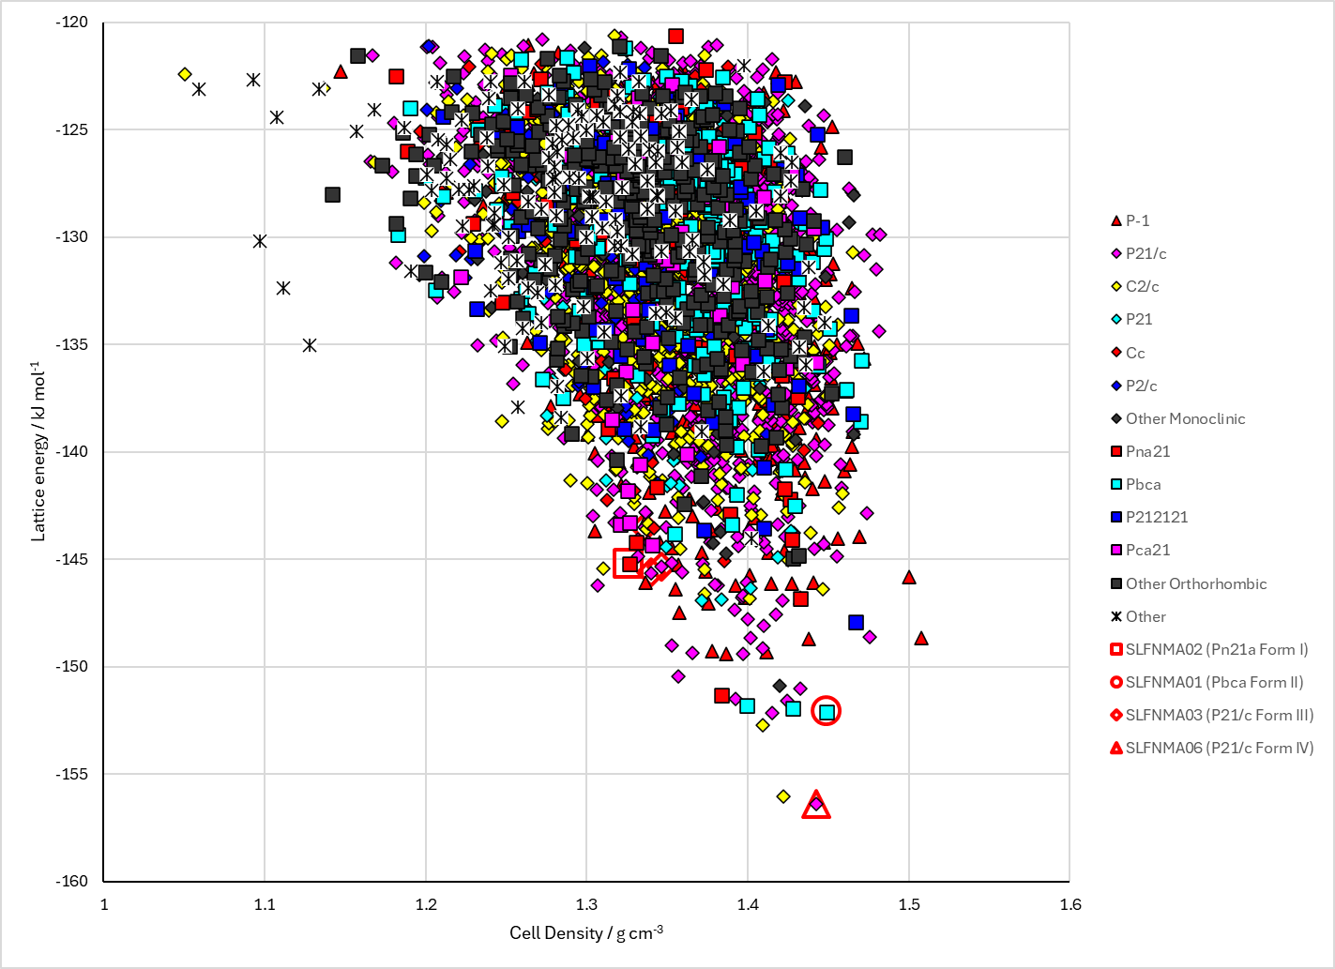 | 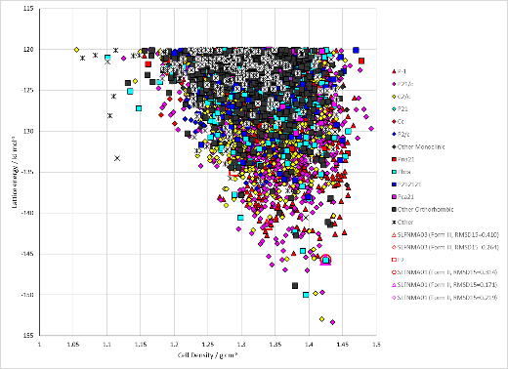
 | 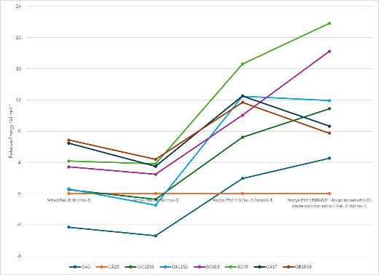
Figure 2. Crystal energy landscape of Sulfamerazine from previous work. Left: Following CrystalOptimizer refinement, Top Right: Following CrystalPredictor (Study_ID=20), Bottom Right: Energy comparisons with DFT.

CSD structures (CSD version 5.44 with Apr, Jun and Sep 2023 updates)
Table 1. Crystallographic information for CSD entries for Sulfamerazine. Different polymorphs are coloured differently.
REFCODE | space group | Z’ | a / Å | b / Å | c / Å | α / ° | β / ° | γ / ° | density / g cm⁻³ | Form
SLFNMA | Pca21 | 2 | 14.65 | 8.1 | 22.12 | 90 | 90 | 90 | 1.338 | Pca21
SLFNMA01 | Pbca | 1 | 9.145 | 11.704 | 22.884 | 90 | 90 | 90 | 1.433 | Pbca Form II
SLFNMA02 | Pn21a | 2 | 14.474 | 21.953 | 8.203 | 90 | 90 | 90 | 1.347 | Pn21a Form I
SLFNMA03 | P21/c | 1 | 11.0966 | 8.3152 | 13.964 | 90 | 99.327 | 90 | 1.381 | P21/c Form III
SLFNMA04 | Pna21 | 2 | 14.4773 | 8.187 | 21.7976 | 90 | 90 | 90 | 1.359 | Pna21 Form I
SLFNMA05 | Pbca | 1.0 | 9.10090 | 11.5490 | 22.8738 | 90.0 | 90.0 | 90.0 | 1.4604 | Pbca Form II
SLFNMA06 | P21/c | 1.0 | 12.571 | 6.367 | 16.175 | 90.0 | 110.215 | 90.0 | 1.4450 | P21/c Form IV
SLFNMA07 | P21/c | 2 | 22.7116 | 8.1883 | 14.4563 | 90 | 106.631 | 90 | 1.363 | P21/c Form V

Table 2. Experimental information for CSD entries for Sulfamerazine.
REFCODE | space group | R factor | T / K | Year | Comments
SLFNMA | Pca21 | 0 | RT | 1980 | Probably disordered, no coordinates. Journal not online.
SLFNMA01 | Pbca | 7.8 | RT | 1982 | Slow evaporation from acetone. Form II.¹
SLFNMA02 | Pn21a | 4.7 | RT | 1992 | Crystallization from dry methanol. Form I.  (also crystallized Pbca form from acetonitrile)²
SLFNMA03 | P21/c | 5.34 | 150 | 2006 | Slow evaporation from DMF at room temperature³
SLFNMA04 | Pna21 | 3.99 | 150 | 2015 | Private communication, recrystallization from ethanol
SLFNMA05 | Pbca | 4.77 | 293 K | 2024 | 10.1007/s13738-024-03110-x
SLFNMA06 | P21/c | 4.65 | 293 K | 2024 | 10.1007/s13738-024-03110-x
SLFNMA07 | P21/c | 5.37 | 150 | 2025 | Re-crystallisation from solvent: MeCN:H2O (80:20, v:v), 10.1021/acs.cgd.5c01406

Make this table include whether polymorphs are solution-grown, sublimation grown, templated or otherwise. Add references.

Other notes

1. K. Ravindra Acharya, K. N. Kuchela and G. Kartha, Journal of Crystallographic and Spectroscopic Research, 1982, 12, 369-376.
2. M. R. Caria and R. Mohamed, Acta Crystallographica Section B, 1992, 48, 492-498.
3. G. Hossain, Acta Crystallographica Section E, 2006, 62, o2166-o2167.

