6-methoxycoumarin
(Last updated May 2026)
Figure 1. The molecular diagram of 6-methoxycoumarin.

CSP studies
REFCODE | DAXBIN
Formula | C10 H8 O3
Common Name | 6-Methoxy-coumarin
IUPAC Systematic Name | 6-Methoxy-chromen-2-one
Other Names
CSD Refcodes | DAXBIN01
Search Identifier | A
Scientist | Ashley Hulme
Date | pre-2010
Publication | No publication planned.
Energy model | 1
Study_ID | 0
Programs | MOLPAK, DMAREL (4.1.1)
Location on S Drive | \CHEMISTRY_CPOSS\0-EarlySearches\home\louise_price.eminerals\6-methoxycoumarin
Potential Description | FIT potential
Intramolecular Description | MP2/6-31G(d,p)

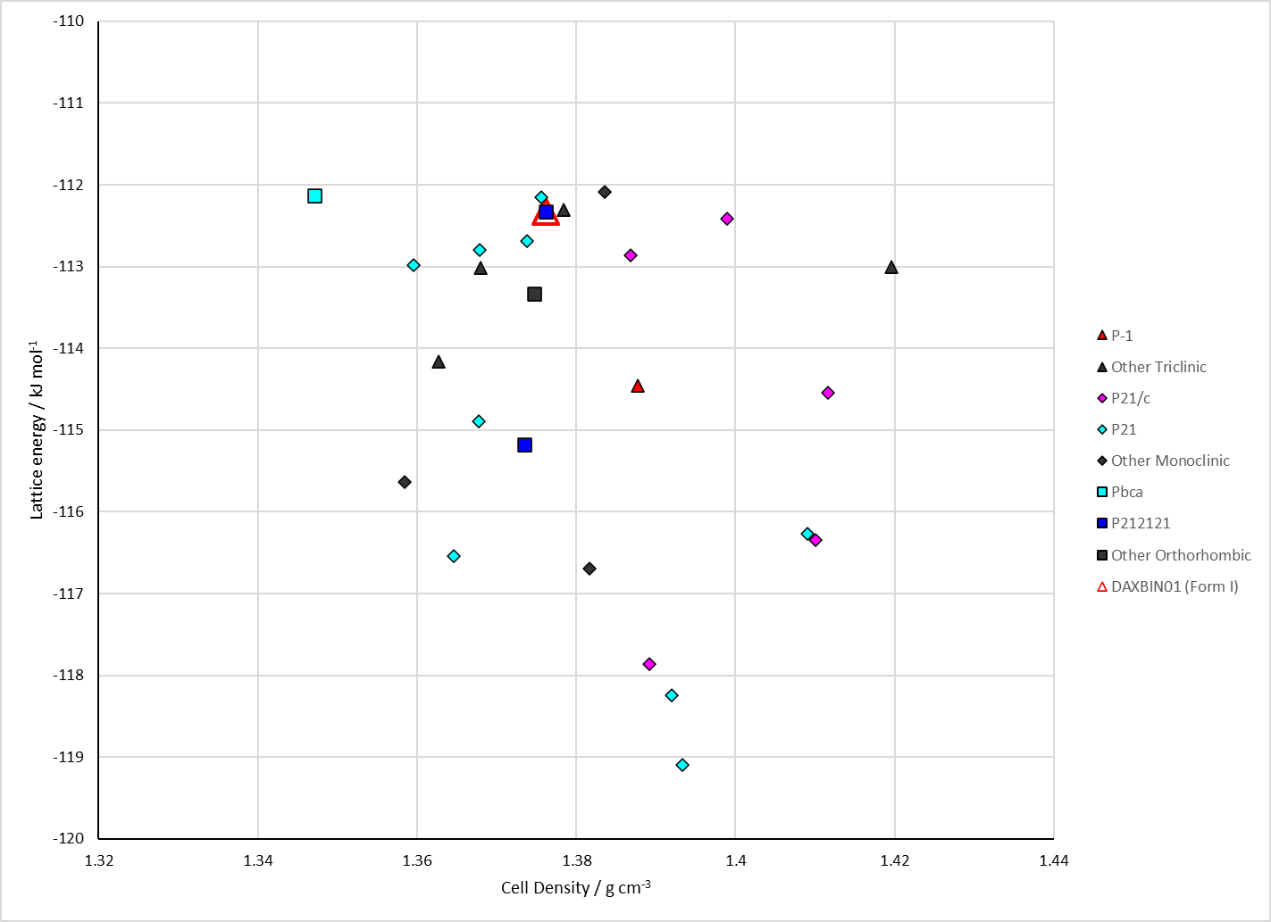
Figure 2. Crystal energy landscape of 6-methoxycoumarin from previous work.

CSD structures (CSD version 6.01 with Feb 2026 update)

Table 1. Crystallographic information for CSD entries for 6-methoxycoumarin. Different polymorphs are coloured differently.
REFCODE | space group | Z’ | a / Å | b / Å | c / Å | α / ° | β / ° | γ / ° | density / g cm⁻³ | Form
DAXBIN01 | Pnma | 0.5 | 6.771 | 6.454 | 18.797 | 90.0 | 90.0 | 90.0 | 1.4245 | None

Table 2. Experimental information for CSD entries for 6-methoxycoumarin.
REFCODE | space group | R factor | T / K | Year | Comments
DAXBIN01 | Pnma | 4.14 | at 203K | 2002 | 10.1021/cg010036i

Make this table include whether polymorphs are solution-grown, sublimation grown, templated or otherwise. Add references.

Other notes

