6-methyluracil
(Last updated May 2026)
Figure 1. The molecular diagram of 6-methyluracil.

CSP studies
REFCODE | CEWVOP
Formula | C5 H6 N2 O2
Common Name | 6-methyluracil
IUPAC Systematic Name | 2,4-dihydroxy-6-methylpyrimidine
Other Names
CSD Refcodes | CEWVOP01, CEWVOP03, CEWVOP06
Search Identifier | A
Scientist | Tom Lewis
Date | 2004
Publication | No publication planned.
Energy model | 1
Study_ID | 0
Programs | MOLPAK, DMAREL (3.0)
Location on S Drive | \CHEMISTRY_CPOSS\0-EarlySearches\home\louise_price.eminerals\6-methyluracil
Potential Description | DMA + FIT
Intramolecular Description | MP2/6-31G(d,p)

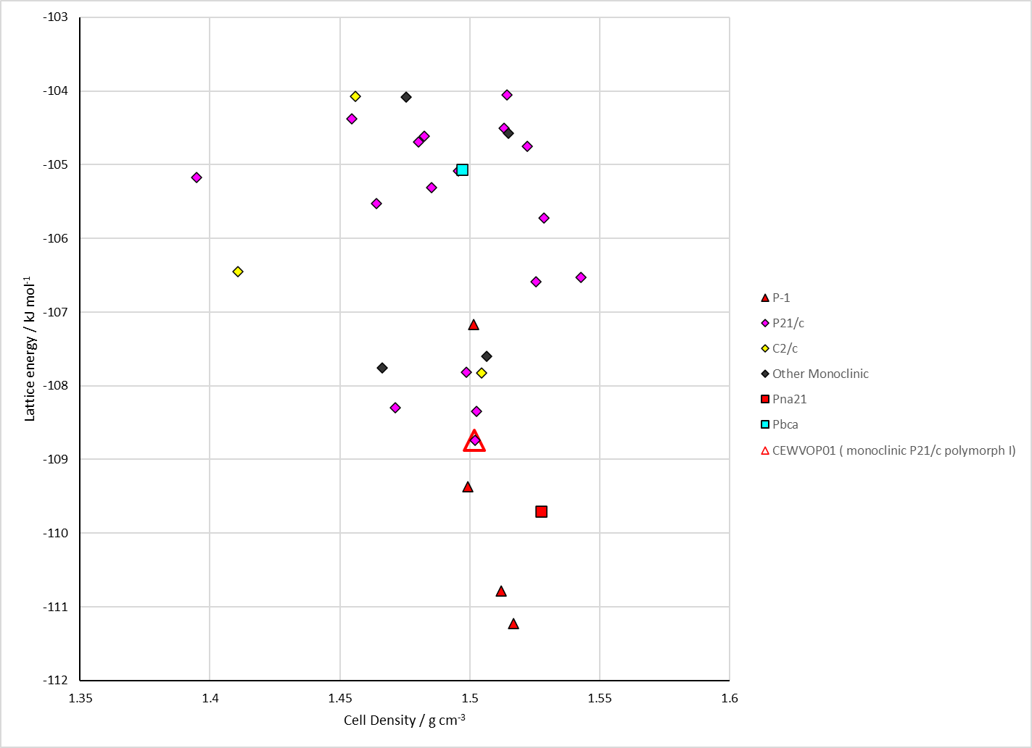
Figure 2. Crystal energy landscape of 6-methyluracil from previous work.

CSD structures (CSD version 6.01 with Feb 2026 update)
Form III (CEWVOP05) overlays 20 out of 20 molecules with Form I (CEWVOP01).
Table 1. Crystallographic information for CSD entries for 6-methyluracil. Different polymorphs are coloured differently.
REFCODE | space group | Z’ | a / Å | b / Å | c / Å | α / ° | β / ° | γ / ° | density / g cm⁻³ | Form
CEWVOP01 | P21/c | 1.0 | 4.5137 | 10.9888 | 11.7224 | 90.0 | 97.554 | 90.0 | 1.4532 | monoclinic P21/c form I
CEWVOP02 | C2/c | 1.0 | 20.5830 | 3.9091 | 14.804 | 90.0 | 110.88 | 90.0 | 1.5053 | monoclinic C2/c form II
CEWVOP03 | C2/c | 1.0 | 20.572 | 3.90520 | 14.811 | 90.0 | 110.95 | 90.0 | 1.5076 | monoclinic C2/c form II
CEWVOP04 | P21/c | 1.0 | 4.5194 | 10.9811 | 11.7294 | 90.0 | 97.75 | 90.0 | 1.4522 | monoclinic P21/c form I
CEWVOP05 | P21/c | 1.0 | 4.6081 | 10.767 | 11.881 | 90.0 | 99.76 | 90.0 | 1.4418 | monoclinic P21/c form III
CEWVOP06 | P21/c | 2.0 | 9.38740 | 11.6695 | 11.3883 | 90.0 | 112.516 | 90.0 | 1.4537 | monoclinic P21/c form IV
CEWVOP07 | C2/c | 1.0 | 20.537 | 3.9108 | 14.801 | 90.0 | 110.97200 | 90.0 | 1.5092 | monoclinic C2/c form II

Table 2. Experimental information for CSD entries for 6-methyluracil.
REFCODE | space group | R factor | T / K | Year | Comments
CEWVOP01 | P21/c | 4.0 | at 297 K | 1988 | 10.1107/S0108767388000315
CEWVOP02 | C2/c | 8.5 | at 295 K | 1993 | None
CEWVOP03 | C2/c | 4.83 | 298 K | 2019 | 10.1107/S2414314619008617
CEWVOP04 | P21/c | 7.149 | 293.1 K | 2023 | 10.1021/acsomega.3c01231
CEWVOP05 | P21/c | 8.16 | 293.1 K | 2023 | 10.1021/acsomega.3c01231
CEWVOP06 | P21/c | 8.05 | 293.1 K | 2023 | 10.1021/acsomega.3c01231
CEWVOP07 | C2/c | 8.53 | 293.1 K | 2023 | 10.1021/acsomega.3c01231

Make this table include whether polymorphs are solution-grown, sublimation grown, templated or otherwise. Add references.

Other notes

