1-benzyl-1H-tetrazole
(Last updated June 2026)
Figure 1. The molecular diagram of 1-benzyl-1H-tetrazole.

CSP studies
REFCODE | ZECWOV
Formula | C8 H8 N4
Common Name | 1-benzyl-1H-tetrazole
IUPAC Systematic Name | 1-benzyl-1H-tetrazole
Other Names
CSD Refcodes | ZECWOV
Search Identifier | A
Scientist | Ogaga Uzoh
Date | 2012
Publication | Spencer J, Patel H, Deadman JJ, Palmer RA, Male L, Coles SJ, Uzoh OG, Price SL 2012. CrystEngComm. 2012, 14, (20), 6441-6446.
Energy model | 2
Study_ID | 30
Programs | Study_ID=10, DMACRYS (2.0.8)
Location on S Drive | \CHEMISTRY_CPOSS\BenzylTetrazole\PCM
Potential Description | GDMA2.2(PCMdielectric3(PBE1PBE/6-31+G(d))) + FIT
Intramolecular Description | PBE1PBE/6-31+G(d)
Energy model | 1
Study_ID | 10
Programs | CrystalPredictor, CrystalOptimizer, DMACRYS (2.0.8)
Location on S Drive | \CHEMISTRY_CPOSS\BenzylTetrazole\CrystOpt
Potential Description | CrystalOptimizer PBE1PBE/6-31G(d,p) intramolecular + GDMA2.2(PBE1PBE/6-31G(d,p)) DMA + FIT
Intramolecular Description | PBE0/6-31G(d,p)

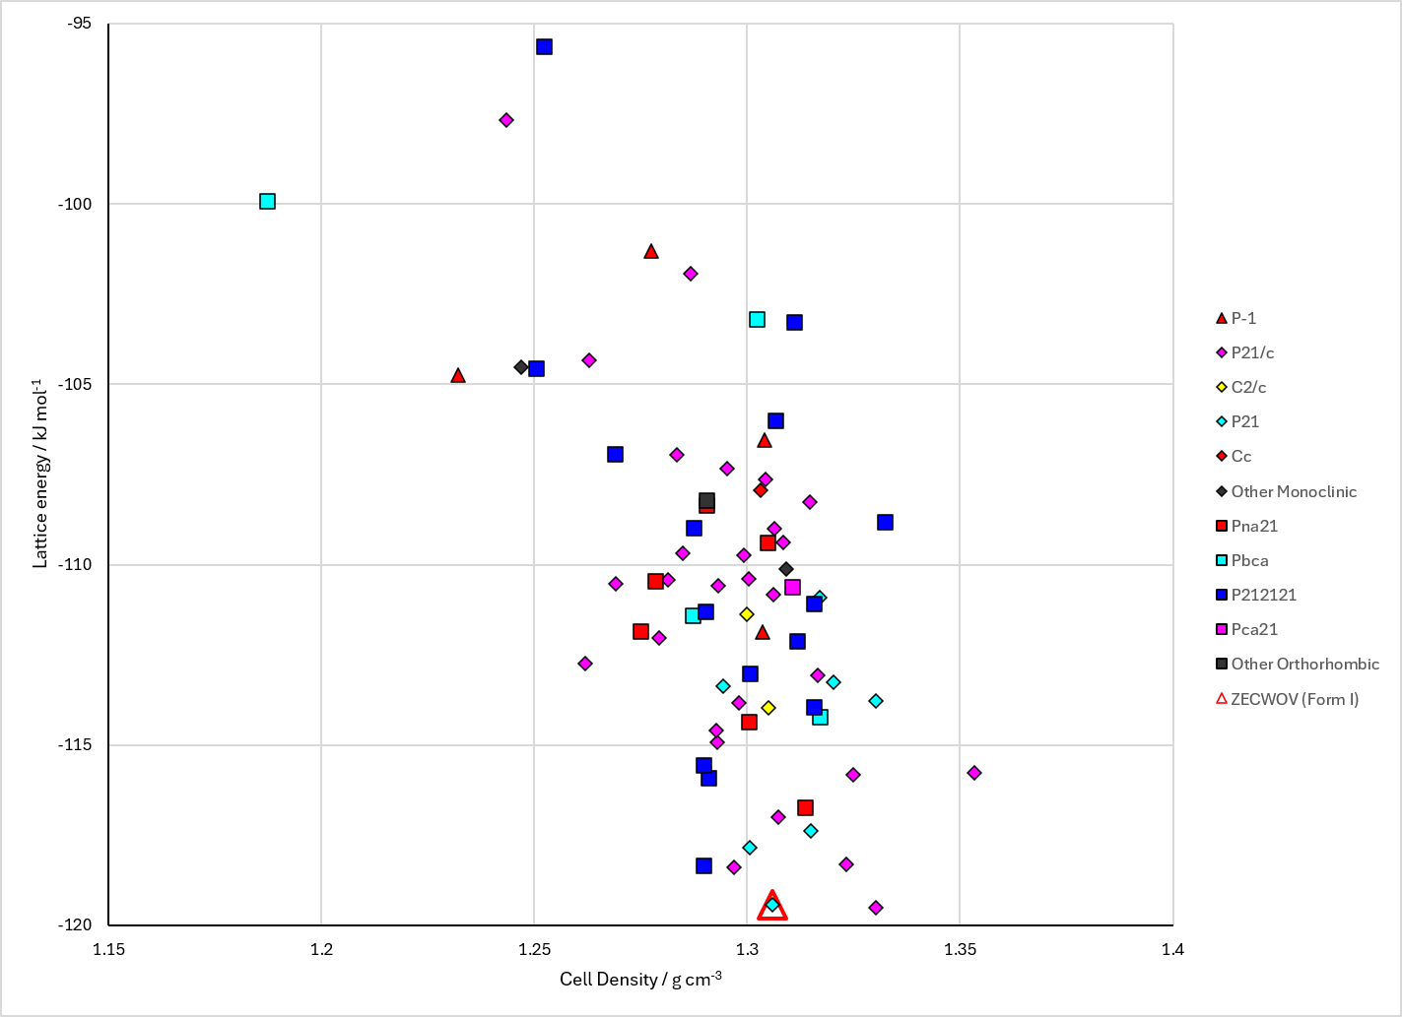
Figure 2. Crystal energy landscape of 1-benzyl-1H-tetrazole from previous work. Energy model A2.

CSD structures (CSD version 6.01 with Feb 2026 update)

Table 1. Crystallographic information for CSD entries for 1-benzyl-1H-tetrazole. Different polymorphs are coloured differently.
REFCODE | space group | Z’ | a / Å | b / Å | c / Å | α / ° | β / ° | γ / ° | density / g cm⁻³ | Form
ZECWOV | P21 | 1.0 | 7.6843 | 5.57940 | 9.4459 | 90.0 | 100.949 | 90.0 | 1.3378 | None

Table 2. Experimental information for CSD entries for 1-benzyl-1H-tetrazole.
REFCODE | space group | R factor | T / K | Year | Comments
ZECWOV | P21 | 4.47 | at 120 K | 2012 | 10.1039/c2ce25940k

Make this table include whether polymorphs are solution-grown, sublimation grown, templated or otherwise. Add references.

Other notes

