Diaminodinitropyrazine
(Last updated May 2026)
Figure 1. The molecular diagram of Diaminodinitropyrazine.

CSP studies
REFCODE | CIWMAW
Formula | C4 H4 N6 O4
Common Name | 2,6-diamino-3,5-dinitro pyrazine
IUPAC Systematic Name | 3,5-Dinitro-pyrazine-2,6-diamine
Other Names | 2,6-dinitro-3,5-diamino-1,4-diazabenzene; 2,6-dinitro-3,5-diamino-1,4-pyrazine
CSD Refcodes | CIWMAW01
Search Identifier | A
Scientist | Binal Patel / Tom Lewis
Date | 2004
Publication | Price, S. L., Patel, B., Pridhanani-Jethani, P., Torrisi, A., Trans. ACA, 39(2), 1-12 (2004)
Energy model | 1
Study_ID | 0
Programs | MOLPAK, DMAREL (3.0)
Location on S Drive | \CHEMISTRY_CPOSS\0-EarlySearches\home\louise_price.eminerals\diamino_dinitro_pyrazine
Potential Description | DMA + FIT
Intramolecular Description | MP2/6-31G(d,p)

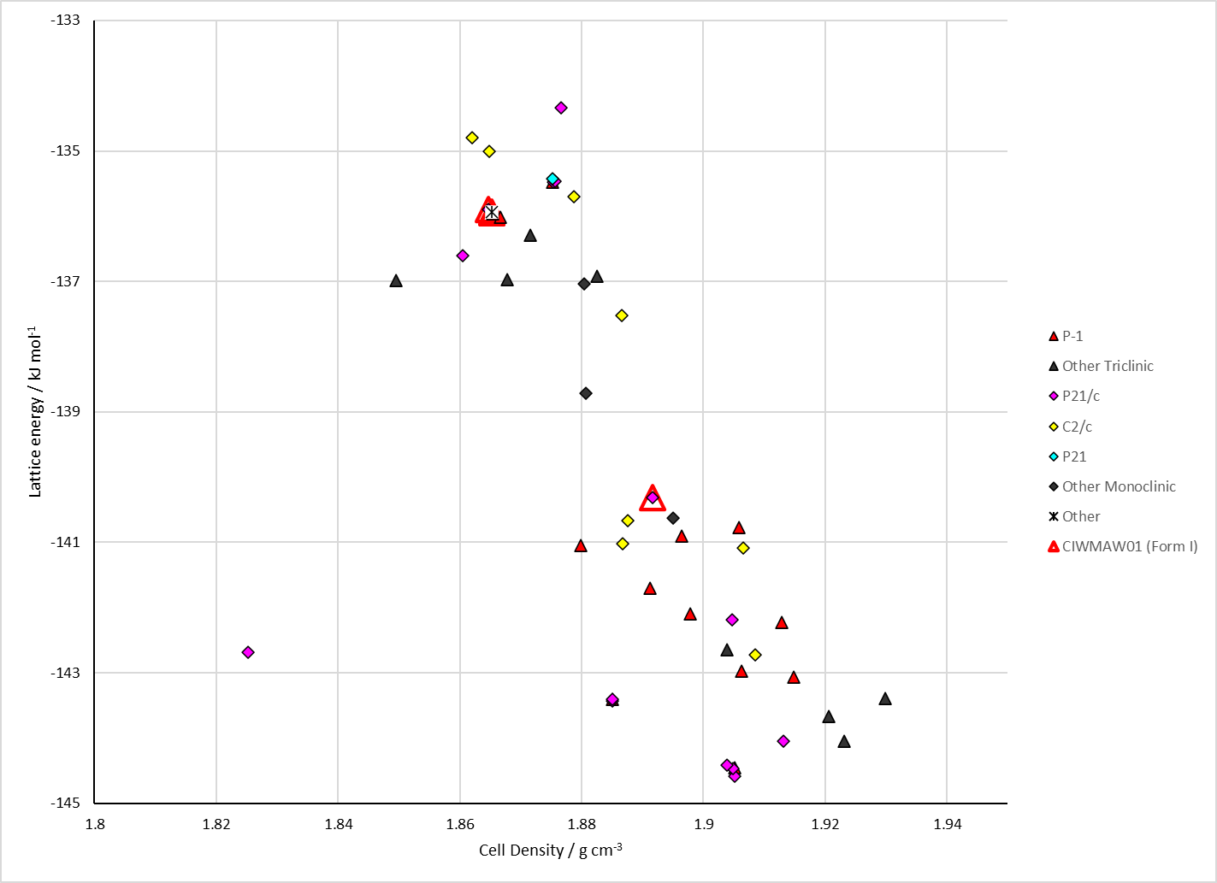
Figure 2. Crystal energy landscape of Diaminodinitropyrazine from previous work.

CSD structures (CSD version 6.01 with Feb 2026 update)

Table 1. Crystallographic information for CSD entries for Diaminodinitropyrazine. Different polymorphs are coloured differently.
REFCODE | space group | Z’ | a / Å | b / Å | c / Å | α / ° | β / ° | γ / ° | density / g cm⁻³ | Form
CIWMAW01 | P21/c | 1.0 | 9.0136 | 12.96 | 6.3936 | 90.0 | 100.77000 | 90.0 | 1.8115 | None

Table 2. Experimental information for CSD entries for Diaminodinitropyrazine.
REFCODE | space group | R factor | T / K | Year | Comments
CIWMAW01 | P21/c | 6.42 | at 294 K | 2001 | 10.1107/S1600536801011734

Make this table include whether polymorphs are solution-grown, sublimation grown, templated or otherwise. Add references.

Other notes

