Imidazole
(Last updated May 2026)
Figure 1. The molecular diagram of Imidazole.

CSP studies
REFCODE | IMAZOL
Formula | C3 H4 N2
Common Name | Imidazole
IUPAC Systematic Name | Imidazole
Other Names
CSD Refcodes | IMAZOL06, IMAZOL25
Search Identifier | A
Scientist | Antonio Torrisi
Date | 2004
Publication | Price, S. L., Patel, B., Pridhanani-Jethani, P., Torrisi, A., Trans. ACA, 39(2), 1-12 (2004)
Energy model | 1
Study_ID | 0
Programs | MOLPAK, DMAREL (3.0)
Location on S Drive | \CHEMISTRY_CPOSS\0-EarlySearches\home\louise_price.eminerals\imidazole
Potential Description | DMA + FIT
Intramolecular Description | MP2/6-31G(d,p)

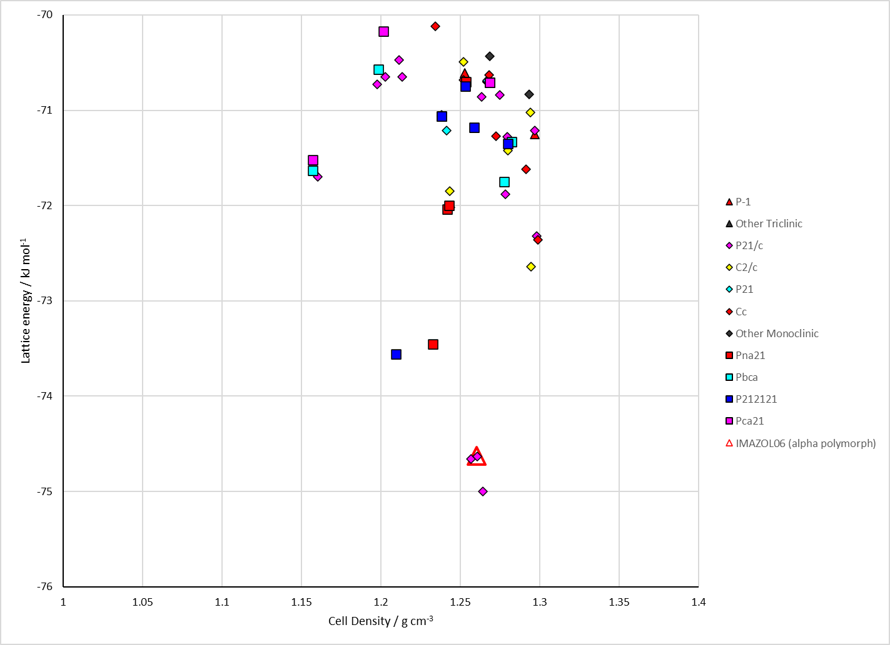
Figure 2. Crystal energy landscape of Imidazole from previous work.

CSD structures (CSD version 6.01 with Feb 2026 update)

Table 1. Crystallographic information for CSD entries for Imidazole. Different polymorphs are coloured differently.
REFCODE | space group | Z’ | a / Å | b / Å | c / Å | α / ° | β / ° | γ / ° | density / g cm⁻³ | Form
IMAZOL01 | P21/c | 1.0 | 7.582 | 5.371 | 9.79000 | 90.0 | 61.020000 | 90.0 | 1.2965 | alpha polymorph
IMAZOL02 | P21/c | 1.0 | 7.746 | 5.447 | 9.75 | 90.0 | 117.5 | 90.0 | 1.2392 | alpha polymorph
IMAZOL03 | P21/n | 1.0 | 7.583 | 5.37400 | 9.02700 | 90.0 | 108.71000 | 90.0 | 1.2977 | alpha polymorph
IMAZOL04 | P21/c | 1.0 | 7.582 | 5.371 | 9.79000 | 90.0 | 118.98 | 90.0 | 1.2965 | alpha polymorph
IMAZOL06 | P21/c | 1.0 | 7.569 | 5.36600 | 9.785 | 90.0 | 119.08 | 90.0 | 1.3018 | alpha polymorph
IMAZOL10 | P21/c | 1.0 | 7.7 | 5.43 | 9.73 | 90.0 | 117.33 | 90.0 | 1.2511 | alpha polymorph
IMAZOL13 | P21/c | 1.0 | 7.732 | 5.458 | 9.779 | 90.0 | 117.26 | 90.0 | 1.2325 | alpha polymorph
IMAZOL14 | P21/n | 1.0 | 7.604 | 5.383 | 9.05600 | 90.0 | 108.876 | 90.0 | 1.2891 | alpha polymorph
IMAZOL15 | P21/c | 1.0 | 7.68 | 5.37900 | 9.773 | 90.0 | 118.29000 | 90.0 | 1.2719 | alpha polymorph
IMAZOL16 | P21/c | 1.0 | 7.577 | 5.282 | 9.727 | 90.0 | 119.64000 | 90.0 | 1.3364 | alpha polymorph
IMAZOL17 | P21/c | 1.0 | 7.503 | 5.202 | 9.688 | 90.0 | 120.54 | 90.0 | 1.3884 | alpha polymorph
IMAZOL18 | P21/c | 1.0 | 7.44 | 5.127 | 9.646 | 90.0 | 121.30000 | 90.0 | 1.4382 | alpha polymorph
IMAZOL19 | P21/c | 1.0 | 7.41400 | 5.091 | 9.618 | 90.0 | 121.75000 | 90.0 | 1.4647 | alpha polymorph
IMAZOL20 | P21/c | 1.0 | 7.36 | 5.035 | 9.574 | 90.0 | 122.25 | 90.0 | 1.5069 | alpha polymorph
IMAZOL21 | P21/c | 1.0 | 7.32600 | 4.997 | 9.55600 | 90.0 | 122.68 | 90.0 | 1.5356 | alpha polymorph
IMAZOL22 | Aba2 | 1.0 | 14.25 | 8.623 | 5.399 | 90.0 | 90.0 | 90.0 | 1.3631 | beta polymorph
IMAZOL23 | Aba2 | 1.0 | 13.914 | 8.603 | 5.335 | 90.0 | 90.0 | 90.0 | 1.4161 | beta polymorph
IMAZOL24 | Aba2 | 1.0 | 13.875 | 8.675 | 5.301 | 90.0 | 90.0 | 90.0 | 1.4173 | beta polymorph
IMAZOL25 | Aba2 | 1.0 | 13.878 | 8.648 | 5.284 | 90.0 | 90.0 | 90.0 | 1.4260 | beta polymorph
IMAZOL26 | Aba2 | 1.0 | 13.817 | 8.624 | 5.287 | 90.0 | 90.0 | 90.0 | 1.4355 | beta polymorph
IMAZOL27 | Aba2 | 1.0 | 13.772 | 8.634 | 5.26800 | 90.0 | 90.0 | 90.0 | 1.4437 | beta polymorph
IMAZOL28 | Aba2 | 1.0 | 13.773 | 8.635 | 5.2607 | 90.0 | 90.0 | 90.0 | 1.4454 | beta polymorph
IMAZOL29 | Aba2 | 1.0 | 13.691 | 8.609 | 5.263 | 90.0 | 90.0 | 90.0 | 1.4578 | beta polymorph
IMAZOL30 | Aba2 | 1.0 | 13.61 | 8.624 | 5.242 | 90.0 | 90.0 | 90.0 | 1.4698 | beta polymorph
IMAZOL31 | Aba2 | 1.0 | 13.308 | 8.581 | 5.15 | 90.0 | 90.0 | 90.0 | 1.5377 | beta polymorph
IMAZOL32 | Aba2 | 1.0 | 13.175 | 8.555 | 5.126 | 90.0 | 90.0 | 90.0 | 1.5652 | beta polymorph
IMAZOL33 | Aba2 | 1.0 | 13.074 | 8.521 | 5.102 | 90.0 | 90.0 | 90.0 | 1.5911 | beta polymorph
IMAZOL34 | P21/n | 1.0 | 7.72950 | 5.4413 | 9.25940 | 90.0 | 110.54100 | 90.0 | 1.2399 | alpha polymorph
IMAZOL35 | P21/n | 1.0 | 7.7485 | 5.46010 | 9.29520 | 90.0 | 110.648 | 90.0 | 1.2287 | alpha polymorph
IMAZOL36 | P21/n | 1.0 | 7.7251 | 5.445 | 9.2599 | 90.0 | 110.556 | 90.0 | 1.2398 | alpha polymorph

Table 2. Experimental information for CSD entries for Imidazole.
REFCODE | space group | R factor | T / K | Year | Comments
IMAZOL01 | P21/c | 11.20 | None | 1966 | 10.1107/S0365110X66001853
IMAZOL02 | P21/c | 10.0 | None | 1971 | None
IMAZOL03 | P21/n | 6.810 | at 173 K | 1999 | None
IMAZOL04 | P21/c | 7.4 | at -150 deg.C | 1977 | neutron, 10.1107/S0567740877008954
IMAZOL06 | P21/c | 2.6 | at 103 K | 1979 | neutron, 10.1107/S0567740879004441
IMAZOL10 | P21/c | 6.4 | None | 1969 | None
IMAZOL13 | P21/c | 4.600 | None | 1977 | neutron, 10.1107/S0567740877008954
IMAZOL14 | P21/n | 3.9 | at 173 K | 2008 | None
IMAZOL15 | P21/c | 8.2 | at 293 K | 2012 | at 0.15 GPa, 10.1021/cg300852t
IMAZOL16 | P21/c | 6.55 | at 293 K | 2012 | at 0.5 GPa, 10.1021/cg300852t
IMAZOL17 | P21/c | 5.75 | at 293 K | 2012 | at 0.94 GPa, 10.1021/cg300852t
IMAZOL18 | P21/c | 4.850 | at 293 K | 2012 | at 1.41 GPa, 10.1021/cg300852t
IMAZOL19 | P21/c | 3.36 | at 293 K | 2012 | at 1.6 GPa, 10.1021/cg300852t
IMAZOL20 | P21/c | 4.29 | at 293 K | 2012 | at 2.24 GPa, 10.1021/cg300852t
IMAZOL21 | P21/c | 7.32 | at 293 K | 2012 | at 2.7 GPa, 10.1021/cg300852t
IMAZOL22 | Aba2 | 6.99 | at 293 K | 2012 | at 0.5 GPa, 10.1021/cg300852t
IMAZOL23 | Aba2 | 5.82 | at 293 K | 2012 | at 0.8 GPa, 10.1021/cg300852t
IMAZOL24 | Aba2 | 5.71 | at 293 K | 2012 | at 0.8 GPa, 10.1021/cg300852t
IMAZOL25 | Aba2 | 4.95 | at 293 K | 2012 | at 0.9 GPa, 10.1021/cg300852t
IMAZOL26 | Aba2 | 5.92 | at 293 K | 2012 | at 1.11 GPa, 10.1021/cg300852t
IMAZOL27 | Aba2 | 6.28 | at 293 K | 2012 | at 1.2 GPa, 10.1021/cg300852t
IMAZOL28 | Aba2 | 5.99 | at 353 K | 2012 | at 1.2 GPa, 10.1021/cg300852t
IMAZOL29 | Aba2 | 5.810 | at 293 K | 2012 | at 1.4 GPa, 10.1021/cg300852t
IMAZOL30 | Aba2 | 9.42 | at 293 K | 2012 | at 1.6 GPa, 10.1021/cg300852t
IMAZOL31 | Aba2 | 8.56 | at 293 K | 2012 | at 2.5 GPa, 10.1021/cg300852t
IMAZOL32 | Aba2 | 7.98 | at 293 K | 2012 | at 3.0 GPa, 10.1021/cg300852t
IMAZOL33 | Aba2 | 7.3 | at 293 K | 2012 | at 3.35 GPa, 10.1021/cg300852t
IMAZOL34 | P21/n | 4.02 | 295 K | 2021 | None
IMAZOL35 | P21/n | 4.22 | 296.1 K | 2024 | None
IMAZOL36 | P21/n | 6.08 | 299.3 K | 2024 | 10.1016/j.optmat.2024.115964

Make this table include whether polymorphs are solution-grown, sublimation grown, templated or otherwise. Add references.

Other notes

