Ibuprofen
(Last updated January 2026)
Figure 1. The molecular diagram of Ibuprofen.

CSP studies

REFCODE | IBPRAC
Formula | C13 H18 O2
Common Name | Ibuprofen
IUPAC Systematic Name | 2-[4-(2-methylpropyl)phenyl]propanoic acid
Other Names | Advil, Motrin, Nurofen
CSD Refcodes | IBPRAC01, IBPRAC04, JEKNOC12
Search Identifier | A
Scientist | Louise Price
Date | 2019
Publication | Francia NF, Price LS, Salvalaglio M, CrystEngComm 2021. 23, 5575-5584.
Energy model | 3
Study_ID | 11
Programs | Study_ID=60, CrystalOptimizer, DMACRYS (2.3.0)
Location on S Drive | \CHEMISTRY_CPOSS\MagnaPharm\Ibuprofen\DFTB3_CrystOpt
Potential Description | CrystalOptimizer with GDMA2.2(PBE1PBE/aug-cc-pVDZ) + PBE1PBE 6-31G(d,p) DEintra + FIT
Intramolecular Description | PBE1PBE/6-31G(d,p)
Energy model | 2
Study_ID | 60
Programs | Study_ID=20, DFTB3D3, DMACRYS (2.3.0)
Location on S Drive | \CHEMISTRY_CPOSS\MagnaPharm\Ibuprofen\DFTB3
Potential Description | CrystalPredictor, followed by DFTB3-D3 refinement, followed by DMACRYS with GDMA2.2(PBE0/aug-cc-pVDZ) + FIT
Intramolecular Description | PPBE0/aug-cc-pVDZ
Energy model | 4
Study_ID | 10
Programs | Study_ID=20, CrystalOptimizer (2.4.7), DMACRYS (2.2.1.0)
Location on S Drive | \CHEMISTRY_CPOSS\MagnaPharm\Ibuprofen\CrystOpt
Potential Description | CrystalOptimizer with GDMA2.2(PBE1PBE/6-31G(d,p) + FIT
Intramolecular Description | PBE1PBE/6-31G(d,p)
Energy model | 1
Study_ID | 20
Programs | Flexible CrystalPredictor (1.9 with torsion groups), DMACRYS (2.2.1.1)
Location on S Drive | \CHEMISTRY_CPOSS\MagnaPharm\Ibuprofen\CrystalPredictor
Potential Description | POTENTIAL_DESCRIPTION
Intramolecular Description | PBE1PBE/6-31G(d,p)
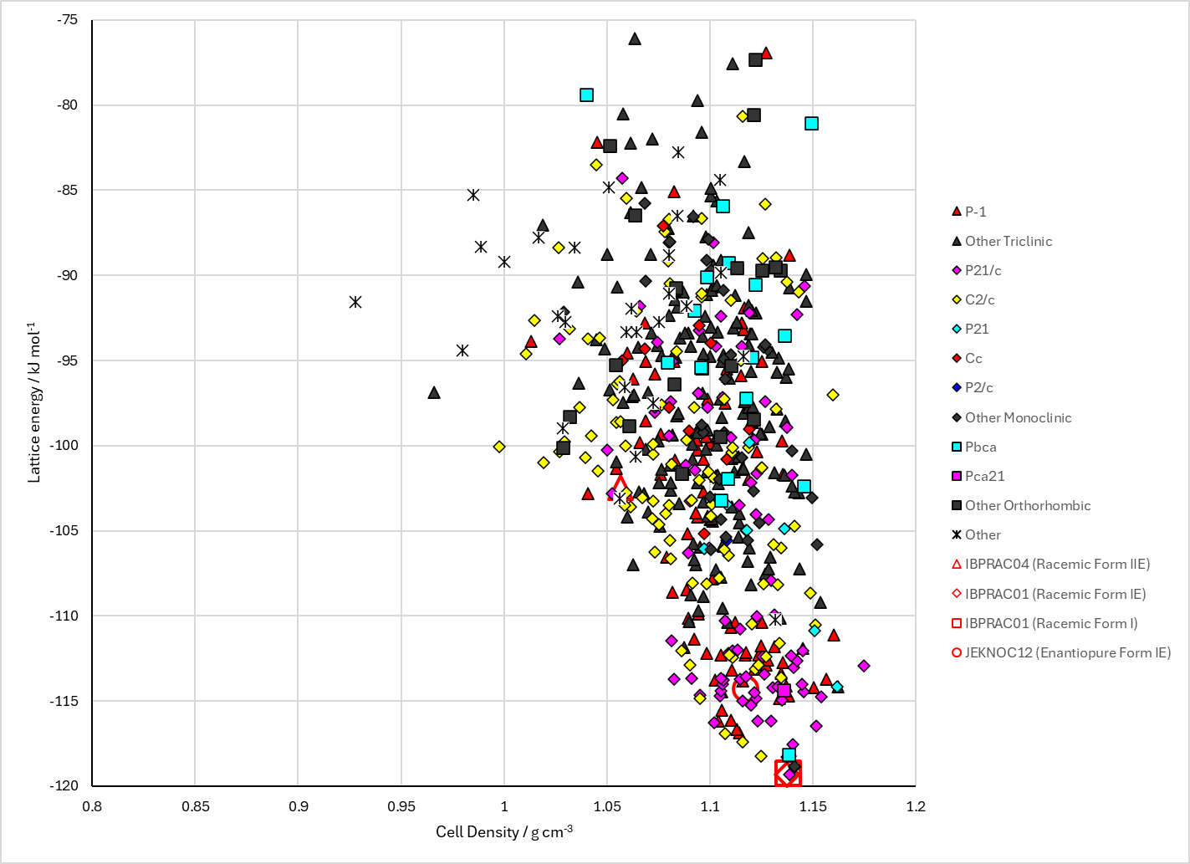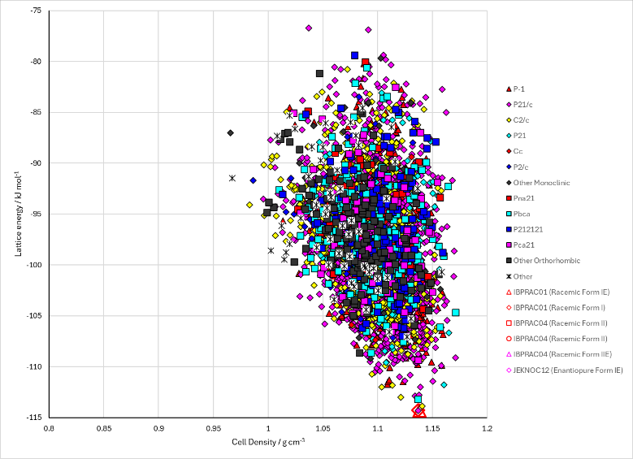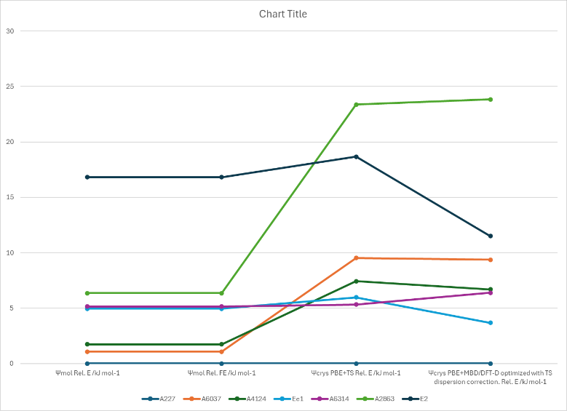
Figure 2. Crystal energy landscape of Ibuprofen from previous work. Top: Following DFTB3D3 and CrystalOptimizer (as published, energy model 3). Bottom left: Following CrystalOptimizer directly from Crystal Predictor. Bottom right: Energy comparisons including DFT+D.

CSD structures (CSD version 5.45 with Nov 2023 update)
The structure that matches Form 2 in the search is a Z’=2 structure in P-1.
Table 1. Crystallographic information for CSD entries for Ibuprofen. Different polymorphs are coloured differently.
REFCODE | space group | Z’ | a / Å | b / Å | c / Å | α / ° | β / ° | γ / ° | density / g cm⁻³ | Form
IBPRAC | P21/c | 1 | 14.667 | 7.886 | 10.73 | 90 | 99.362 | 90 | 1.119 | 1
IBPRAC01 | P21/c | 1 | 14.397 | 7.818 | 10.506 | 90 | 99.7 | 90 | 1.176 | 1
IBPRAC02 | P21/c | 1 | 14.397 | 7.818 | 10.506 | 90 | 99.7 | 90 | 1.176 | 1
IBPRAC03 | P21/c | 1 | 14.6712 | 7.8893 | 10.7288 | 90 | 99.428 | 90 | 1.118 | 1
IBPRAC04 | P21/c | 1 | 12.3794 | 5.8723 | 17.5615 | 90 | 94.873 | 90 | 1.077 | 2
IBPRAC05 | P21/c | 1 | 14.522 | 7.817 | 10.619 | 90 | 99.54 | 90 | 1.153 | 1
IBPRAC06 | P21/c | 1 | 14.6737 | 7.895 | 10.7345 | 90 | 99.541 | 90 | 1.117 | 1
IBPRAC07 | P21/c | 1 | 14.309 | 7.686 | 10.47 | 90 | 99.85 | 90 | 1.208 | 1
IBPRAC08 | P21/c | 1 | 14.205 | 7.6697 | 10.318 | 90 | 100.09 | 90 | 1.238 | 1
IBPRAC09 | P21/c | 1 | 14.196 | 7.638 | 10.32 | 90 | 100.13 | 90 | 1.244 | 1
IBPRAC10 | P21/c | 1 | 13.977 | 7.536 | 10.12 | 90 | 100.3 | 90 | 1.306 | 1
IBPRAC11 | P21/c | 1 | 13.9958 | 7.514 | 10.067 | 90 | 100.41 | 90 | 1.316 | 1
IBPRAC12 | P21/c | 1 | 13.905 | 7.4574 | 10.007 | 90 | 100.21 | 90 | 1.342 | 1
IBPRAC13 | P21/c | 1 | 13.865 | 7.4064 | 9.977 | 90 | 100.27 | 90 | 1.359 | 1
IBPRAC14 | P21/c | 1 | 13.779 | 7.324 | 9.844 | 90 | 100.28 | 90 | 1.402 | 1
IBPRAC15 | P21/c | 1 | 13.7397 | 7.2685 | 9.804 | 90 | 100.195 | 90 | 1.422 | 1
IBPRAC16 | P21/c | 1 | 14.4847 | 7.8321 | 10.4907 | 90 | 99.743 | 90 | 1.168 | 1
IBPRAC17 | P21/c | 1 | 14.5144 | 7.8429 | 10.5297 | 90 | 99.609 | 90 | 1.159 | 1
IBPRAC18 | P21/c | 1 | 14.5609 | 7.857 | 10.5867 | 90 | 99.563 | 90 | 1.147 | 1
IBPRAC19 | P21/c | 1 | 14.605 | 7.8721 | 10.6507 | 90 | 99.525 | 90 | 1.135 | 1
IBPRAC20 | P21/c | 1 | 14.65 | 7.88 | 10.73 | 90 | 99.7 | 90 | 1.122 | 1
IBPRAC21 | P21/c | 1 | 14.465 | 7.815 | 10.435 | 90 | 99.66 | 90 | 1.178 | 1
IBPRAC22 | P21/c | 1 | 14.65 | 7.88 | 10.73 | 90 | 99.7 | 90 | 1.122 | 1
JEKNOC | P21 | 2 | 12.462 | 8.035 | 13.539 | 90 | 112.89 | 90 | 1.097
JEKNOC10 | P21 | 2 | 12.462 | 8.035 | 13.539 | 90 | 112.89 | 90 | 1.097
JEKNOC11 | P21 | 2 | 12.456 | 8.0362 | 13.533 | 90 | 112.86 | 90 | 1.098
JEKNOC12 | P21 | 2 | 12.109 | 7.9598 | 13.3618 | 90 | 111.951 | 90 | 1.147
JEKNOC13 | P21 | 2 | 12.368 | 8.021 | 13.536 | 90 | 112.24 | 90 | 1.102
JEKNOC14 | P21 | 2 | 12.368 | 8.021 | 13.536 | 90 | 112.24 | 90 | 1.102
JEKNOC15 | P21 | 2 | 12.368 | 8.021 | 13.536 | 90 | 112.24 | 90 | 1.102
JEKNOC16 | P21 | 2 | 12.368 | 8.021 | 13.536 | 90 | 112.24 | 90 | 1.102
JEKNOC17 | P21 | 2 | 12.368 | 8.021 | 13.536 | 90 | 112.24 | 90 | 1.102

Table 2. Experimental information for CSD entries for Ibuprofen.
REFCODE | space group | R factor | T / K | Year | Comments
IBPRAC | P21/c | 3.9 | 295 | 1974 | Reference not online
IBPRAC01 | P21/c | 5.3 | 100 | 1996 | Neutron data, recrystallized from acetonitrile¹
IBPRAC02 | P21/c | 5.3 | 100 | 1997 | See IBPRAC01²
IBPRAC03 | P21/c | 0 | 295 | 2009 | Synchrotron data, mixtures with acetaminophen prepared from commercial tablets³
IBPRAC04 | P21/c | 5.8 | 258 | 2010 | Powder diffraction, high temperature annealing⁴
IBPRAC05 | P21/c | 8.33 | 296 | 2015 | Under pressure, with chiral coformers or in chiral solvents⁵
IBPRAC06 | P21/c | 5.36 | 296 | 2015 | Under pressure, with chiral coformers or in chiral solvents⁵
IBPRAC07 | P21/c | 8.17 | 296 | 2015 | Under pressure, with chiral coformers or in chiral solvents⁵
IBPRAC08 | P21/c | 10.66 | 296 | 2015 | Under pressure, with chiral coformers or in chiral solvents⁵
IBPRAC09 | P21/c | 8.3 | 296 | 2015 | Under pressure, with chiral coformers or in chiral solvents⁵
IBPRAC10 | P21/c | 9.95 | 296 | 2015 | Under pressure, with chiral coformers or in chiral solvents⁵
IBPRAC11 | P21/c | 19.04 | 296 | 2015 | Under pressure, with chiral coformers or in chiral solvents⁵
IBPRAC12 | P21/c | 11.93 | 296 | 2015 | Under pressure, with chiral coformers or in chiral solvents⁵
IBPRAC13 | P21/c | 11.85 | 296 | 2015 | Under pressure, with chiral coformers or in chiral solvents⁵
IBPRAC14 | P21/c | 10.03 | 296 | 2015 | Under pressure, with chiral coformers or in chiral solvents⁵
IBPRAC15 | P21/c | 11.18 | 296 | 2015 | Under pressure, with chiral coformers or in chiral solvents⁵
IBPRAC16 | P21/c | 4.24 | 100 | 2015 | Under pressure, with chiral coformers or in chiral solvents⁵
IBPRAC17 | P21/c | 4.51 | 150 | 2015 | Under pressure, with chiral coformers or in chiral solvents⁵
IBPRAC18 | P21/c | 4.64 | 200 | 2015 | Under pressure, with chiral coformers or in chiral solvents⁵
IBPRAC19 | P21/c | 4.84 | 250 | 2015 | Under pressure, with chiral coformers or in chiral solvents⁵
IBPRAC20 | P21/c | 25.41 | 293 | 2018 | Electron diffraction, Kroger-branded ibuprofen tablets, crushed with pestle and mortar⁶
IBPRAC21 | P21/c | 1.44 | 25 | 2020 | Synchrotron data, slow evaporation of a saturated methanol solution⁷
IBPRAC22 | P21/c | 25.41 | 293 | 2020 | See IBPRAC20
JEKNOC | P21 | 6.3 | 295 | 1990 | Reference not online
JEKNOC10 | P21 | 5.6 | 295 | 1993 | From methanol (supplied by Boots chemicals)⁸
JEKNOC11 | P21 | 3.85 | 323 | 2003 | Slow evaporation from n-heptanol solution⁹
JEKNOC12 | P21 | 3.8 | 99 | 2011 | Slow evaporation from methanol solution¹⁰
JEKNOC13 | P21 | 17.94 | 95 | 2023 | Electron diffraction, not specified¹¹
JEKNOC14 | P21 | 19.11 | 95 | 2023 | Electron diffraction, not specified¹¹
JEKNOC15 | P21 | 18.82 | 95 | 2023 | Electron diffraction, not specified¹¹
JEKNOC16 | P21 | 19.01 | 95 | 2023 | Electron diffraction, not specified¹¹
JEKNOC17 | P21 | 19.02 | 95 | 2023 | Electron diffraction, not specified¹¹

Make this table include whether polymorphs are solution-grown, sublimation grown, templated or otherwise. Add references.

Other notes
The structure matching is poor. Structure matches with CrystalPredictor are outside RMSD₃₀=0.3 Å (it was CrystalPredictor 1.9, so the molecule is made up of rigid fragments and is not a good match). Matches to racemic form 2 are also not good, because the form 2 structure is poor. Old manual matching is retained, rather than stating that nothing much matches and the searches were unsuccessful.

1. N. Shankland, A. J. Florence, P. J. Cox, D. B. Sheen, S. W. Love, N. S. Stewart and C. C. Wilson, Chemical Communications, 1996, 855-856.
2. N. Shankland, C. C. Wilson, A. J. Florence and P. J. Cox, Acta Crystallographica Section C - Crystal Structure Communications, 1997, 53, 951-954.
3. K. H. Stone, S. H. Lapidus and P. W. Stephens, Journal of Applied Crystallography, 2009, 42, 385-391.
4. P. Derollez, E. Dudognon, F. Affouard, F. Danede, N. T. Correia and M. Descamps, Acta Crystallographica Section B, 2010, 66, 76-80.
5. K. Ostrowska, M. Kropidlowska and A. Katrusiak, Crystal Growth & Design, 2015, 15, 1512-1517.
6. C. G. Jones, M. W. Martynowycz, J. Hattne, T. J. Fulton, B. M. Stoltz, J. A. Rodriguez, H. M. Nelson and T. Gonen, ACS Central Science, 2018, 4, 1587-1592.
7. F. Kleemiss, A. Justies, D. Duvinage, P. Watermann, E. Ehrke, K. Sugimoto, M. Fugel, L. A. Malaspina, A. Dittmer, T. Kleemiss, P. Puylaert, N. R. King, A. Staubitz, T. M. Tzschentke, R. Dringen, S. Grabowsky and J. Beckmann, Journal of Medicinal Chemistry, 2020, 63, 12614-12622.
8. A. A. Freer, J. M. Bunyan, N. Shankland and D. B. Sheen, Acta Crystallographica Section C, 1993, 49, 1378-1380.
9. L. K. Hansen, G. L. Perlovich and A. Bauer-Brandl, Acta Crystallographica Section E, 2003, 59, o1357-o1358.
10. M. D. King, W. D. Buchanan and T. M. Korter, Journal of Pharmaceutical Sciences, 2011, 100, 1116-1129.
11. M. Khouchen, P. B. Klar, H. Chintakindi, A. Suresh and L. Palatinus, Acta Crystallographica Section A, 2023, 79, 427-439.

