Cytosine
(Last updated April 2026)
Figure 1. The molecular diagram of Cytosine.

CSP studies
REFCODE | CYTSIN
Formula | C4 H5 N3 O1
Common Name | Cytosine
IUPAC Systematic Name | 4-amino-3,4-dihydro-1H-pyrimidin-2-one
Other Names | 4-amino-2-hydroxypyrimidine
CSD Refcodes | CYTSIN02, CYTSIN03
Search Identifier | A
Scientist | Tom Lewis
Date | 2005
Publication | No publication planned.
Energy model | 1
Study_ID | 0
Programs | MOLPAK, DMAREL (4.1.1)
Location on S Drive | \CHEMISTRY_CPOSS\0-EarlySearches\home\louise_price.eminerals\cytosine
Potential Description | MP2 6-31G(d,p) DMA + 25% reduced Carbon repulsion FIT
Intramolecular Description | none

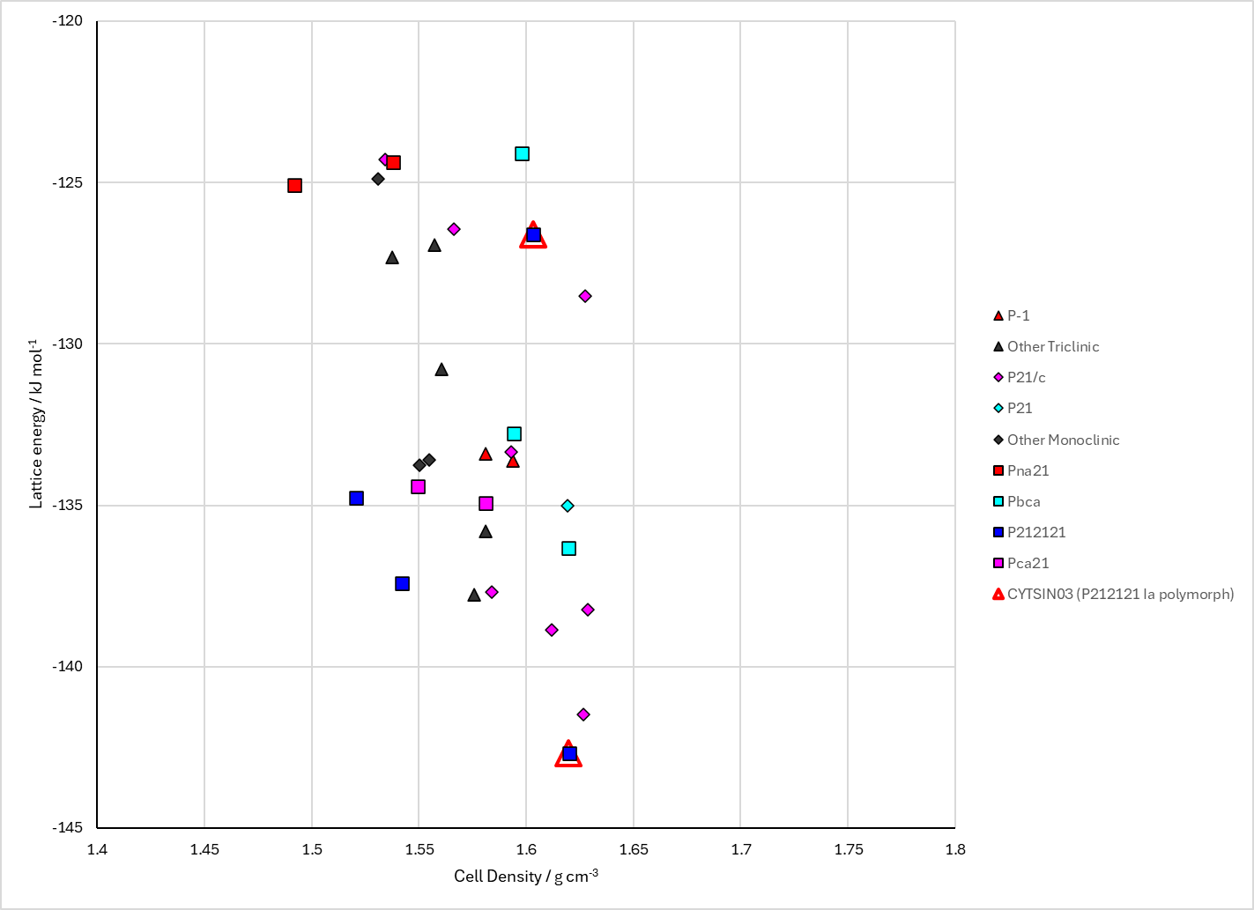
Figure 2. Crystal energy landscape of Cytosine from previous work.

CSD structures (CSD version 6.01 with Feb 2026 update)

Table 1. Crystallographic information for CSD entries for Cytosine. Different polymorphs are coloured differently.
REFCODE | space group | Z’ | a / Å | b / Å | c / Å | α / ° | β / ° | γ / ° | density / g cm⁻³ | Form
CYTSIN | P212121 | 1.0 | 13.041 | 9.494 | 3.815 | 90.0 | 90.0 | 90.0 | 1.5623 | P212121 Ia polymorph
CYTSIN01 | P212121 | 1.0 | 13.044 | 9.496 | 3.814 | 90.0 | 90.0 | 90.0 | 1.5620 | P212121 Ia polymorph
CYTSIN02 | Pccn | 2.0 | 15.1040 | 15.1212 | 9.2948 | 90.0 | 90.0 | 90.0 | 1.3905 | Pccn Ib polymorph
CYTSIN03 | P212121 | 1.0 | 13.0339 | 9.49302 | 3.81349 | 90.0 | 90.0 | 90.0 | 1.5639 | P212121 Ia polymorph

Table 2. Experimental information for CSD entries for Cytosine.
REFCODE | space group | R factor | T / K | Year | Comments
CYTSIN | P212121 | 7.0 | None | 1964 | 10.1107/S0365110X64003899
CYTSIN01 | P212121 | 3.1 | None | 1973 | 10.1107/S0567740873004292
CYTSIN02 | Pccn | 5.149 | 294 K | 2015 | 10.1107/S2053229615000492
CYTSIN03 | P212121 | 0.647 | 293 K | 2023 | 10.1002/hlca.202200087

Make this table include whether polymorphs are solution-grown, sublimation grown, templated or otherwise. Add references.

Other notes

