Beta Estradiol
(Last updated April 2026)
Figure 1. The molecular diagram of beta Estradiol.

CSP studies
REFCODE | PIPHOO
Formula | C18 H24 O2
Common Name | beta-estradiol
IUPAC Systematic Name | 3-hydroxy-1,3,5(10)-estratriene-17beta-ol
Other Names | Estra-1,3,5(10)-triene-3,17beta-diol, DB00783
CSD Refcodes | PIPHOO
Search Identifier | A
Scientist | Eric Stevenson
Date | 2017
Publication | Stevenson, E. L.; Lancaster, R. W.; Buanz, A. B. M.; Price, L. S.; Tocher, D. A.; Price, S. L., CrystEngComm 2019, 21(13), 2154-2163.
Energy model | 1
Study_ID | 10
Programs | Flexible CrystalPrecictor (2.x), CrystalOptimizer, DMACRYS (2.2.1.0)
Location on S Drive | \CHEMISTRY_CPOSS\Estradiol\CrystOpt
Potential Description | CrystalOptimizer with GDMA2.2(PBE1PBE/6-31G(d,p)) + FIT
Intramolecular Description | PBE1PBE/6-31G(d,p)

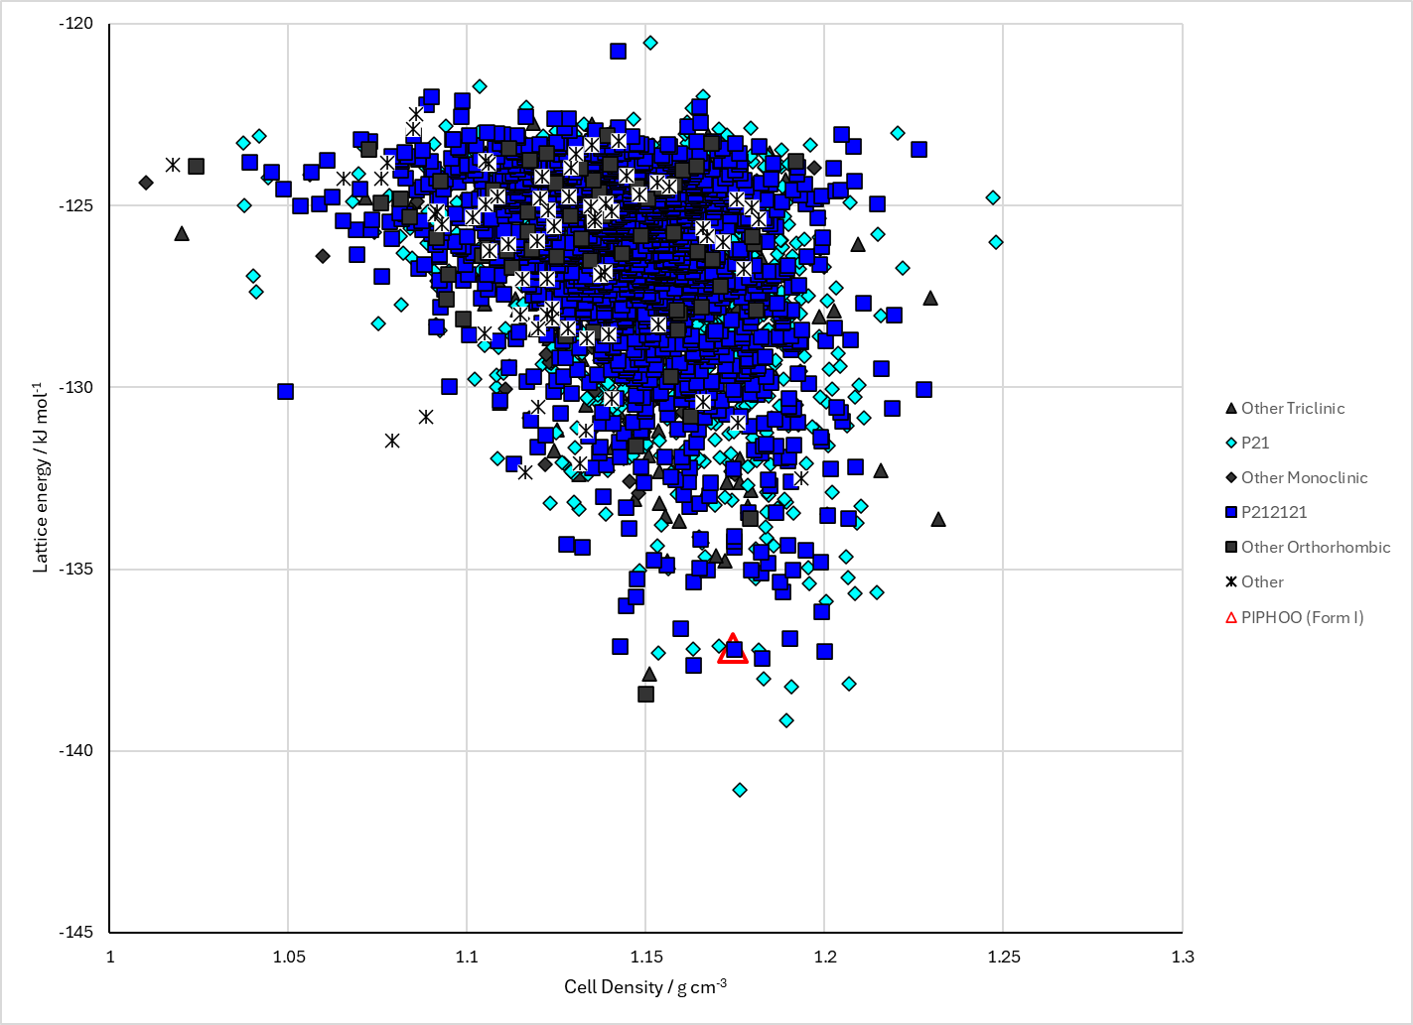
Figure 2. Crystal energy landscape of beta Estradiol from previous work.

CSD structures (CSD version 6.01 with Feb 2026 update)

Table 1. Crystallographic information for CSD entries for beta Estradiol. Different polymorphs are coloured differently.
REFCODE | space group | Z’ | a / Å | b / Å | c / Å | α / ° | β / ° | γ / ° | density / g cm⁻³ | Form
PIPHOO | P212121 | 2.0 | 6.41117 | 12.1972 | 37.9575 | 90.0 | 90.0 | 90.0 | 1.2190 | polymorph I

Table 2. Experimental information for CSD entries for beta Estradiol.
REFCODE | space group | R factor | T / K | Year | Comments
PIPHOO | P212121 | 3.84 | 150 K | 2019 | 10.1039/C8CE01874J

Make this table include whether polymorphs are solution-grown, sublimation grown, templated or otherwise. Add references.

Other notes

