Adenine
(Last updated February 2026)
Figure 1. The molecular diagram of Adenine.

CSP studies
REFCODE | KOBFUD
Formula | C5 H5 N5
Common Name | Adenine
IUPAC Systematic Name | 9H-Purin-6-ylamine
Other Names | Adenine; Vitamin B6; 6-aminopurine
CSD Refcodes | KOBFUD, KOBFUD01
Search Identifier | A
Scientist | Tom Lewis
Date | 2004
Publication | No publication planned.
Energy model | 1
Study_ID | 0
Programs | Molpak, DMAREL (3.0)
Location on S Drive | \CHEMISTRY_CPOSS\0-EarlySearches\home\louise_price.eminerals\adenine
Potential Description | DMA + FIT
Intramolecular Description | Ab initio optimised
Search Identifier | B
Scientist | Louise Price
Date | 2013
Publication | No publication planned.
Energy model | 1
Study_ID | 20
Programs | CrystalPredictor, DMACRYS (2.0.8RC1)
Location on S Drive | \CHEMISTRY_CPOSS\adenine
Potential Description | CrystalPredictor with GDMA2.2(PBE0/6-31G(d,p)) + FIT
Intramolecular Description | PBE0/6-31G(d,p)

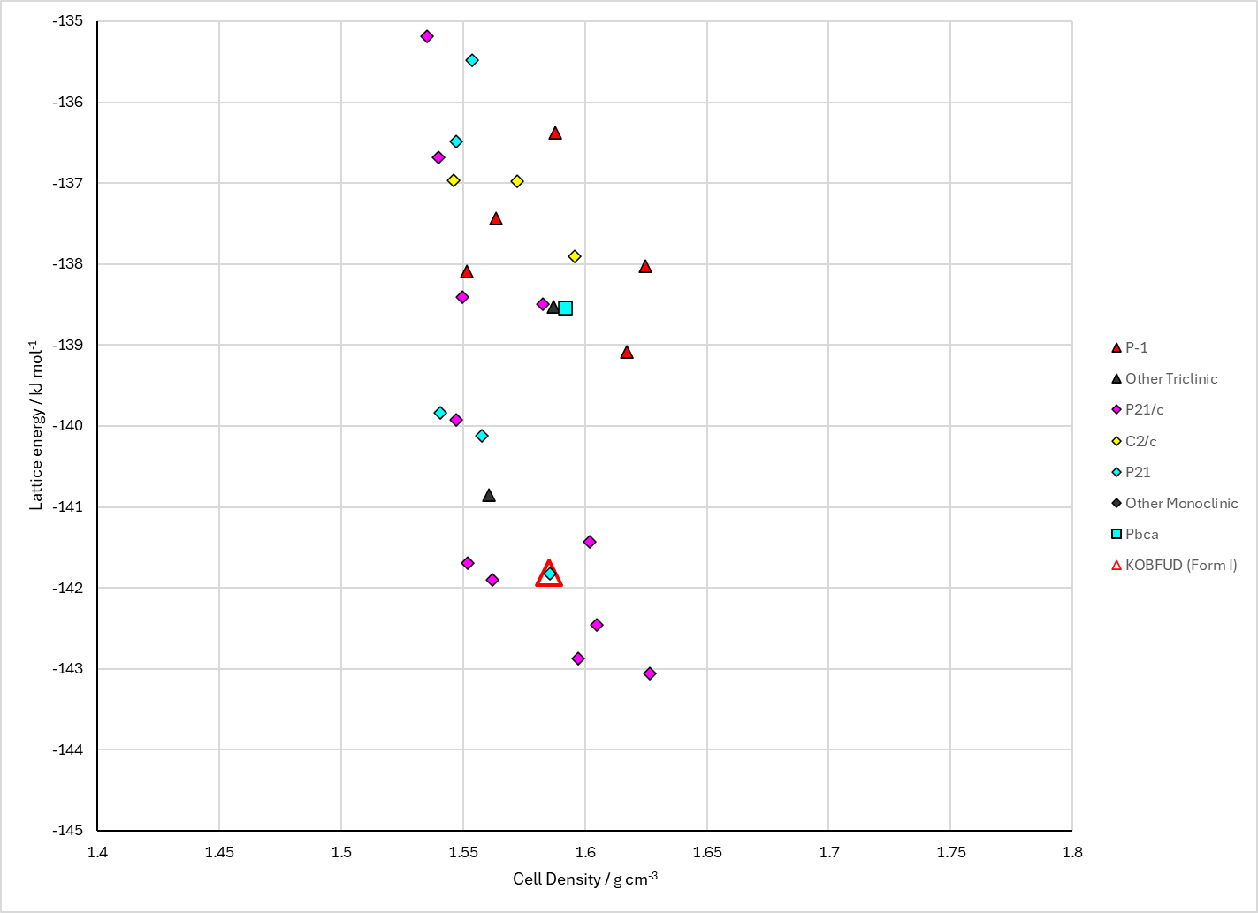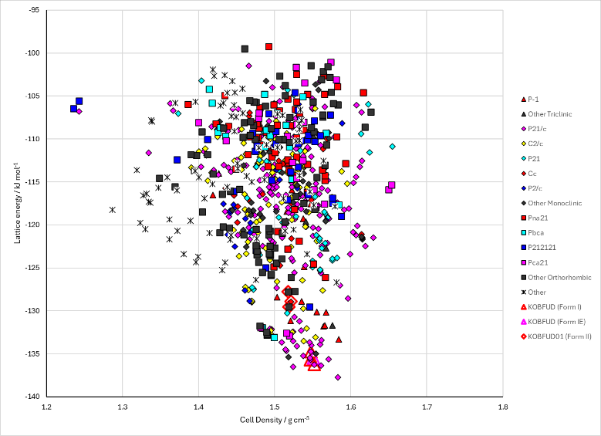
Figure 2. Crystal energy landscape of Adenine from previous work. Left: Energy Model A1. Right: Energy Model B1.

CSD structures (CSD version 6.01)

Table 1. Crystallographic information for CSD entries for Adenine. Different polymorphs are coloured differently.
REFCODE | space group | Z’ | a / Å | b / Å | c / Å | α / ° | β / ° | γ / ° | density / g cm⁻³ | Form
KOBFUD | P21/c | 2.0 | 7.891 | 22.242 | 7.448 | 90.0 | 113.193 | 90.0 | 1.4939 | Form I
KOBFUD01 | Fdd2 | 1.0 | 8.49635 | 22.2821 | 12.7348 | 90.0 | 90.0 | 90.0 | 1.4891 | Form II

Table 2. Experimental information for CSD entries for Adenine.
REFCODE | space group | R factor | T / K | Year | Comments
KOBFUD | P21/c | 8.53 | at 292 K | 2008 | 10.1021/cg700743w
KOBFUD01 | Fdd2 | 6.8 | 293 K | 2016 | 10.1021/acs.cgd.6b00243

Make this table include whether polymorphs are solution-grown, sublimation grown, templated or otherwise. Add references.

Other notes
The .res files generated in search A1 with for the planar conformation had the SYMM cards for the Pnnm or Cmca spacegroups (depending on LATT). The only ones that were correct were the symmetry reduced structures. The SYMM lines have been corrected according to https://www.chem.ucl.ac.uk/cposs/computational/spacegroups.html The original .res files are also stored on the S: drive in "incorrect_res"
No intramolecular energy penalty is available for Search A.

