Carbamazepine Picolinamide cocrystal
(Last updated May 2026)
Figure 1. The molecular diagrams of Carbamazepine and Picolinamide.

CSP studies
REFCODE | AVCZPA
Formula | C15 H12 N2 O1 - C6 H6 N2 O1
Common Name | Carbamazepine picolinamide cocrystal
IUPAC Systematic Name | 5-carbamoyl-5H-dibenz[b,f]azepine pyridine-2-carboxamide
Other Names
CSD Refcodes
Search Identifier | A
Scientist | Matthew Habgood
Date | 2009
Publication | Habgood M, Deij MA, Mazurek J, Price SL, ter Horst JH 2009. Cryst Growth Des 10, 903-912.
Energy model | 1
Study_ID | 20
Programs | Flexible CrystalPredictor (1), DMACRYS (1.1.1)
Location on S Drive | \CHEMISTRY_CPOSS\0-EarlySearches\home\louise_price.eminerals\carbamazepine-picolinamide
Potential Description | DMA + Williams potential modified at amine
Intramolecular Description | MP2/6-31G(d,p)

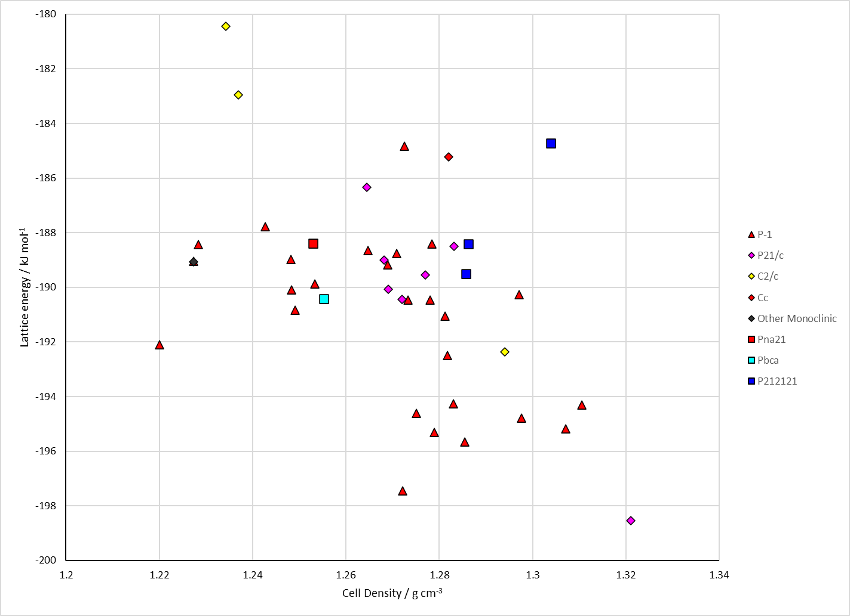
Figure 2. Crystal energy landscape of the Carbamazepine Picolinamide cocrystal from previous work.

CSD structures (CSD version 6.01 with Feb 2026 update)

Table 1. Crystallographic information for CSD entries for the Carbamazepine Picolinamide cocrystal. Different polymorphs are coloured differently.
REFCODE | space group | Z’ | a / Å | b / Å | c / Å | α / ° | β / ° | γ / ° | density / g cm⁻³ | Form

Table 2. Experimental information for CSD entries for the Carbamazepine Picolinamide cocrystal.
REFCODE | space group | R factor | T / K | Year | Comments

Make this table include whether polymorphs are solution-grown, sublimation grown, templated or otherwise. Add references.

Other notes

