Barbituric Acid
(Last updated May 2026)
Figure 1. The molecular diagram of Barbituric Acid.

CSP studies
REFCODE | BARBAC
Formula | C4 H4 N2 O3
Common Name | Barbituric Acid
IUPAC Systematic Name | pyrimidine-2,4,6-trione
Other Names
CSD Refcodes | BARBAC01, BARBAC02, BARBAC03
Search Identifier | A
Scientist | Tom Lewis
Date | 2004
Publication | Lewis, T. C., Tocher, D. A., Price, S. L., Crystal Growth and Design, 4(5), 979-987 (2004); Lewis, T. C., Tocher, D. A., Price, S. L., Cryst. Growth Des., 5(3), 983-993 (2005)
Energy model | 1
Study_ID | 0
Programs | MOLPAK, DMAREL (3.0)
Location on S Drive | \CHEMISTRY_CPOSS\0-EarlySearches\home\louise_price.eminerals\barbituric
Potential Description | DMA + adjusted FIT
Intramolecular Description | Ab initio MP2

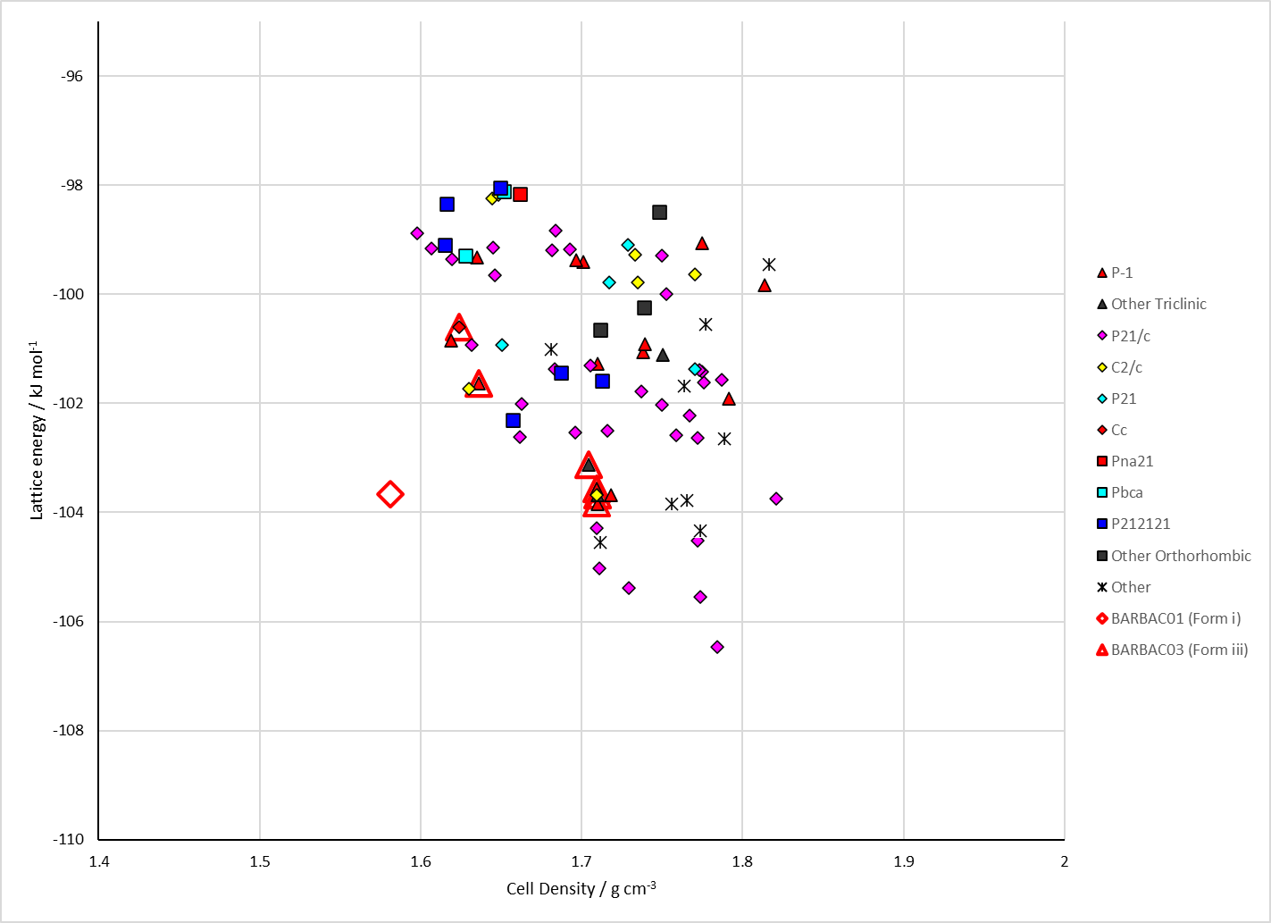
Figure 2. Crystal energy landscape of Barbituric Acid from previous work.

CSD structures (CSD version 6.01 with Feb 2026 update)

Table 1. Crystallographic information for CSD entries for Barbituric Acid. Different polymorphs are coloured differently.
REFCODE | space group | Z’ | a / Å | b / Å | c / Å | α / ° | β / ° | γ / ° | density / g cm⁻³ | Form
BARBAC | P21/c | 1.0 | 6.817 | 14.31 | 6.248 | 90.0 | 118.57000 | 90.0 | 1.5893 | polymorph i
BARBAC01 | P21/c | 1.0 | 6.7305 | 14.029 | 6.2309 | 90.0 | 116.36800 | 90.0 | 1.6139 | polymorph i
BARBAC02 | P21/c | 2.0 | 8.0828 | 12.5828 | 9.7644 | 90.0 | 96.15 | 90.0 | 1.7233 | polymorph ii
BARBAC03 | C2/c | 0.5 | 8.5302 | 6.8167 | 9.33040 | 90.0 | 89.865 | 90.0 | 1.0474 | polymorph iii

Table 2. Experimental information for CSD entries for Barbituric Acid.
REFCODE | space group | R factor | T / K | Year | Comments
BARBAC | P21/c | 10.20 | None | 1963 | 10.1107/S0365110X63000438
BARBAC01 | P21/c | 3.94 | at 150 K | 2004 | 10.1021/cg034209a
BARBAC02 | P21/c | 5.600 | at 150 K | 2004 | 10.1021/cg034209a
BARBAC03 | C2/c | None | 509 K | 2012 | 10.1039/C2CE06636J

Make this table include whether polymorphs are solution-grown, sublimation grown, templated or otherwise. Add references.

Other notes
Table 3. Hydrogen bonding arrangement in CSD structures of barbituric acid. Left: the simplest hydrogen bonded sheet / chain. Right: the packing of the motifs on the left. Colouring is by element on the left and by symmetry operation on the right with one unit of the motif on the left depicted as black ball-and-stick.
BARBAC01  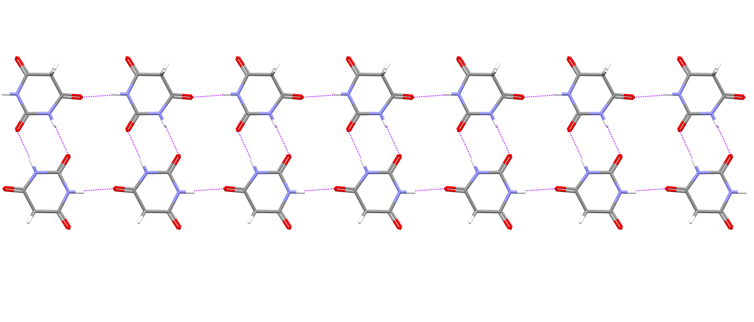 | 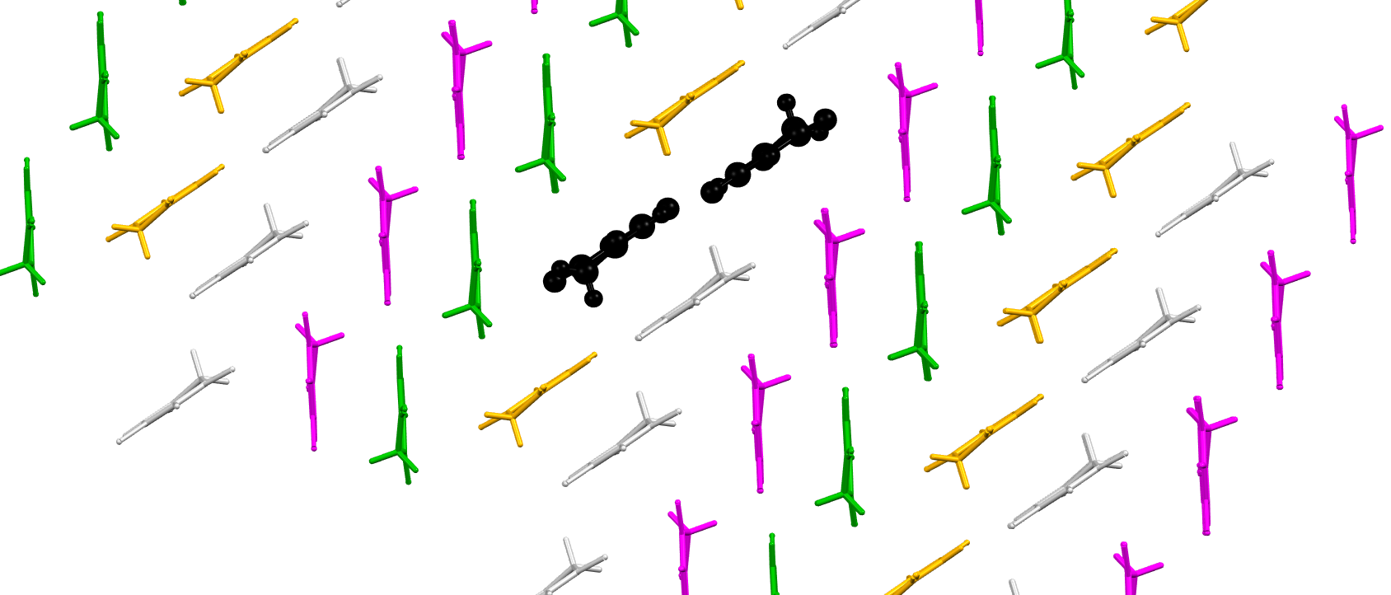
BARBAC02  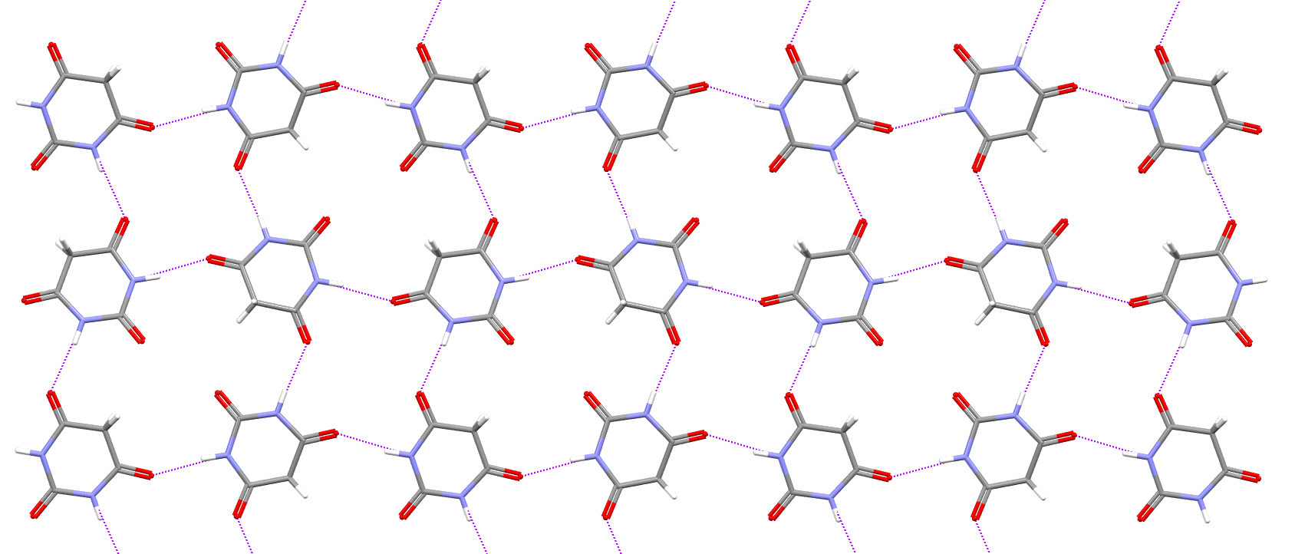 | 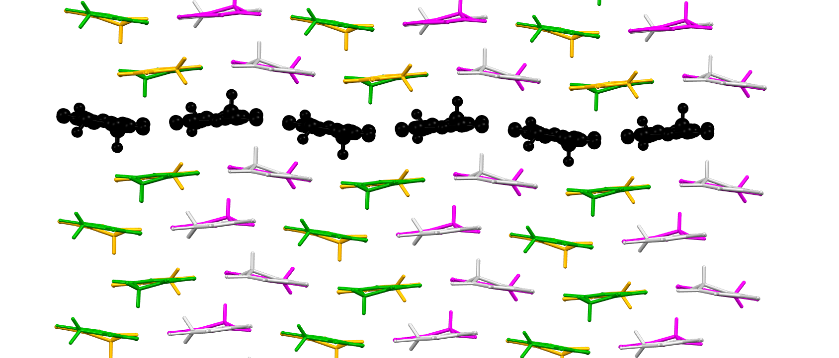
BARBAC03  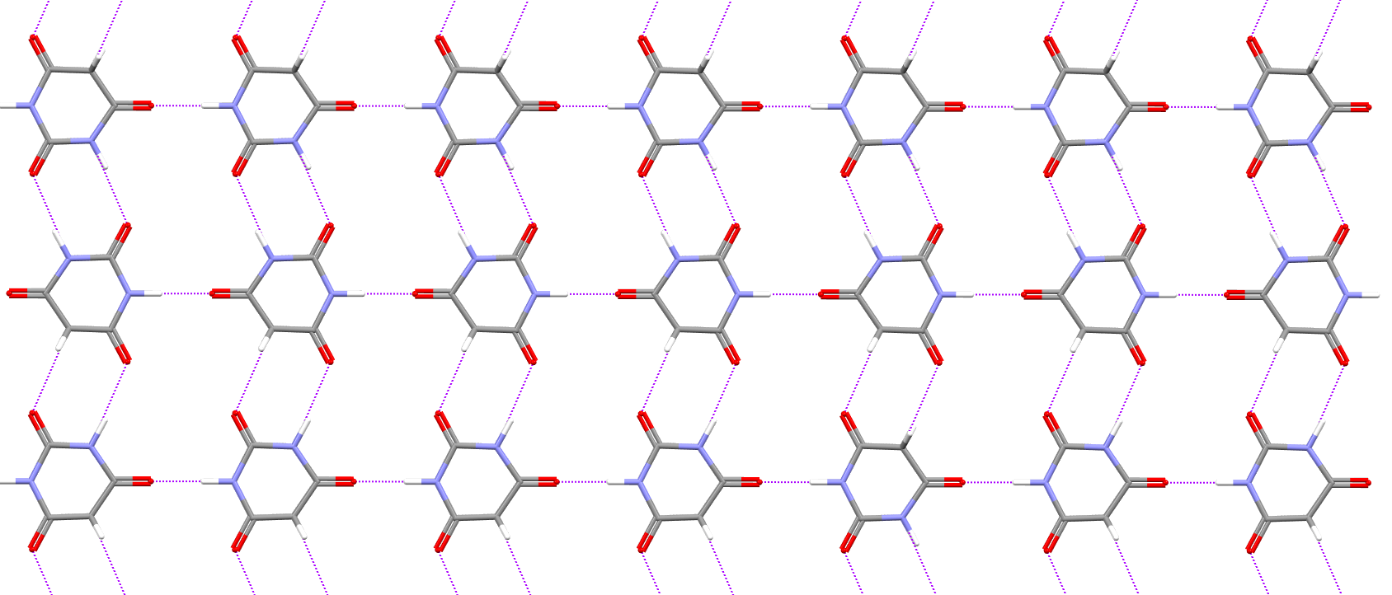 | 