Coumarin
(Last updated May 2026)
Figure 1. The molecular diagram of Coumarin.

CSP studies
REFCODE | COUMAR
Formula | C9 H6 O2
Common Name | Coumarin
IUPAC Systematic Name | Coumarin
Other Names
CSD Refcodes | COUMAR11, COUMAR20, COUMAR15, COUMAR16, COUMAR18
Search Identifier | A
Scientist | Ashley Hulme
Date | 2005
Publication | No publication planned.
Energy model | 1
Study_ID | 0
Programs | MOLPAK, DMAREL (4.1.1)
Location on S Drive | \CHEMISTRY_CPOSS\0-EarlySearches\home\louise_price.eminerals\coumarin
Potential Description | FIT
Intramolecular Description | Ab initio MP2 631G

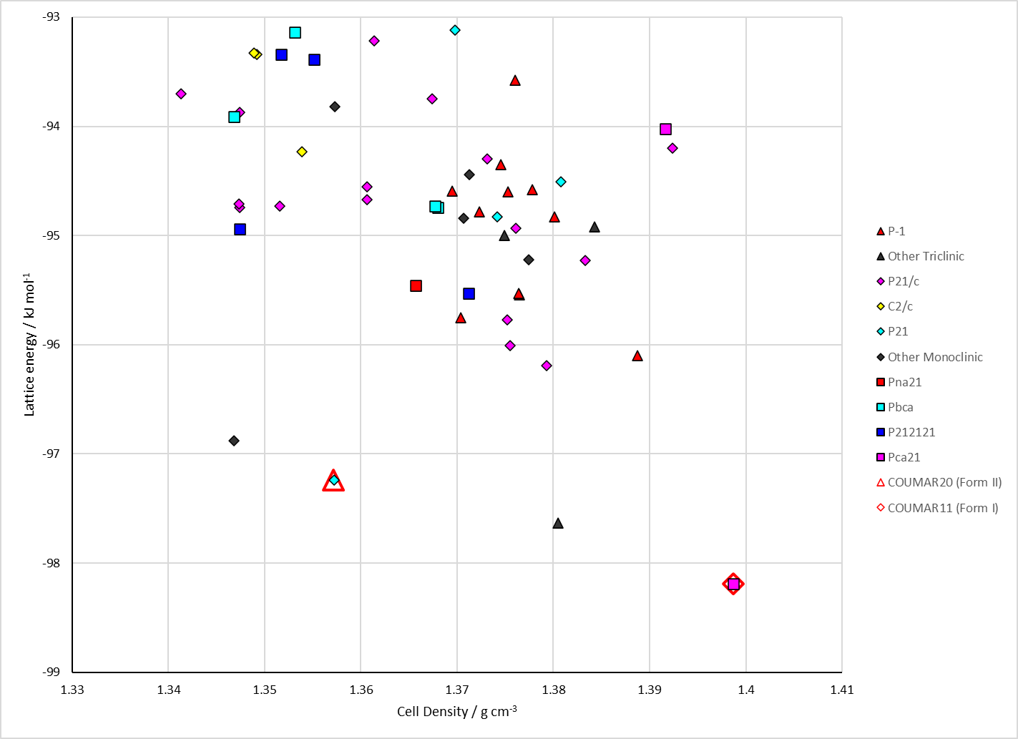
Figure 2. Crystal energy landscape of Coumarin from previous work.

CSD structures (CSD version 6.01 with Feb 2026 update)

Table 1. Crystallographic information for CSD entries for Coumarin. Different polymorphs are coloured differently.
REFCODE | space group | Z’ | a / Å | b / Å | c / Å | α / ° | β / ° | γ / ° | density / g cm⁻³ | Form
COUMAR01 | Pca21 | 1.0 | 15.5 | 5.664 | 7.915 | 90.0 | 90.0 | 90.0 | 1.3969 | Form I
COUMAR02 | Pca21 | 1.0 | 15.503 | 5.666 | 7.918 | 90.0 | 90.0 | 90.0 | 1.3956 | Form I
COUMAR10 | Pca21 | 1.0 | 15.4660 | 5.676 | 7.917 | 90.0 | 90.0 | 90.0 | 1.3967 | Form I
COUMAR11 | Pc21b | 1.0 | 5.60910 | 7.7343 | 15.478 | 90.0 | 90.0 | 90.0 | 1.4456 | Form I
COUMAR12 | Pca21 | 1.0 | 15.5023 | 5.663 | 7.91020 | 90.0 | 90.0 | 90.0 | 1.3978 | Form I
COUMAR13 | P21 | 1.0 | 3.97954 | 15.2907 | 5.8583 | 90.0 | 94.237000 | 90.0 | 1.3652 | Form II
COUMAR14 | P212121 | 2.0 | 16.7822 | 5.92141 | 13.8522 | 90.0 | 90.0 | 90.0 | 1.4103 | Form III
COUMAR15 | P212121 | 2.0 | 17.0617 | 6.03613 | 13.9083 | 90.0 | 90.0 | 90.0 | 1.3553 | Form III
COUMAR16 | P212121 | 3.0 | 24.2702 | 5.92061 | 14.1893 | 90.0 | 90.0 | 90.0 | 1.4282 | Form IV
COUMAR17 | P212121 | 3.0 | 24.7224 | 5.99422 | 14.3101 | 90.0 | 90.0 | 90.0 | 1.3732 | Form IV
COUMAR18 | P212121 | 1.0 | 4.86771 | 6.88178 | 20.8508 | 90.0 | 90.0 | 90.0 | 1.3897 | Form V
COUMAR19 | Pca21 | 1.0 | 15.5001 | 5.636 | 7.8224 | 90.0 | 90.0 | 90.0 | 1.4204 | Form I
COUMAR20 | P21 | 1.0 | 3.87010 | 15.2836 | 5.8211 | 90.0 | 93.608 | 90.0 | 1.4124 | Form II
COUMAR21 | Pca21 | 1.0 | 15.5258 | 5.66900 | 7.9119 | 90.0 | 90.0 | 90.0 | 1.3939 | Form I
COUMAR22 | Pca21 | 1.0 | 15.5205 | 5.663 | 7.91630 | 90.0 | 90.0 | 90.0 | 1.3951 | Form I
COUMAR23 | Pca21 | 1.0 | 15.4963 | 5.6173 | 7.7853 | 90.0 | 90.0 | 90.0 | 1.4323 | Form I

Table 2. Experimental information for CSD entries for Coumarin.
REFCODE | space group | R factor | T / K | Year | Comments
COUMAR01 | Pca21 | 10.4 | None | 1973 | None
COUMAR02 | Pca21 | 4.0 | None | 1976 | None
COUMAR10 | Pca21 | 4.8 | None | 1974 | 10.1107/S0567740874004791
COUMAR11 | Pc21b | 2.43 | at 90.0 K | 2005 | 10.1021/jp046388s
COUMAR12 | Pca21 | 3.62 | at 295 K | 2005 | 10.1016/j.molstruc.2005.02.009
COUMAR13 | P21 | 6.97 | 298 K | 2017 | synchrotron, powder, 10.1039/C7SC00168A
COUMAR14 | P212121 | 9.82 | 90 K | 2017 | powder, 10.1039/C7SC00168A
COUMAR15 | P212121 | 4.74 | 298 K | 2017 | powder, 10.1039/C7SC00168A
COUMAR16 | P212121 | 10.36 | 90 K | 2017 | synchrotron, powder, 10.1039/C7SC00168A
COUMAR17 | P212121 | 13.35 | 298 K | 2017 | synchrotron, powder, 10.1039/C7SC00168A
COUMAR18 | P212121 | 7.95 | 298 K | 2017 | powder, 10.1039/C7SC00168A
COUMAR19 | Pca21 | 3.26 | 200 K | 2021 | 10.1021/acs.joc.0c02011
COUMAR20 | P21 | 3.429 | 160 K | 2021 | 10.1021/acs.chemmater.0c04560
COUMAR21 | Pca21 | 6.890 | 303.2 K | 2021 | 10.1021/acs.chemmater.0c04560
COUMAR22 | Pca21 | 5.229 | 293 K | 2021 | 10.1021/acs.chemmater.0c04560
COUMAR23 | Pca21 | 2.840 | 150 K | 2024 | 10.1021/acs.jchemed.4c00797

Make this table include whether polymorphs are solution-grown, sublimation grown, templated or otherwise. Add references.

Other notes

