Aspirin
(Last updated December 2025)
Figure 1. The molecular diagram of Aspirin.

CSP studies
REFCODE | ACSALA
Formula | C9 H8 O4
Common Name | Aspirin
IUPAC Systematic Name | 2-Acetoxybenzoic acid
Other Names | Acetyl salicylic acid
CSD Refcodes | ACSALA21, ACSALA20, ACSALA23
Search Identifier | A
Scientist | Carole Ouvrard
Date | 2004
Publication | Ouvrard, C., Price, S. L., Special Issue of Crystal Growth and Design, 4(6), 1119-1127 (2004)
Energy model | 1
Study_ID | 0
Programs | MOLPAK, DMAREL (3.0)
Location on S Drive | \CHEMISTRY_CPOSS\0-EarlySearches\home\louise_price.eminerals\Aspirin
Potential Description | DMA + FIT
Intramolecular Description | MP2/6-31G(d,p)

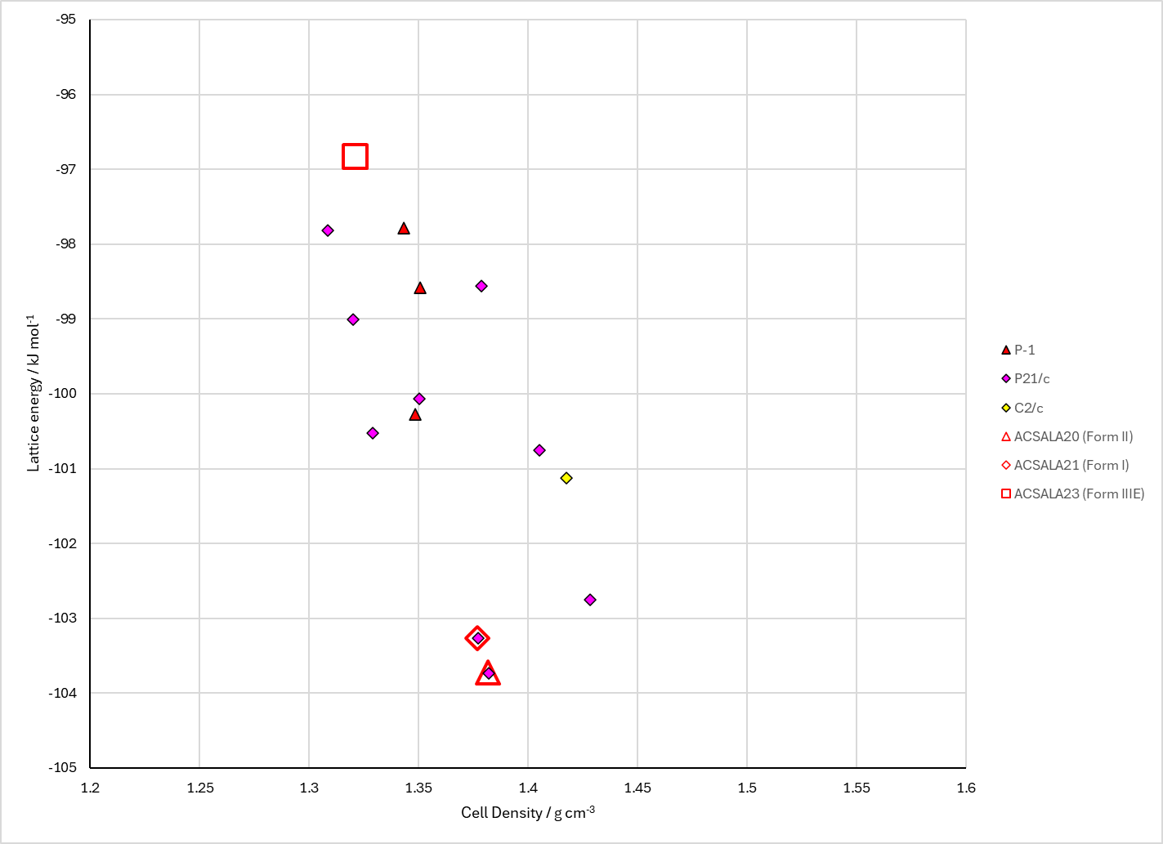
Figure 2. Crystal energy landscape of Aspirin from previous work.

CSD structures (CSD version 5.41)

Table 1. Crystallographic information for CSD entries for aspirin. Different polymorphs are coloured differently.
REFCODE | space group | Z’ | a / Å | b / Å | c / Å | α / ° | β / ° | γ / ° | density / g cm⁻³ | Form
ACSALA | P21/c | 1.0 | 11.446 | 6.596 | 11.388 | 90.0 | 95.55 | 90.0 | 1.3983 | I
ACSALA01 | P21/c | 1.0 | 11.43 | 6.591 | 11.395 | 90.0 | 95.68 | 90.0 | 1.4008 | I
ACSALA02 | P21/c | 1.0 | 11.233 | 6.54400 | 11.231 | 90.0 | 95.89 | 90.0 | 1.4571 | I
ACSALA03 | P21/c | 1.0 | 11.273 | 6.55500 | 11.271 | 90.0 | 95.820000 | 90.0 | 1.4442 | I
ACSALA04 | P21/c | 1.0 | 11.305 | 6.56300 | 11.305 | 90.0 | 95.880000 | 90.0 | 1.4341 | I
ACSALA05 | P21/c | 1.0 | 11.186 | 6.54 | 11.217 | 90.0 | 96.070000 | 90.0 | 1.4664 | I
ACSALA06 | P21/c | 1.0 | 11.34 | 6.57400 | 11.318 | 90.0 | 95.87 | 90.0 | 1.4257 | I
ACSALA07 | P21/c | 1.0 | 11.416 | 6.598 | 11.483 | 90.0 | 95.600000 | 90.0 | 1.3901 | I
ACSALA08 | P21/c | 1.0 | 11.204 | 6.54400 | 11.223 | 90.0 | 95.95 | 90.0 | 1.4621 | I
ACSALA09 | P21/c | 1.0 | 11.233 | 6.54400 | 11.231 | 90.0 | 95.89 | 90.0 | 1.4571 | I
ACSALA10 | P21/c | 1.0 | 11.233 | 6.54400 | 11.231 | 90.0 | 95.89 | 90.0 | 1.4571 | I
ACSALA11 | P21/c | 1.0 | 11.233 | 6.54400 | 11.231 | 90.0 | 95.89 | 90.0 | 1.4571 | I
ACSALA12 | P21/c | 1.0 | 11.233 | 6.54400 | 11.231 | 90.0 | 95.89 | 90.0 | 1.4571 | I
ACSALA13 | P21/c | 1.0 | 12.095 | 6.49100 | 11.323 | 90.0 | 111.509 | 90.0 | 1.4468 | II
ACSALA14 | P21/c | 1.0 | 11.2776 | 6.5517 | 11.2741 | 90.0 | 95.837 | 90.0 | 1.4439 | I
ACSALA15 | P21/c | 1.0 | 12.1515 | 6.5064 | 11.3677 | 90.0 | 111.574 | 90.0 | 1.4317 | II
ACSALA17 | P21/c | 1.0 | 12.2696 | 6.5575 | 11.496 | 90.0 | 68.163 | 90.0 | 1.3937 | II
ACSALA19 | P21/c | 1.0 | 12.1016 | 6.4721 | 11.3344 | 90.0 | 111.593 | 90.0 | 1.4496 | II
ACSALA20 | P21/c | 1.0 | 12.3578 | 6.5315 | 11.4964 | 90.0 | 112.436 | 90.0 | 1.3951 | II
ACSALA21 | P21/c | 1.0 | 11.268 | 6.5498 | 11.2646 | 90.0 | 95.933 | 90.0 | 1.4471 | I
ACSALA23 | P21/c | 2.0 | 16.7413 | 4.79496 | 23.8021 | 90.0 | 111.08160 | 90.0 | 1.3424 | None
ACSALA24 | P21/c | 2.0 | 16.6569 | 4.44469 | 23.7812 | 90.0 | 111.06022 | 90.0 | 1.4566 | None
ACSALA25 | P21/c | 1.0 | 11.4511 | 6.6028 | 11.4182 | 90.0 | 95.69 | 90.0 | 1.3929 | I

Table 2. Experimental information for CSD entries for Aspirin.
REFCODE | space group | R factor | T / K | Year | Comments
ACSALA | P21/c | 10.8 | None | 1964 | 10.1039/JR9640006036
ACSALA01 | P21/c | 4.600 | None | 1985 | 10.1248/cpb.33.2641
ACSALA02 | P21/c | 7.97 | at 100 K | 2002 | 10.1039/b203775k
ACSALA03 | P21/c | 8.77 | at 140 K | 2002 | 10.1039/b203775k
ACSALA04 | P21/c | 8.84 | at 180 K | 2002 | 10.1039/b203775k
ACSALA05 | P21/c | 8.76 | at 20 K | 2002 | 10.1039/b203775k
ACSALA06 | P21/c | 9.03 | at 220 K | 2002 | 10.1039/b203775k
ACSALA07 | P21/c | 8.73 | at 300 K | 2002 | 10.1039/b203775k
ACSALA08 | P21/c | 8.2 | at 60 K | 2002 | 10.1039/b203775k
ACSALA09 | P21/c | 9.58 | at 100 K | 2003 | 10.1039/b203379h
ACSALA10 | P21/c | 13.02 | at 100 K | 2003 | 10.1039/b203379h
ACSALA11 | P21/c | 9.540 | at 200 K | 2003 | 10.1039/b203379h
ACSALA12 | P21/c | 11.27 | at 300 K | 2003 | 10.1039/b203379h
ACSALA13 | P21/c | 16.22 | at 100 K | 2005 | 10.1021/ja056455b
ACSALA14 | P21/c | 3.300 | at 123 K | 2007 | 10.1002/anie.200602378
ACSALA15 | P21/c | 4.060 | 180 K | 2007 | 10.1002/anie.200603373
ACSALA17 | P21/c | 4.29 | at 293 K | 2010 | 10.1107/S0108768110037055
ACSALA19 | P21/c | 4.73 | at 123 K | 2011 | 10.1039/c1sc00430a
ACSALA20 | P21/c | 3.62 | at 120 K | 2011 | 10.1039/c1sc00430a
ACSALA21 | P21/c | 3.31 | at 90 K | 2012 | 10.1021/cg300269n
ACSALA23 | P21/c | 2.61 | 240 K | 2017 | 10.1021/acs.cgd.7b00673
ACSALA24 | P21/c | None | 240-260 K | 2017 | 10.1021/acs.cgd.7b00673
ACSALA25 | P21/c | 4.34 | 198 K | 2018 | None

Make this table include whether polymorphs are solution-grown, sublimation grown, templated or otherwise. Add references.

Other notes

