2-Thioxo-benzothiazole-3-carbothioic acid dimethylamide (Blind Test XIV)
(Last updated February 2026)
Figure 1. The molecular diagram of 2-Thioxo-benzothiazole-3-carbothioic acid dimethylamide.

CSP studies
REFCODE | WIDBAO
Formula | C10 H10 N2 S3
Common Name | BTXIVS
IUPAC Systematic Name | 2-Thioxo-benzothiazole-3-carbothioic acid dimethylamide
Other Names | Blind Test molecule XIV
CSD Refcodes | WIDBAO
Search Identifier | A
Scientist | Gareth Welch
Date | 2008
Publication | Day GM, 2009. Acta Crystallogr , Sect B 65, 107-125.
Energy model | 2
Study_ID | 10
Programs | Study_ID=0, Dmaflex, DMAREL (3.11)
Location on S Drive | \CHEMISTRY_CPOSS\0-EarlySearches\home\louise_price.eminerals\BlindTestXIVS_dmaflex
Potential Description | MP2 6-31G(d,p DMA(v2, 30Ang)+ fit.pots+iso S
Intramolecular Description | MP2 6-31G(d,p)
Energy model | 1
Study_ID | 0
Programs | MOLPAK, DMAREL (4.1.1)
Location on S Drive | \CHEMISTRY_CPOSS\0-EarlySearches\home\louise_price.eminerals\BlindTestXIVS
Potential Description | MP2 6-31G(d,p DMA(v1.2)+ fit.pots+iso S
Intramolecular Description | MP2 6-31G(d,p)

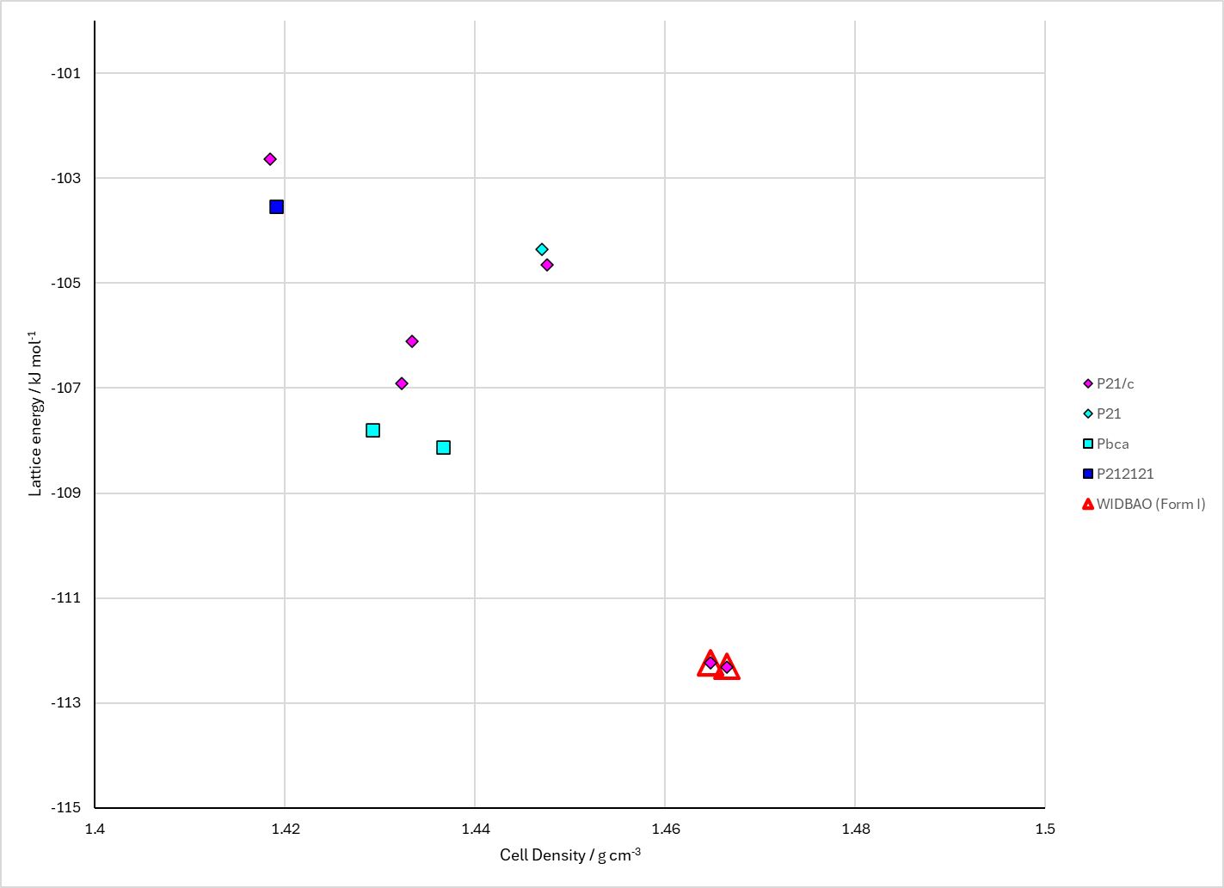
Figure 2. Crystal energy landscape of 2-Thioxo-benzothiazole-3-carbothioic acid dimethylamide from previous work.

CSD structures (CSD version 6.01)

Table 1. Crystallographic information for CSD entries for 2-Thioxo-benzothiazole-3-carbothioic acid dimethylamide. Different polymorphs are coloured differently.
REFCODE | space group | Z’ | a / Å | b / Å | c / Å | α / ° | β / ° | γ / ° | density / g cm⁻³ | Form
WIDBAO | P21/c | 1.0 | 13.06 | 9.738 | 9.335 | 90.0 | 105.8 | 90.0 | 1.4791 | None

Table 2. Experimental information for CSD entries for 2-Thioxo-benzothiazole-3-carbothioic acid dimethylamide.
REFCODE | space group | R factor | T / K | Year | Comments
WIDBAO | P21/c | 3.24 | 150 K | 2009 | 10.1107/S0108768109004066

Make this table include whether polymorphs are solution-grown, sublimation grown, templated or otherwise. Add references.

Other notes

