Dehydroproline anhydride
(Last updated April 2026)
Figure 1. The molecular diagram of Dehydroproline anhydride.

CSP studies
REFCODE | DHPROA
Formula | C10 H10 N2 O2
Common Name | 3,4-Dehydroproline anhydride
IUPAC Systematic Name | 3,4-Dehydroproline anhydride
Other Names
CSD Refcodes | DHPROA
Search Identifier | A
Scientist | Emiliana D'Oria
Date | 2009
Publication | D'Oria E, Karamertzanis PG, Price SL 2010. Cryst Growth Des 10, 1749-1756.
Energy model | 2
Study_ID | 10
Programs | Study_ID=0, Dmaflex (2), DMACRYS (1.1.1)
Location on S Drive | \CHEMISTRY_CPOSS\DehydroprolineAnhydride\dmaflex
Potential Description | DMA + FIT
Intramolecular Description | HF/6-31G(d,p)
Energy model | 1 (published)
Study_ID | 0
Programs | MOLPAK, DMAREL (4.1.1)
Location on S Drive | \CHEMISTRY_CPOSS\DehydroprolineAnhydride\opt
Potential Description | DMA + FIT
Intramolecular Description | MP2/6-31G(d,p)
Search Identifier | B
Scientist | Emiliana D'Oria
Date | 2009
Publication | D'Oria E, Karamertzanis PG, Price SL 2010. Cryst Growth Des 10, 1749-1756.
Energy model | 1
Study_ID | 1
Programs | MOLPAK, DMAREL (4.1.1)
Location on S Drive | \CHEMISTRY_CPOSS\DehydroprolineAnhydride\exp
Potential Description | DMA + FIT
Intramolecular Description | MP2/6-31G(d,p)

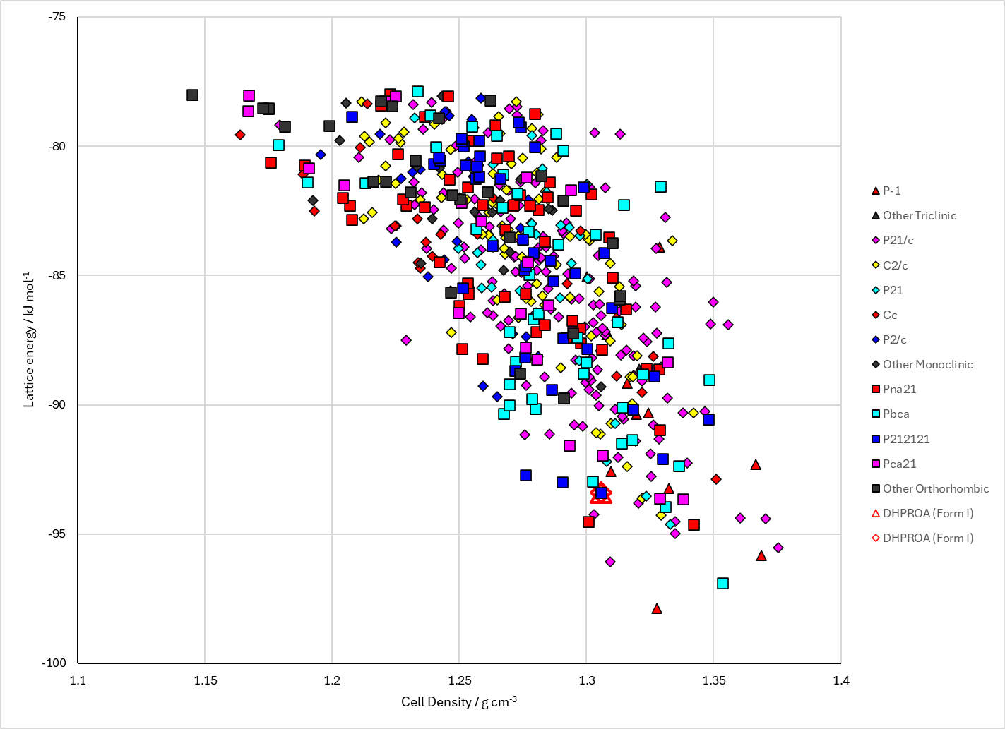
Figure 2. Crystal energy landscape of Dehydroproline anhydride from previous work.

CSD structures (CSD version 6.01 with Feb 2026 update)

Table 1. Crystallographic information for CSD entries for Dehydroproline anhydride. Different polymorphs are coloured differently.
REFCODE | space group | Z’ | a / Å | b / Å | c / Å | α / ° | β / ° | γ / ° | density / g cm⁻³ | Form
DHPROA | P41212 | 0.5 | 5.607 | 5.607 | 28.753 | 90.0 | 90.0 | 90.0 | 1.3975 | None

Table 2. Experimental information for CSD entries for Dehydroproline anhydride.
REFCODE | space group | R factor | T / K | Year | Comments
DHPROA | P41212 | 4.0 | None | 1974 | 10.1021/ja00809a033

Make this table include whether polymorphs are solution-grown, sublimation grown, templated or otherwise. Add references.

Other notes

