Parabanic Acid
(Last updated June 2026)
Figure 1. The molecular diagram of Parabanic Acid.

CSP studies
REFCODE | PARBAC
Formula | C3 H2 N2 O3
Common Name | Parabanic acid
IUPAC Systematic Name | 2,4,5-trioxoimidazolidine
Other Names
CSD Refcodes | PARBAC04
Search Identifier | A
Scientist | Tom Lewis
Date | 2005
Publication | Lewis TC, Tocher DA, Price SL, Cryst. Growth Des., 5(3), 983-993 (2005)
Energy model | 1
Study_ID | 0
Programs | MOLPAK, DMAREL (3.0)
Location on S Drive | \CHEMISTRY_CPOSS\0-EarlySearches\home\louise_price.eminerals\parabanic_acid
Potential Description | SCF DMA + adjusted W99
Intramolecular Description | Ab initio MP2

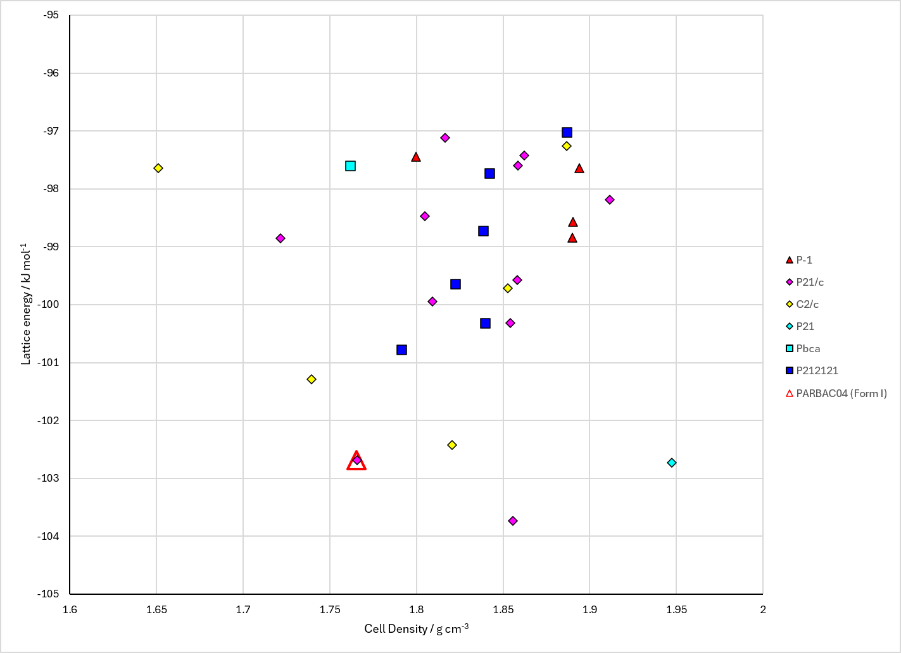
Figure 2. Crystal energy landscape of Parabanic Acid from previous work.

CSD structures (CSD version 6.01 with Feb 2026 update)

Table 1. Crystallographic information for CSD entries for Parabanic Acid. Different polymorphs are coloured differently.
REFCODE | space group | Z’ | a / Å | b / Å | c / Å | α / ° | β / ° | γ / ° | density / g cm⁻³ | Form
PARBAC | P21/n | 1.0 | 10.685 | 8.1974 | 5.054 | 90.0 | 92.73 | 90.0 | 1.7133 | None
PARBAC02 | P21/n | 1.0 | 10.69 | 8.194 | 5.049 | 90.0 | 92.74 | 90.0 | 1.7149 | None
PARBAC03 | P21/n | 1.0 | 10.704 | 8.187 | 4.969 | 90.0 | 92.32 | 90.0 | 1.7412 | None
PARBAC04 | P21/n | 1.0 | 10.692 | 8.194 | 5.051 | 90.0 | 92.74 | 90.0 | 1.7139 | None
PARBAC11 | P21/n | 1.0 | 10.692 | 8.194 | 5.051 | 90.0 | 92.74 | 90.0 | 1.7139 | None

Table 2. Experimental information for CSD entries for Parabanic Acid.
REFCODE | space group | R factor | T / K | Year | Comments
PARBAC | P21/n | 9.0 | None | 1955 | 10.1107/S0365110X5500056X
PARBAC02 | P21/n | 1.7 | None | 1979 | 10.1107/S0567740879005203
PARBAC03 | P21/n | 5.5 | at 123 K | 1988 | 10.1107/S0108768187011108
PARBAC04 | P21/n | 2.2 | None | 1988 | 10.1107/S0108768187011108
PARBAC11 | P21/n | 3.6 | None | 1979 | 10.1107/S0567740879005203

Make this table include whether polymorphs are solution-grown, sublimation grown, templated or otherwise. Add references.

Other notes

