Pyridone
(Last updated June 2026)
Figure 1. The molecular diagram of Pyridone.

CSP studies
REFCODE | PYRIDO
Formula | C5 H5 N1 O1
Common Name | 2-Pyridone
IUPAC Systematic Name | Pyridin-2(1H)-one
Other Names
CSD Refcodes | PYRIDO04, PYRIDO12
Search Identifier | A
Scientist | Not sure
Date | 2012
Publication | No publication planned.
Energy model | 1
Study_ID | 0
Programs | MOLPAK, DMACRYS (2.0.4)
Location on S Drive | \CHEMISTRY_CPOSS\Pyridone\FIT
Potential Description | DMA(PBE0/aug-cc-pVTz) + GDMA2 + FIT
Intramolecular Description | PBE0/aug-cc-pVTz
Search Identifier | B
Scientist | Not sure
Date | 2012
Publication | No publication planned.
Energy model | 1
Study_ID | 1
Programs | MOLPAK, DMACRYS (2.0.4)
Location on S Drive | \CHEMISTRY_CPOSS\Pyridone\WILLIAMS
Potential Description | DMA(PBE0/aug-cc-pVTz) + GDMA2 + WILLIAMS
Intramolecular Description | PBE0/aug-cc-pVTz

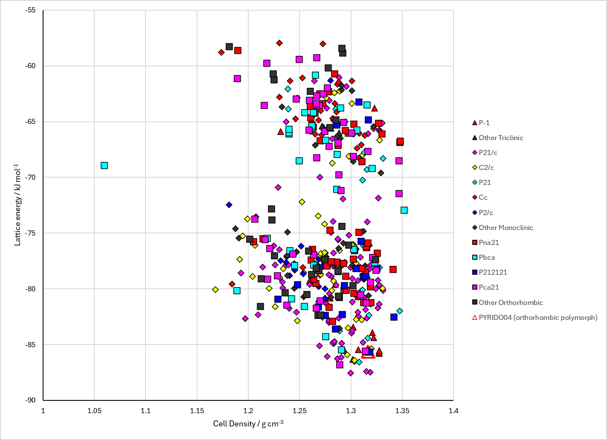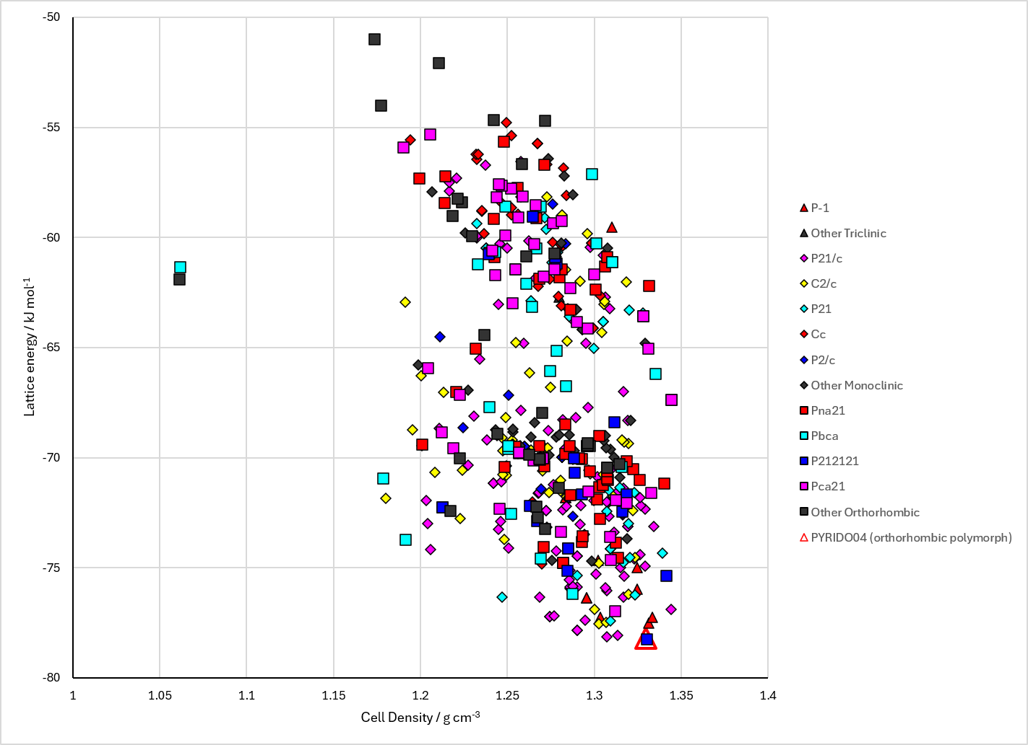
Figure 2. Crystal energy landscape of Pyridone from previous work. Left: Energy model A1. Right: Energy model B1.

CSD structures (CSD version 6.01 with Feb 2026 update)

Table 1. Crystallographic information for CSD entries for Pyridone. Different polymorphs are coloured differently.
REFCODE | space group | Z’ | a / Å | b / Å | c / Å | α / ° | β / ° | γ / ° | density / g cm⁻³ | Form
PYRIDO | P212121 | 1.0 | 13.63 | 5.89 | 5.67 | 90.0 | 90.0 | 90.0 | 1.3876 | orthorhombic polymorph
PYRIDO02 | P212121 | 1.0 | 13.645 | 5.9 | 5.692 | 90.0 | 90.0 | 90.0 | 1.3784 | orthorhombic polymorph
PYRIDO03 | P212121 | 1.0 | 13.564 | 5.792 | 5.598 | 90.0 | 90.0 | 90.0 | 1.4362 | orthorhombic polymorph
PYRIDO04 | P212121 | 1.0 | 13.564 | 5.795 | 5.604 | 90.0 | 90.0 | 90.0 | 1.4339 | orthorhombic polymorph
PYRIDO05 | P212121 | 1.0 | 13.585 | 5.806 | 5.603 | 90.0 | 90.0 | 90.0 | 1.4293 | orthorhombic polymorph
PYRIDO11 | P212121 | 1.0 | 13.657 | 5.912 | 5.70100 | 90.0 | 90.0 | 90.0 | 1.3722 | orthorhombic polymorph
PYRIDO12 | P21/n | 2.0 | 6.2027 | 16.327 | 9.1046 | 90.0 | 92.242 | 90.0 | 1.3711 | monoclinic polymorph
PYRIDO13 | P212121 | 1.0 | 5.613 | 5.80840 | 13.5959 | 90.0 | 90.0 | 90.0 | 1.4250 | orthorhombic polymorph

Table 2. Experimental information for CSD entries for Pyridone.
REFCODE | space group | R factor | T / K | Year | Comments
PYRIDO | P212121 | 6.7 | None | 1953 | 10.1107/S0365110X5300168X
PYRIDO02 | P212121 | 3.9 | None | 1984 | None
PYRIDO03 | P212121 | 4.1 | at 120 K | 1984 | None
PYRIDO04 | P212121 | 2.6 | at 120 K | 1984 | None
PYRIDO05 | P212121 | 4.0 | at 123 K | 1998 | 10.1107/S0108768198006545
PYRIDO11 | P212121 | 3.4 | None | 1984 | None
PYRIDO12 | P21/n | 4.4 | at 98 K | 2009 | 10.1107/S1600536809049496
PYRIDO13 | P212121 | 2.719 | 123 K | 2024 | 10.1002/chir.23617

Make this table include whether polymorphs are solution-grown, sublimation grown, templated or otherwise. Add references.

Other notes

