5-Fluorocytosine
(Last updated May 2026)
Figure 1. The molecular diagram of 5-Fluorocytosine.

CSP studies
REFCODE | MEBQEQ
Formula | C4 H4 N3 O1 F1
Common Name | Fluorocytosine
IUPAC Systematic Name | 5-fluorocytosine
Other Names
CSD Refcodes | MEBQEQ, MEBQEQ01
Search Identifier | A
Scientist | Ashley Hulme
Date | 2006
Publication | Hulme, A. T.; Tocher, D. A. Cryst. Growth Des. 6(2), 481-487 (2006)
Energy model | 1
Study_ID | 0
Programs | MOLPAK, DMAREL (4.1.1)
Location on S Drive | \CHEMISTRY_CPOSS\0-EarlySearches\home\louise_price.eminerals\fluorocytosine
Potential Description | DMA + FIT + Williams F parameters
Intramolecular Description | Ab initio MP2

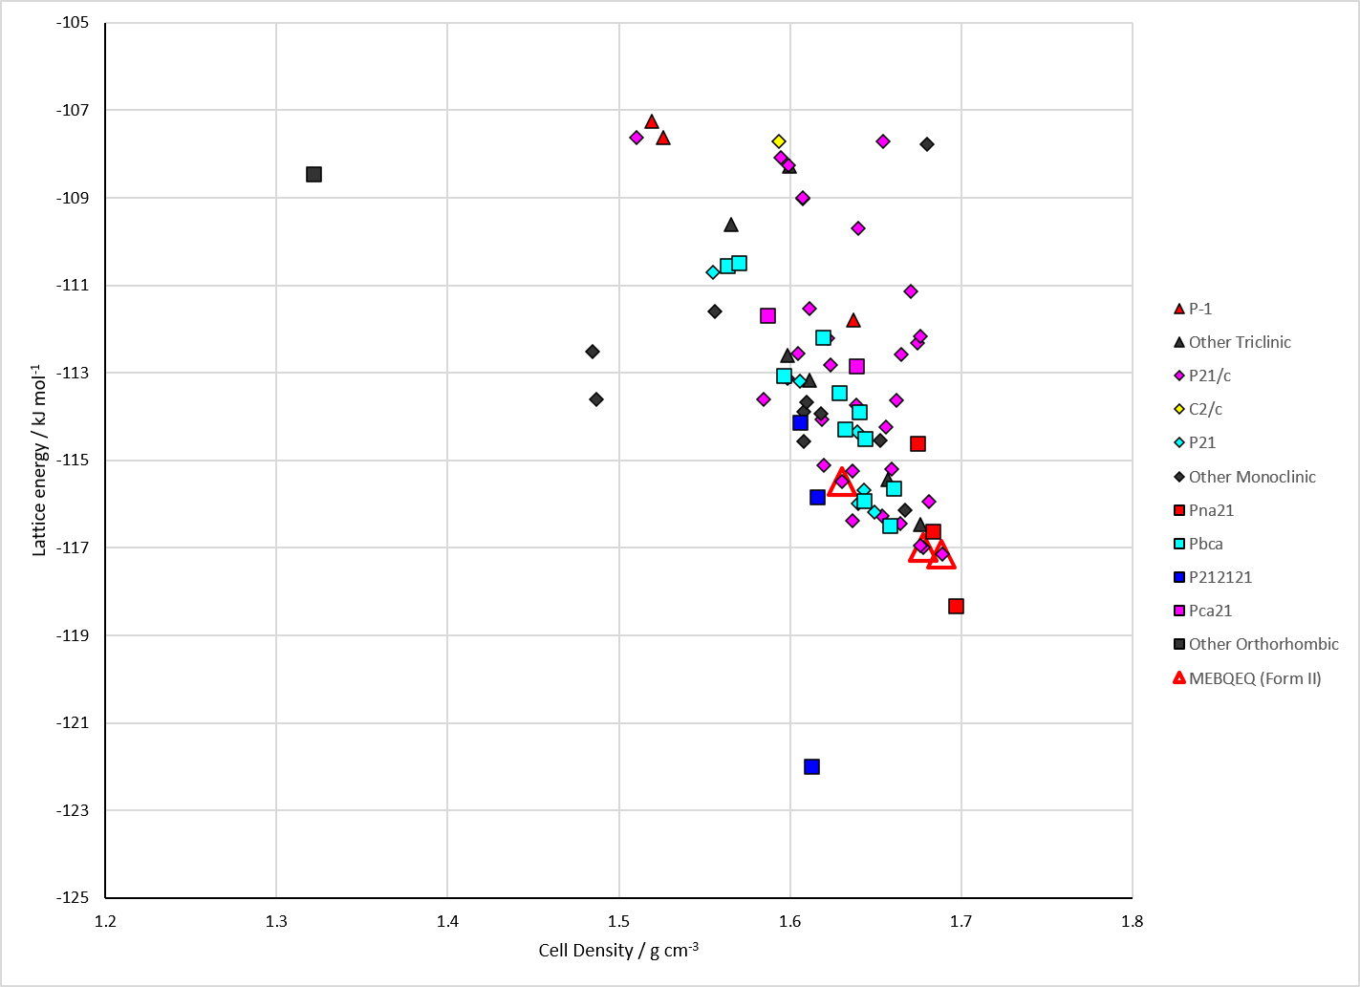
Figure 2. Crystal energy landscape of 5-Fluorocytosine from previous work.

CSD structures (CSD version 6.01 with Feb 2026 update)

Table 1. Crystallographic information for CSD entries for 5-Fluorocytosine. Different polymorphs are coloured differently.
REFCODE | space group | Z’ | a / Å | b / Å | c / Å | α / ° | β / ° | γ / ° | density / g cm⁻³ | Form
MEBQEQ | P21/n | 1.0 | 4.0629 | 9.5211 | 12.7386 | 90.0 | 92.986 | 90.0 | 1.7424 | polymorph II
MEBQEQ01 | P41212 | 1.0 | 6.6387 | 6.6387 | 23.471 | 90.0 | 90.0 | 90.0 | 1.6578 | polymorph I

Table 2. Experimental information for CSD entries for 5-Fluorocytosine.
REFCODE | space group | R factor | T / K | Year | Comments
MEBQEQ | P21/n | 3.41 | at 150 K | 2006 | 10.1021/cg050398g
MEBQEQ01 | P41212 | 3.34 | at 150 K | 2006 | 10.1021/cg050398g

Make this table include whether polymorphs are solution-grown, sublimation grown, templated or otherwise. Add references.

Other notes

