Urazole
(Last updated May 2026)
Figure 1. The molecular diagram of Urazole.

CSP studies
REFCODE | KOXRIY
Formula | C2 H3 N3 O2
Common Name | Urazole
IUPAC Systematic Name | [1,2,4]Triazolidine-3,5-dione
Other Names
CSD Refcodes | KOXRIY
Search Identifier | A
Scientist | Tom Lewis
Date | 2005
Publication | Lewis, T. C., Tocher, D. A., Price, S. L., Cryst. Growth Des., 5(3), 983-993 (2005)
Energy model | 1
Study_ID | 0
Programs | MOLPAK, DMAREL (3.0)
Location on S Drive | \CHEMISTRY_CPOSS\0-EarlySearches\home\louise_price.eminerals\urazole
Potential Description | DMA + adjusted FIT
Intramolecular Description | Ab initio MP2 631G

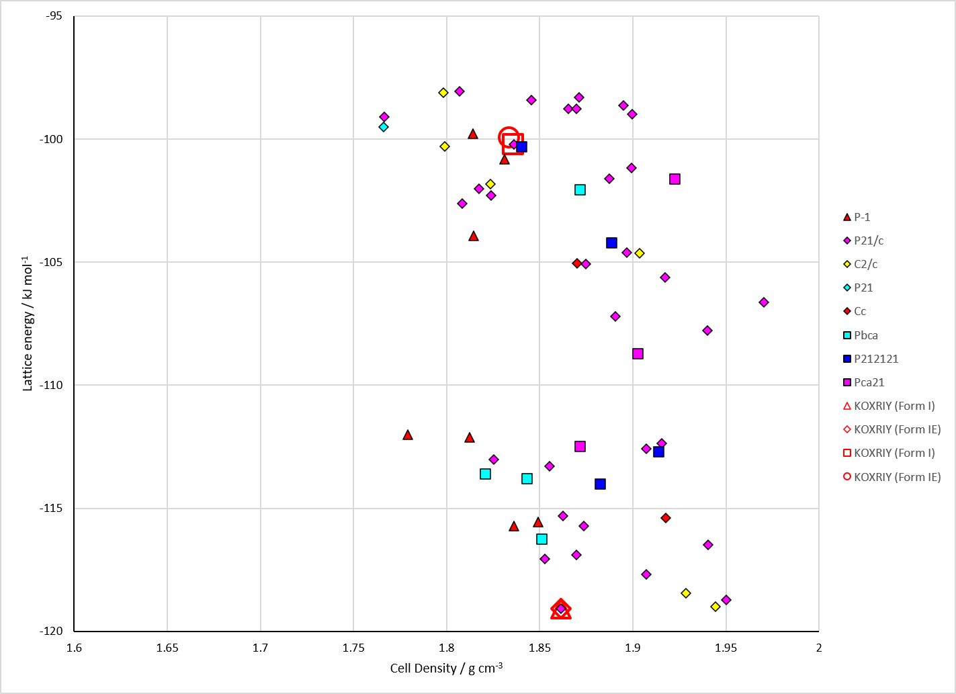
Figure 2. Crystal energy landscape of Urazole from previous work.

CSD structures (CSD version 6.01 with Feb 2026 update)

Table 1. Crystallographic information for CSD entries for Urazole. Different polymorphs are coloured differently.
REFCODE | space group | Z’ | a / Å | b / Å | c / Å | α / ° | β / ° | γ / ° | density / g cm⁻³ | Form
KOXRIY | P21/n | 1.0 | 3.462 | 9.513 | 10.9950 | 90.0 | 95.06 | 90.0 | 1.8610 | None

Table 2. Experimental information for CSD entries for Urazole.
REFCODE | space group | R factor | T / K | Year | Comments
KOXRIY | P21/n | 3.6 | at 105 K | 1992 | 10.1107/S0108270191013525

Make this table include whether polymorphs are solution-grown, sublimation grown, templated or otherwise. Add references.

Other notes

