Iminodibenzyl
(Last updated June 2026)
Figure 1. The molecular diagram of Iminodibenzyl.

CSP studies
REFCODE | HBZAZP
Formula | C14 H13 N1
Common Name | Iminodibenzyl
IUPAC Systematic Name | 10,11-Dihydro-5H-dibenzo[b,f]azepin
Other Names
CSD Refcodes | HBZAZP01
Search Identifier | A
Scientist | Not sure
Date | pre-2010
Publication | No publication planned.
Energy model | 1
Study_ID | 0
Programs | MOLPAK, DMAREL (4.1.1)
Location on S Drive | \CHEMISTRY_CPOSS\0-EarlySearches\home\louise_price.eminerals\iminodibenzyl
Potential Description | DMA + FIT
Intramolecular Description | MP2/6-31G(d,p)
Energy model | 2
Study_ID | 1
Programs | Study_ID=0, DMACRYS (2.2.3.0)
Location on S Drive | \CHEMISTRY_CPOSS\0-EarlySearches\home\louise_price.eminerals\iminodibenzyl_2
Potential Description | DMA + FIT
Intramolecular Description | MP2/6-31G(d,p)

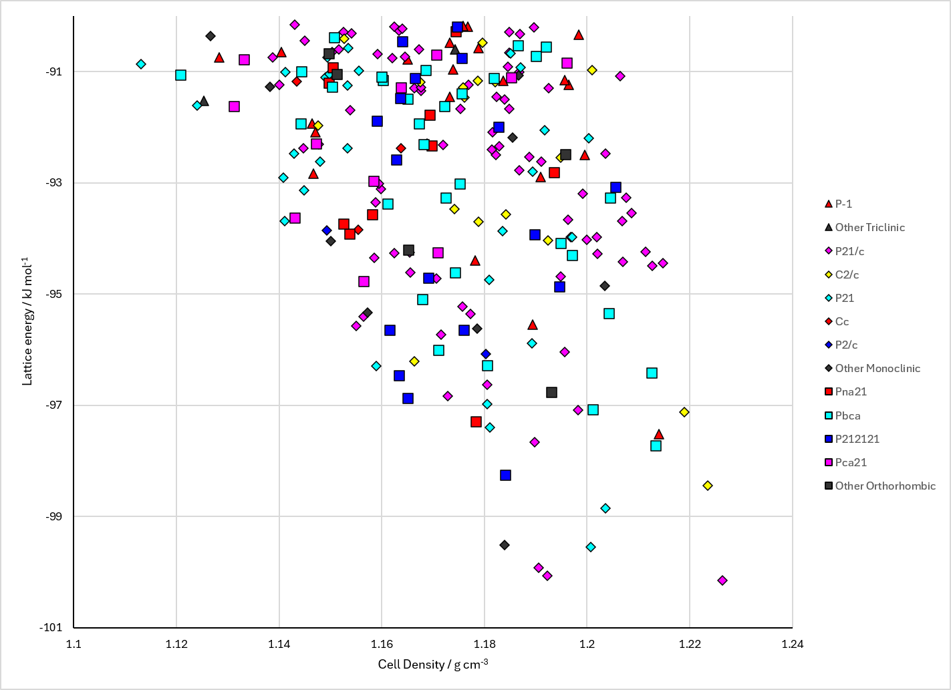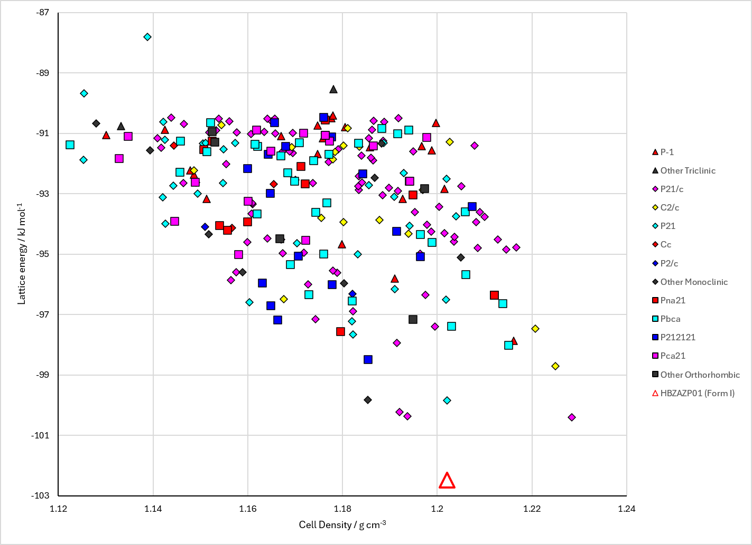
Figure 2. Crystal energy landscape of Iminodibenzyl from previous work. Left: Energy model A1. Right: Energy model A2.

CSD structures (CSD version 6.01 with Feb and May 2026 updates)

Table 1. Crystallographic information for CSD entries for Iminodibenzyl. Different polymorphs are coloured differently.
REFCODE | space group | Z’ | a / Å | b / Å | c / Å | α / ° | β / ° | γ / ° | density / g cm⁻³ | Form
HBZAZP | P21/c | 2.0 | 11.6040 | 11.269 | 20.05 | 90.0 | 126.55 | 90.0 | 1.2315 | None
HBZAZP01 | P21/n | 2.0 | 11.5031 | 11.2088 | 15.9044 | 90.0 | 91.049 | 90.0 | 1.2651 | None

Table 2. Experimental information for CSD entries for Iminodibenzyl.
REFCODE | space group | R factor | T / K | Year | Comments
HBZAZP | P21/c | 4.9 | None | 1980 | 10.1107/S0567740880008035
HBZAZP01 | P21/n | 3.88 | 120 K | 2014 | None

Make this table include whether polymorphs are solution-grown, sublimation grown, templated or otherwise. Add references.

Other notes

