Methanol
(Last updated June 2026)
Figure 1. The molecular diagram of Methanol.

CSP studies
REFCODE | METHOL
Formula | C1 H4 O1
Common Name | Methanol
IUPAC Systematic Name | Methanol
Other Names
CSD Refcodes | METHOL, METHOL02, METHOL05, METHOL03, METHOL06
Search Identifier | A
Scientist | Not sure
Date | 2013
Publication | No publication planned.
Energy model | 1
Study_ID | 10
Programs | CrystalPredictor, CrystalOptimizar, DMACRYS (2.0.8RC1)
Location on S Drive | \CHEMISTRY_CPOSS\Methanol
Potential Description | CrystalOptimizer PBE1PBE/6-31G(d,p) intramolecular + GDMA2.2(PBE1PBE/6-31G(d,p)) DMA + FIT
Intramolecular Description | PBE1PBE 6-31G(d,p)

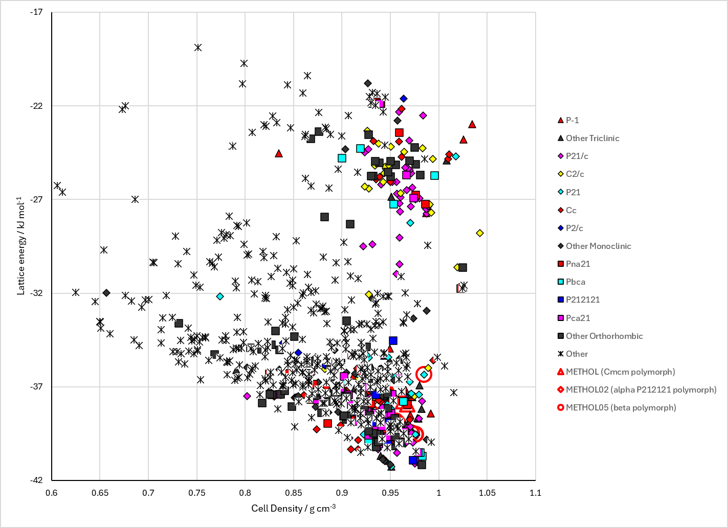
Figure 2. Crystal energy landscape of Methanol from previous work.

CSD structures (CSD version 6.01 with Feb and May 2026 updates)

Table 1. Crystallographic information for CSD entries for Methanol. Different polymorphs are coloured differently.
REFCODE | space group | Z’ | a / Å | b / Å | c / Å | α / ° | β / ° | γ / ° | density / g cm⁻³ | Form
METHOL | Cmcm | 0.25 | 6.43 | 7.24 | 4.67 | 90.0 | 90.0 | 90.0 | 0.9789 | Cmcm polymorph
METHOL01 | Unknown | 0.0 | 4.44 | 4.44 | 7.25 | 90.0 | 90.0 | 120.0 | None | gamma polymorph
METHOL02 | P212121 | 1.0 | 4.8728 | 4.6411 | 8.8671 | 90.0 | 90.0 | 90.0 | 1.0613 | alpha P212121 polymorph
METHOL03 | P-1 | 3.0 | 7.67 | 4.4101 | 7.199 | 88.10 | 102.89 | 93.85 | 1.3481 | high pressure gamma polymorph
METHOL04 | P212121 | 1.0 | 4.64690 | 4.92850 | 9.0403 | 90.0 | 90.0 | 90.0 | 1.0279 | alpha P212121 polymorph
METHOL05 | Cmc21 | 0.5 | 6.401 | 7.22 | 4.647 | 90.0 | 90.0 | 90.0 | 0.9442 | beta polymorph
METHOL06 | P21/c | 3.0 | 4.3989 | 11.8090 | 10.981 | 90.0 | 126.69 | 90.0 | 1.3958 | high pressure epsilon polymorph

Table 2. Experimental information for CSD entries for Methanol.
REFCODE | space group | R factor | T / K | Year | Comments
METHOL | Cmcm | None | 163 K | 1952 | 10.1107/S0365110X52001696
METHOL01 | Unknown | None | None | 1952 | None
METHOL02 | P212121 | 3.9 | at 15 K | 1989 | None
METHOL03 | P-1 | 12.0 | None | 1998 | 10.1103/PhysRevB.58.R11809
METHOL04 | P212121 | 3.38 | at 122 K | 2008 | 10.1021/cg0701877
METHOL05 | Cmc21 | 3.7 | at 160 K | 2008 | 10.1021/cg0701877
METHOL06 | P21/c | 8.58 | 293 K | 2022 | 10.1039/D2CE01157C

Make this table include whether polymorphs are solution-grown, sublimation grown, templated or otherwise. Add references.

Other notes

