Tetrolic Acid
(Last updated June 2026)
Figure 1. The molecular diagram of Tetrolic Acid.

CSP studies
REFCODE | TETROL
Formula | C4 H4 O2
Common Name | Tetrolic Acid
IUPAC Systematic Name | But-2-ynoic Acid
Other Names
CSD Refcodes | TETROL02, TETROL07
Search Identifier | A
Scientist | Matthew Habgood
Date | 2012
Publication | Habgood M 2012. Phys Chem Chem Phys 14, 9195-9203.
Energy model | 1
Study_ID | 30
Programs | Rigid CrystalPredictor, DMACRYS (2.0.4)
Location on S Drive | \CHEMISTRY_CPOSS\TetrolicAcid\PCM
Potential Description | GDMA2.2(PCMdielectric3(MP2/6-31G(d,p))) + FIT with a increased by 1.1 and c increased by 1.25
Intramolecular Description | MP2/6-31G(d,p)
Energy model | 2
Study_ID | 10
Programs | Study_ID=30, CrystalOptimizer, DMACRYS (2.0.4)
Location on S Drive | \CHEMISTRY_CPOSS\TetrolicAcid\CrystOpt
Potential Description | CrystalOptimizer, GDMA2.2(MP2/6-31G(d,p)) + FIT
Intramolecular Description | PBE0(6-31G(d,p))

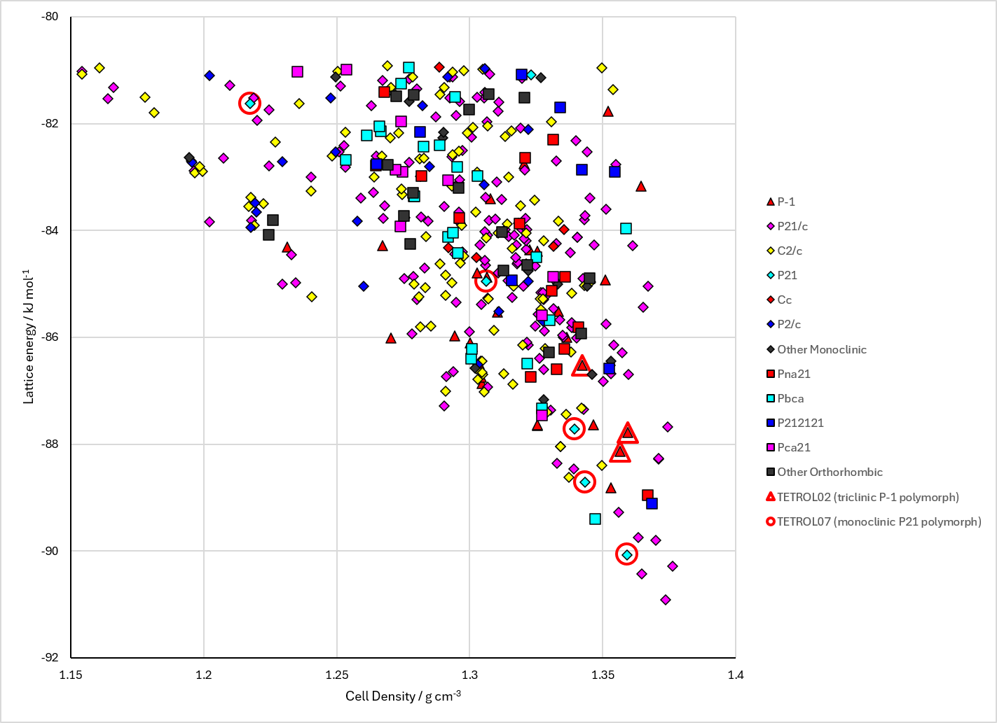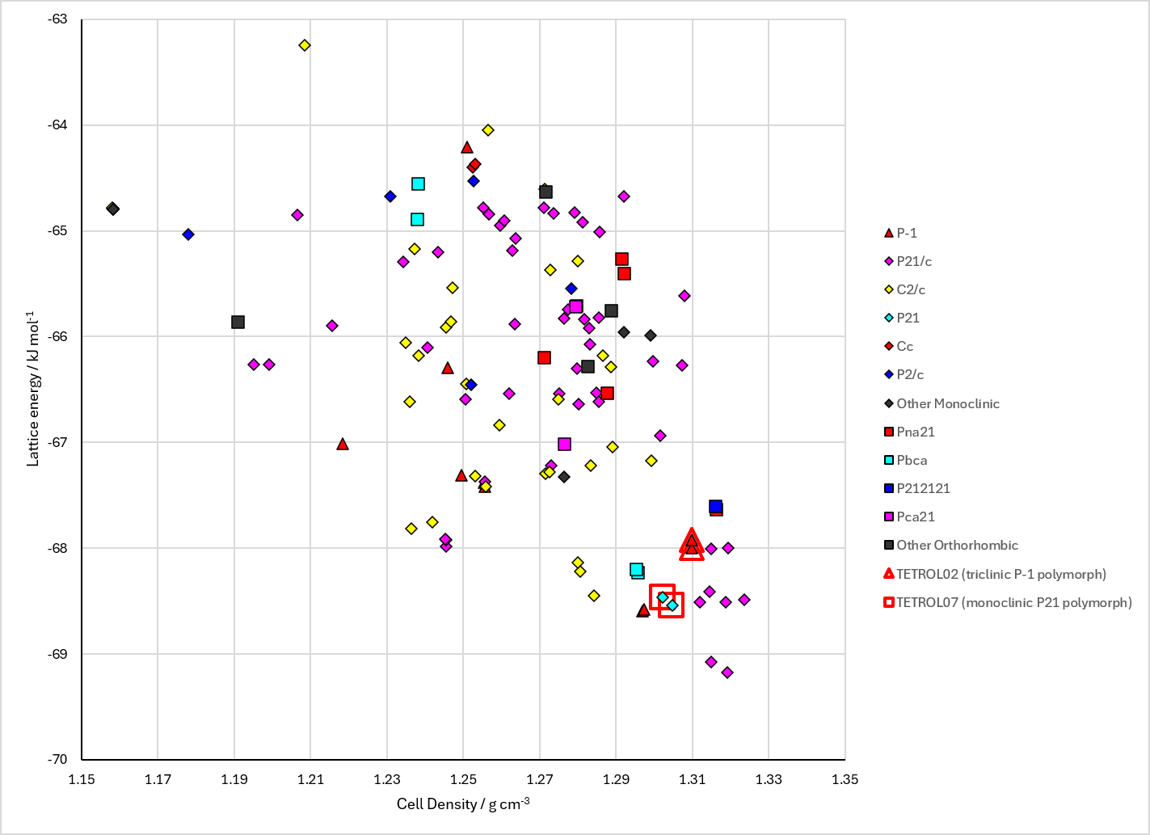
Figure 2. Crystal energy landscape of Tetrolic Acid from previous work. Left: Energy model A1. Right: Energy model A2.

CSD structures (CSD version 6.01 with Feb 2026 update)

Table 1. Crystallographic information for CSD entries for Tetrolic Acid. Different polymorphs are coloured differently.
REFCODE | space group | Z’ | a / Å | b / Å | c / Å | α / ° | β / ° | γ / ° | density / g cm⁻³ | Form
TETROL | P-1 | 1.0 | 7.32 | 5.099 | 7.226 | 83.91 | 117.46 | 112.0 | 1.2624 | alpha polymorph
TETROL01 | P21 | 1.0 | 7.887 | 7.121 | 3.937 | 90.0 | 100.18 | 90.0 | 1.2829 | beta polymorph
TETROL02 | P-1 | 1.0 | 5.0156 | 6.9262 | 7.0836 | 112.956 | 97.227 | 107.388 | 1.3433 | triclinic P-1 polymorph
TETROL03 | P-1 | 1.0 | 5.0359 | 6.9758 | 7.1152 | 112.963 | 97.033 | 107.706 | 1.3245 | triclinic P-1 polymorph
TETROL04 | P-1 | 1.0 | 5.058 | 7.0169 | 7.1325 | 112.92 | 96.962 | 108.002 | 1.3099 | triclinic P-1 polymorph
TETROL05 | P-1 | 1.0 | 5.0673 | 7.0638 | 7.163 | 113.064 | 96.689 | 108.347 | 1.2968 | triclinic P-1 polymorph
TETROL06 | P21 | 1.0 | 3.91580 | 7.1104 | 7.871 | 90.0 | 100.59 | 90.0 | 1.2961 | monoclinic P21 polymorph
TETROL07 | P21 | 1.0 | 3.8248 | 7.0987 | 7.7801 | 90.0 | 101.058 | 90.0 | 1.3467 | monoclinic P21 polymorph
TETROL08 | P21 | 1.0 | 3.85180 | 7.0956 | 7.79240 | 90.0 | 100.862 | 90.0 | 1.3349 | monoclinic P21 polymorph
TETROL09 | P21 | 1.0 | 3.8856 | 7.1138 | 7.8353 | 90.0 | 100.93 | 90.0 | 1.3130 | monoclinic P21 polymorph
TETROL10 | P21 | 1.0 | 3.8912 | 7.11410 | 7.8453 | 90.0 | 100.8 | 90.0 | 1.3088 | monoclinic P21 polymorph
TETROL11 | P21 | 1.0 | 3.9127 | 7.1074 | 7.8489 | 90.0 | 100.422 | 90.0 | 1.3006 | monoclinic P21 polymorph
TETROL12 | P21 | 1.0 | 3.9417 | 7.1096 | 7.878 | 90.0 | 100.25 | 90.0 | 1.2852 | monoclinic P21 polymorph

Table 2. Experimental information for CSD entries for Tetrolic Acid.
REFCODE | space group | R factor | T / K | Year | Comments
TETROL | P-1 | 7.0 | None | 1972 | 10.1039/p29720001763
TETROL01 | P21 | 4.0 | None | 1972 | 10.1039/p29720001763
TETROL02 | P-1 | 5.38 | 118 K | 2015 | 10.1039/C5NJ00196J
TETROL03 | P-1 | 5.75 | 154 K | 2015 | 10.1039/C5NJ00196J
TETROL04 | P-1 | 6.4 | 190 K | 2015 | 10.1039/C5NJ00196J
TETROL05 | P-1 | 6.05 | 226 K | 2015 | 10.1039/C5NJ00196J
TETROL06 | P21 | 6.33 | 262 K | 2015 | 10.1039/C5NJ00196J
TETROL07 | P21 | 4.0 | 118 K | 2015 | 10.1039/C5NJ00196J
TETROL08 | P21 | 4.26 | 154 K | 2015 | 10.1039/C5NJ00196J
TETROL09 | P21 | 4.36 | 190 K | 2015 | 10.1039/C5NJ00196J
TETROL10 | P21 | 4.64 | 226 K | 2015 | 10.1039/C5NJ00196J
TETROL11 | P21 | 4.600 | 262 K | 2015 | 10.1039/C5NJ00196J
TETROL12 | P21 | 5.13 | 298 K | 2015 | 10.1039/C5NJ00196J

Make this table include whether polymorphs are solution-grown, sublimation grown, templated or otherwise. Add references.

Other notes

