Beta-Resorcylic Acid
(Last updated April 2026)
Figure 1. The molecular diagram of beta-Resorcylic Acid.

CSP studies
The search for anhydrous beta-Resorcylic Acid was done, but the original files are missing so it cannot be updated. It is still on the database, so a landscape is included here.
REFCODE | QIVTUK
Formula | 2(C7 H6 O4) - H2 O1
Common Name | beta-Resorcylic Acid Hemihydrate
IUPAC Systematic Name | 2,4-Dihydroxybenzoic Acid Hemihydrate
Other Names
CSD Refcodes | QIVTUK
Search Identifier | A
Scientist | Doris Braun
Date | 2011
Publication | Braun DE, Karamertzanis PG, Price SL 2011. Chem Commun 47, 5443-5445.
Energy model | 3
Study_ID | 30
Programs | Study_ID=10, DMACRYS (2.0.4)
Location on S Drive | \CHEMISTRY_CPOSS\betaResorcylicAcid\bRA_hemihydrate_PCM
Potential Description | GDMA2.2(PCMdielectric3(PBE0/aug-cc-pVTZ)) + FIT
Intramolecular Description | PCMdielectric=3(PBE1PBE/aug-cc-pVTZ)
Energy model | 2
Study_ID | 10
Programs | Study_ID=20, CrystalOptimizer, DMACRYS (2.0.2)
Location on S Drive | \CHEMISTRY_CPOSS\betaResorcylicAcid\bRA_hemihydrate_CO
Potential Description | GDMA2(PBE0/aug-cc-pVTZ) + FIT
Intramolecular Description | PBE0/6-31G(d,p)
Energy model | 1
Study_ID | 20
Programs | Rigid CrystalPredictor, DMACRYS (2.0.2)
Location on S Drive | \CHEMISTRY_CPOSS\betaResorcylicAcid\bRA_hemihydrate
Potential Description | GDMA2(PBE0/aug-cc-pVTZ) + FIT
Intramolecular Description | SCF/6-31G(d,p)
REFCODE | YUXGUV
Formula | C7 H6 O4 - H2 O1
Common Name | beta Resorcylic Acid monohydrate
IUPAC Systematic Name | 2,4-Dihydroxybenzoic acid monohydrate
Other Names
CSD Refcodes | YUXGUV
Search Identifier | A
Scientist | Doris Braun
Date | 2011
Publication | Braun DE, Karamertzanis PG, Price SL 2011. Chem Commun 47, 5443-5445.
Energy model | 3
Study_ID | 30
Programs | Study_ID=10, DMACRYS (2.0.4)
Location on S Drive | \CHEMISTRY_CPOSS\betaResorcylicAcid\bRA_monohydrate_PCM
Potential Description | GDMA2.2(PCMdielectric3(PBE0/aug-cc-pVTZ)) + FIT
Intramolecular Description | PCMdielectric=3(PBE1PBE/aug-cc-pVTZ)
Energy model | 2
Study_ID | 10
Programs | Study_ID=20, CrystalOptimizer, DMACRYS (2.0.2)
Location on S Drive | \CHEMISTRY_CPOSS\betaResorcylicAcid\bRA_monohydrate_CO
Potential Description | Crystal Predictor DMA(PBE0/aug-cc-pVTE) + FIT
Intramolecular Description | PBE0/6-31G(d,p)
Energy model | 1
Study_ID | 20
Programs | Rigid CrystalPredictor, DMACRYS (2.0.2)
Location on S Drive | \CHEMISTRY_CPOSS\betaResorcylicAcid\bRA_monohydrate
Potential Description | Crystal Predictor DMA(PBE0/aug-cc-pVTE) + FIT
Intramolecular Description | SCF/6-31G(d,p)
REFCODE | UCLDBB
Formula | C7 H6 O4 - 2(H2 O1)
Common Name | beta Resorcylic Acid Dihydrate
IUPAC Systematic Name | 2,4-Dihydroxybenzoic Acid Dihydrate
Other Names
CSD Refcodes
Search Identifier | A
Scientist | Doris Braun
Date | 2011
Publication | Braun DE, Karamertzanis PG, Price SL 2011. Chem Commun 47, 5443-5445.
Energy model | 3
Study_ID | 30
Programs | Study_ID=10, DMACRYS (2.0.4)
Location on S Drive | \CHEMISTRY_CPOSS\betaResorcylicAcid\bRA_dihydrate_PCM
Potential Description | GDMA2.2(PCMdielectric3(PBE0/aug-cc-pVTZ)) + FIT
Intramolecular Description | PCMdielectric=3(PBE1PBE/aug-cc-pVTZ)
Energy model | 2
Study_ID | 10
Programs | Study_ID=20, CrystalOptimizer, DMACRYS (2.0.2)
Location on S Drive | \CHEMISTRY_CPOSS\betaResorcylicAcid\bRA_dihydrate_CO
Potential Description | CrystalOptimizer GDMA2 (MP2/6-31G(d,p)) + FIT
Intramolecular Description | PBE0/6-31G(d,p)
Energy model | 1
Study_ID | 20
Programs | Rigid CrystalPredictor, DMACRYS (2.0.2)
Location on S Drive | \CHEMISTRY_CPOSS\betaResorcylicAcid\bRA_dihydrate
Potential Description | GDMA2(PBE0/aug-cc-pVTZ) + FIT
Intramolecular Description | SCF/6-31G(d,p)

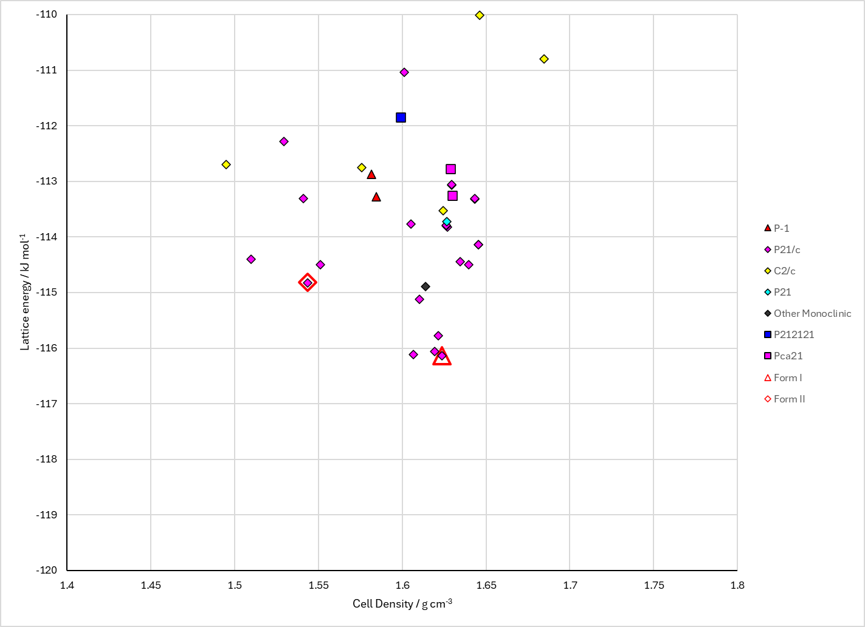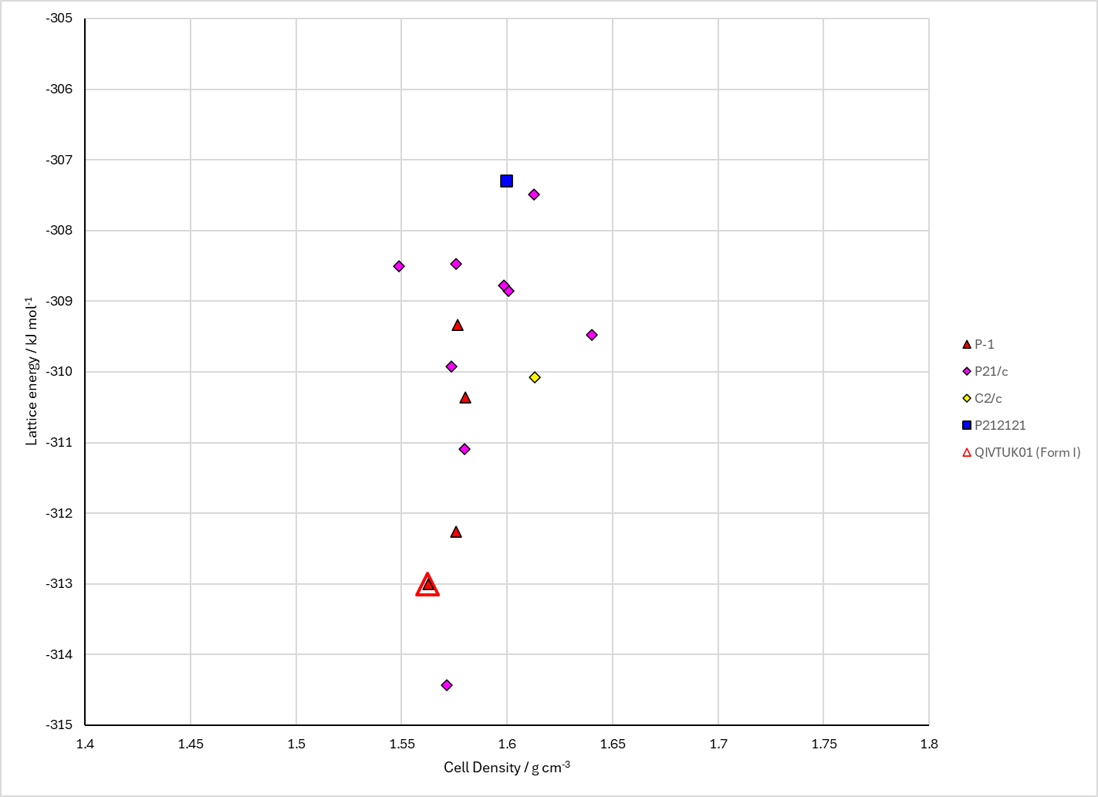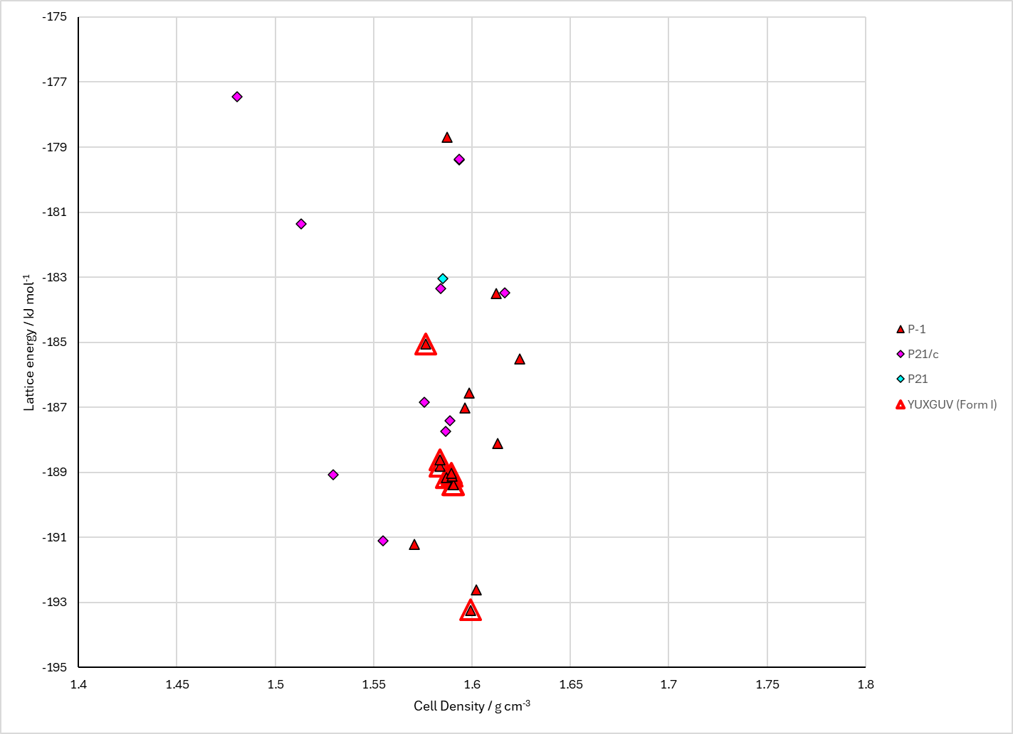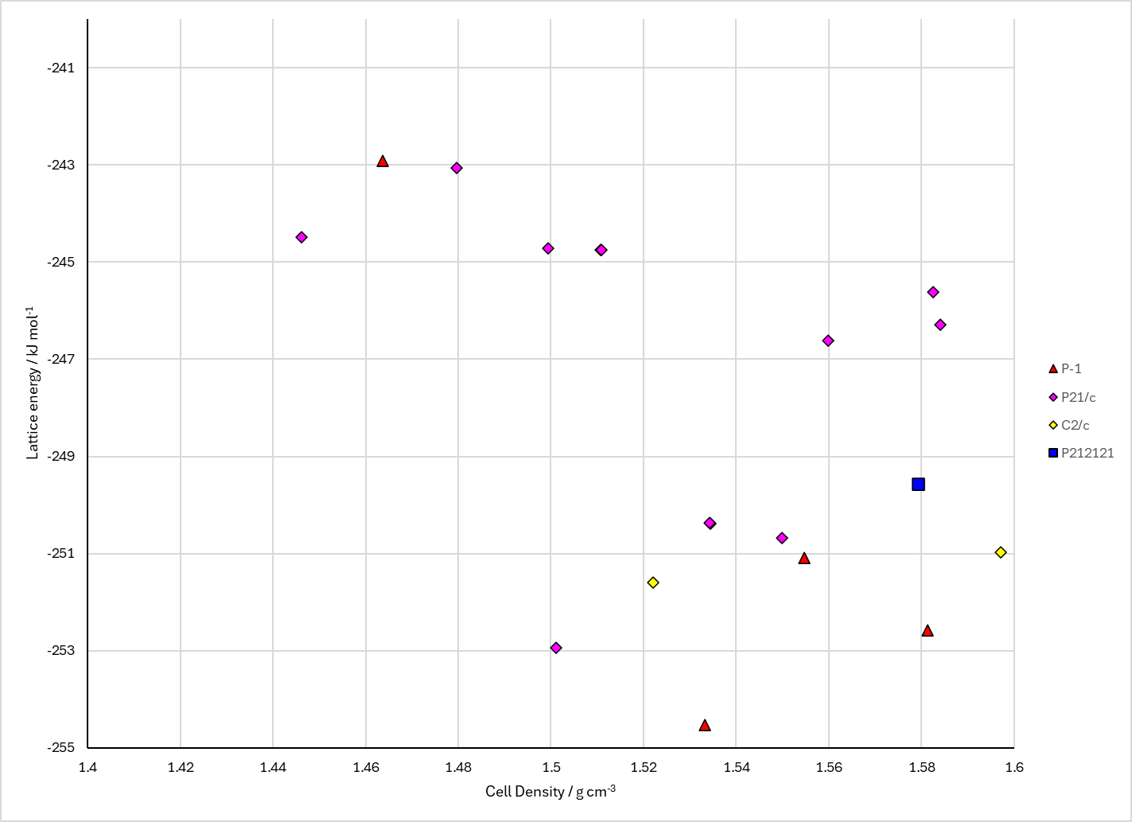
Figure 2. Crystal energy landscape of beta-Resorcylic Acid hydrates from previous work. Top left: anhydrate (probably CrystalOptimizer). Top right: hemihydrate. Bottom left: monohydrate. Bottom right: Dihydrate. All PCM landscapes, Energy model 3.

CSD structures (CSD version 6.01 with Feb 2026 update)

Table 1. Crystallographic information for CSD entries for beta-Resorcylic Acid and hydrates. Different polymorphs are coloured differently.
REFCODE | space group | Z’ | a / Å | b / Å | c / Å | α / ° | β / ° | γ / ° | density / g cm⁻³ | Form
ZZZEEU01 | P21/n | 1.0 | 3.6686 | 22.3330 | 8.0046 | 90.0 | 99.63 | 90.0 | 1.5832 | polymorph II
ZZZEEU02 | P21/n | 1.0 | 3.67210 | 22.341 | 8.007 | 90.0 | 99.602 | 90.0 | 1.5805 | polymorph II
ZZZEEU03 | P21/n | 1.0 | 3.67420 | 22.341 | 8.0065 | 90.0 | 99.567000 | 90.0 | 1.5795 | polymorph II
ZZZEEU04 | P21/n | 1.0 | 3.6854 | 22.367 | 8.0085 | 90.0 | 99.448000 | 90.0 | 1.5720 | polymorph II
ZZZEEU05 | P21/n | 1.0 | 3.656 | 22.329 | 8.009 | 90.0 | 99.76 | 90.0 | 1.5887 | polymorph II
ZZZEEU06 | P21/n | 1.0 | 3.669 | 22.3473 | 8.012 | 90.0 | 99.63 | 90.0 | 1.5805 | polymorph II
ZZZEEU07 | P21/n | 1.0 | 3.686 | 22.3680 | 8.015 | 90.0 | 99.44 | 90.0 | 1.5703 | polymorph II
ZZZEEU08 | P21/a | 1.0 | 23.1978 | 5.5469 | 5.198 | 90.0 | 92.215 | 90.0 | 1.5316 | polymorph I
QIVTUK | P-1 | 2.0 | 7.026 | 9.547 | 11.199 | 96.78 | 104.34000 | 98.850000 | 1.5271 | None
QIVTUK01 | P-1 | 2.0 | 7.027 | 9.5449 | 11.1763 | 96.684 | 104.319 | 98.903 | 1.5300 | None
YUXGUV | P-1 | 1.0 | 3.8229 | 8.972 | 11.645 | 75.011 | 89.036 | 81.735 | 1.4975 | None

There is also a Form III of the anhydrate, but there are no coordinates on the CSD. The REFCODE is ZZZEEU.
Table 2. Experimental information for CSD entries for beta-Resorcylic Acid and hydrates.
REFCODE | space group | R factor | T / K | Year | Comments
ZZZEEU01 | P21/n | 5.41 | at 90 K | 2007 | 10.1107/S0108768106055212
ZZZEEU02 | P21/n | 5.09 | at 100 K | 2007 | 10.1107/S0108768106055212
ZZZEEU03 | P21/n | 5.08 | at 110 K | 2007 | 10.1107/S0108768106055212
ZZZEEU04 | P21/n | 5.4 | at 150 K | 2007 | 10.1107/S0108768106055212
ZZZEEU05 | P21/n | 7.890 | at 20 K | 2010 | 10.1039/b9nj00353c
ZZZEEU06 | P21/n | 8.13 | at 90 K | 2010 | 10.1039/b9nj00353c
ZZZEEU07 | P21/n | 7.44 | at 150 K | 2010 | 10.1039/b9nj00353c
ZZZEEU08 | P21/a | 5.5 | at 298 K | 2011 | 10.1021/cg101162a
QIVTUK | P-1 | 4.63 | None | 1999 | None
QIVTUK01 | P-1 | 3.820 | at 173 K | 2011 | 10.1021/cg101162a
YUXGUV | P-1 | 4.8 | 294 K | 2015 | 10.1107/S2053229615020628

Make this table include whether polymorphs are solution-grown, sublimation grown, templated or otherwise. Add references.

Other notes

